THM Design Co.
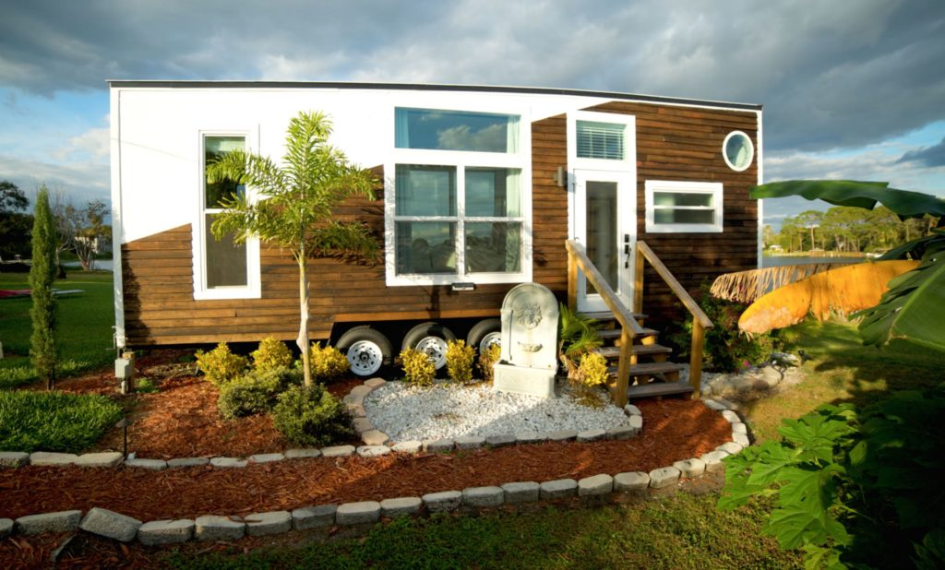
Building Plan: Week 6
The Outside!

Finishing the outside:
When finishing the outside, you will have 2 things to consider:
A. The exterior of the building – think about where this tiny house is going. What is the weather like? How does this impact the materials you use on the outside of the home?
B. The surrounding landscape – think about what your client(s) lifestyle. How might they use the yard? What types of outdoor things will help them enjoy the outdoor space?

The Exterior:
You have an additional $5000 to complete the exterior of your tiny house. Be sure to add this to your budget sheets and include the following items:
- Siding material (vinyl, wood, composite, brick, metal, a combination, etc.)
- Windows and doors (style, colour of frame, size)
- Roofing material (cedar shakes, shingles, metal)
When adding these materials to your prototype, be sure to give some thought to the colours!

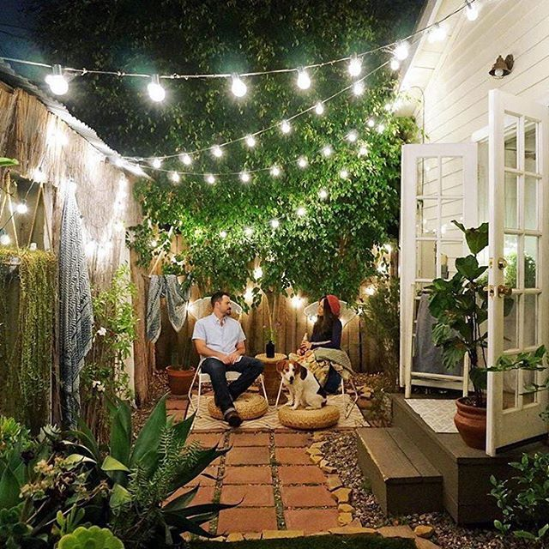
The Landscaping:
You have an additional $1000 to complete the landscaping of the outdoor space. Be sure to add this to your budget sheets. Here are things to consider:
- Decks, patios and barbeques
- Driveways and storage sheds
- Shade covers, patio furniture and lighting
- Garden beds and trees
You will have to secure your prototype to a piece of cardboard to be able to add the landscaping elements around the house. If you have the lot size, try to get your outdoor space to the same scale as well…a good challenge!

