THM Design Co.
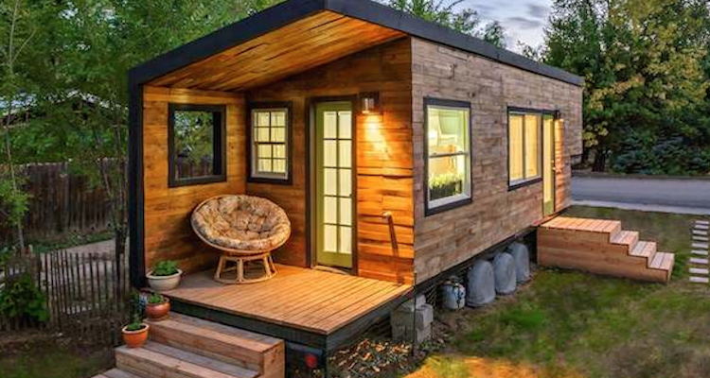
Building Plan: Week 2
Working with a budget:
Items already provided for you:
- The trailer
- The framing materials
- The labour
Your budget breakdown of $15 000:
- $10 000 for the interior (kitchen, bathroom, bedroom, living room, eating area, etc.)
- $5 000 for the exterior (siding, doors, roofing, windows)
Later you will also receive:
- $500 for decorating
- $1 000 for landscaping

Getting Started: $10 000 for the interior:
Use the budgeting sheet provided (& a pencil) OR create your own spreadsheet to keep track of your spending. You will also want to collect pictures of the items you are planning to use for the tiny home design so you can present these to your client(s). This will give them a better picture of how it will look when it is all done. To start, think about the following:
- What are the things you need to put in the tiny home for everyday living? (try making a list for each room, go through your own house, think about your own day)
- What are your big-ticket items?
- What are your “must haves” going to cost?
- What are the things you need, but can shop around to find a better price for?
- Are there things that can be multiuse or multifunction to save money?
- Are there things that would be nice if there is money, but could be left out if you run out?
- Can you make something or repurpose/refinish something for less?

**Your client(s) will want to see your final, good copy of the budget sheet**
It is important for them to know how you spent their money.

Budget Planning Examples: Doc, Excel

Creating a floorplan:
You will need to create 2 layouts for your client(s) to choose from. Have 2 draft copies ready for the next staff meeting and any questions or concerns you are facing. Draft means penciled in ideas.
When designing a floorplan, here are a few things to keep in mind:
- ALWAYS TO SCALE! You choose the scale (1 square = 12 inches, or 1 square = 6 inches, etc.) and what you use for the drawings (graph paper, provided grid, own created grid, etc.)
- EVERYTHING TO SCALE! Everything you put inside the 8 feet by 30 feet area (by 10 feet high ceiling) of the house needs to also be the same scale as the floor area. For example, if you are using a scale of 1 square = 12 inches, and you decide to put in a stove that is 30” wide and 24” deep, you would need to show an area on your floorplan that is to scale. The blue shows how much space a stove of this size would take up.

- LABELS! It’s important to know what things are. You can either label items with symbols, or use the picture items included.
- PATHWAYS! Think about how much space you are giving the client(s) to walk around, go up stairs or ladders, pull out chairs, open doors, closets, cabinets and sit on the toilet! All these also need to be to scale and shown in the floorplan as empty squares.
- LEVELS! If your plan includes a loft, you need to show that as a second level space on a separate grid that matches in size and can be placed over top and lines up with the bottom floorplan.
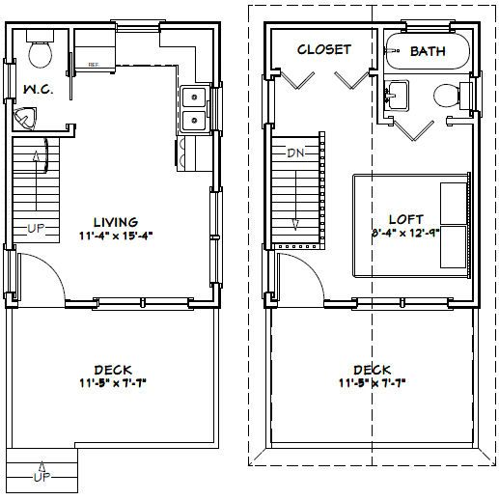
Here is an example:

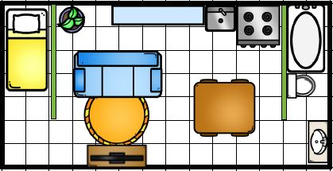

Floorplan Paper:

Items to consider:
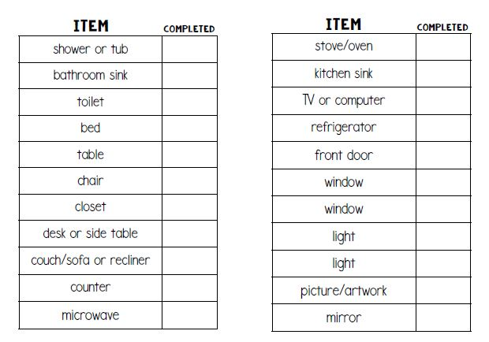

Use symbols or drawings to label items in your floorplan – floorplan helper PDF

