Which Animal Do You Connect With?

Wolf is a great communicator. I can share my thinking by…
- Talking about the things I’ve learned
- Working together and playing with others cooperatively
- Listening and thinking about what others say about my ideas

Raven is a creative thinker. I can be creative by…
- Being playful and enjoying what I am doing
- Gathering ideas from others and making something new
- Working to make my ideas come to life
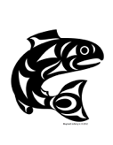

Salmon is a critical thinker. I can be critical like Salmon by…
- Watching a situation and deciding what I think
- Asking questions and exploring my options
- Experimenting when I’m trying to solve a problem

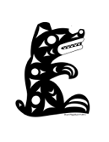
Bear is a great protector. I can be reflective like Bear by…
- Celebrating when I’ve done something I am proud of
- Listening to my feelings no matter how I am feeling
- Using calm down strategies to help me when I am upset

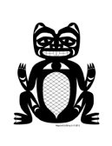

Beaver is a diligent collaborator. I can make the world a better place like Beaver by….
- Noticing when there is a problem and working to solve it
- Being kind and respectful to others
- Working with others to clean up or make something better

Orca is a noble navigator. I can honour my roots like Orca by…
- Knowing who I am and what is important to me
- Recognizing the things I am good at and working on things I need to improve
- Understanding and appreciating my family’s heritage

From Six Cedar Trees by Margot Landahl; Indigenous animal images from Cowichan School District Image Library

