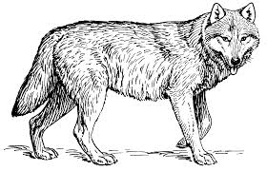
Understanding Each Animal

Wolf is a great communicator. He represents the Communication Competency. Through Wolf, we can learn to connect and engage with others; gather and share information; and cooperate with others by listening to and respecting each other.
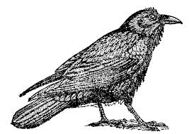
Raven is a creative thinker. He represents the Creative Thinking Competency. Through Raven, we can learn to generate novel ideas inspired by others or by our own personal experiences. As Creative Thinkers, we can persevere to develop our ideas by thinking “outside of the box.”
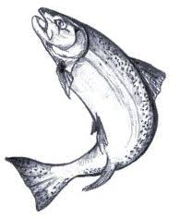
Salmon is a critical thinker. He represents the Critical Thinking Competency. Through Salmon, we learn to observe, analyze and critique information and experiences. Our inquiries, allow us opportunities to question and investigate as well as develop and design plans.

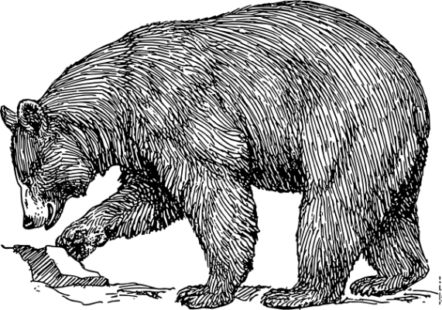
Bear is a great protector. He represents Personal Awareness and Responsibility. Through Bear, we can learn to nurture our own personal well-being by valuing ourselves and our accomplishments; understanding our feelings and making good choices that demonstrate respect for ourselves and others.
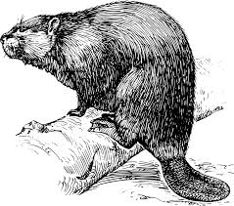

Beaver is a diligent collaborator. He represents Social Responsibility. Through Beaver, we can learn to care for our community and environment by valuing diversity, advocating for others and working together for a greater good.

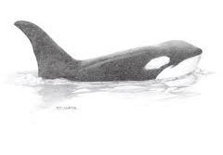
Orca is a noble navigator. He represents Positive Personal and Cultural Identity. Through Orca, we can learn about ourselves by exploring our relationship to others through cultural contexts such as family background, heritage, language, sexuality, etc. We can develop an understanding of our personal strengths and abilities, as well as how our values shape our choices in the varied contexts of our lives.
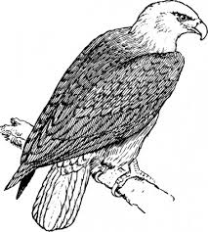

Eagle is a wise guide. Eagle is the only animal in the story that does not represent one of BC’s six Core Competencies. Yet we have much to learn from him. Eagle is our guide, our teacher, our inner voice. He helps us to find balance, strength and honour as we embark on our journey of learning and self-exploration.

From Six Cedar Trees by Margot Landahl

