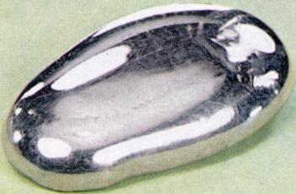

Erin Greenwood

Period 1 Science

*http://en.wikipedia.org/wiki/Silver*

**47  
Ag**

**Silver**

**107.8682(2)**

SILVER

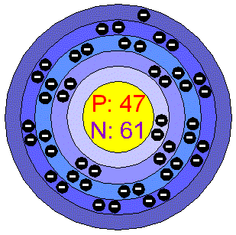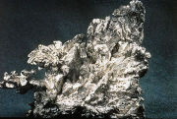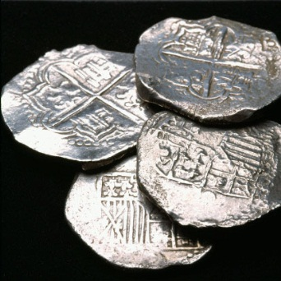

http://www.chemicalelements.com/elements/ag.html

Silver has 61 Neutrons

47 Protons are found in the Nucleus

Silver has 47 electrons in 5 energy levels

A model of Silver’s

Subatomic Particles

*http://en.wikipedia.org/wiki/Silver*

*http://en.wikipedia.org/wiki/Silver*

Physical Properties

* Silver or white brilliant metal
* Density = 10.49 g·cm−3
* [Melting point](http://en.wikipedia.org/wiki/Melting_point) = 1234.93 [K](http://en.wikipedia.org/wiki/Kelvin) (961.78 °[C](http://en.wikipedia.org/wiki/Celsius), 1763.2 °[F](http://en.wikipedia.org/wiki/Fahrenheit))
* [Boiling point](http://en.wikipedia.org/wiki/Boiling_point) 2435 [K](http://en.wikipedia.org/wiki/Kelvin) (2162 °[C](http://en.wikipedia.org/wiki/Celsius), 3924 °[F](http://en.wikipedia.org/wiki/Fahrenheit))
* Hardness – 2.5 Mohs Scale
* Highest thermal conductivity of all metals
* Electrical Conductivity of 630.5 1/mohm-cm

Chemical Properties

* Non-reactive with oxygen
* Non-reactive with water
* Reactive with hydrogen sulfide which causes silver to tarnish
* Non-radioactive
* Tarnishes due to sulfur in the air

Silver has been known about and used for thousands of years. More recently it has been found in North America and has been a major force in the westward expansion of the United States. Silver mining and the other minerals associated with it (lead and galena) are commonly found across the western US. The locations of major silver claims are in [Colorado](http://en.wikipedia.org/wiki/Colorado), [Nevada](http://en.wikipedia.org/wiki/Nevada), [Cobalt, Ontario](http://en.wikipedia.org/wiki/Cobalt%2C_Ontario) , [California](http://en.wikipedia.org/wiki/California) and the [Kootenay](http://en.wikipedia.org/wiki/Kootenays) region of British Columbia. The largest silver deposits in the United States were discovered in 1859 at the [Comstock Lode](http://en.wikipedia.org/wiki/Comstock_Lode) in Virginia City, Nevada. Although mining in the US began only in the 1800s, much of the high grade ores were depleted in the early 1900s. Because silver remains a high-demand element for a variety of industries, it has been necessary to create new technologies to refine lower quality silver ores.

silverinstitute.org

History

Uses in Industry

## Silver is used in many different industries. Silver’s most popular use is as a precious metal. This precious metal is used in jewelry and silverware, most often in its sterling silver form which is 92.5% silver usually alloyed with copper. Based on silver’s historical significance, it has also been used for thousands of years for the manufacture of money. Other uses of silver are in the photography, dental and electronic industries. Silver also has antibacterial properties that are used in water purification, in clothing to prevent odor and as an antibiotic medication. And remember, silver still means second place in the Olympics!

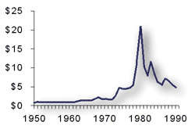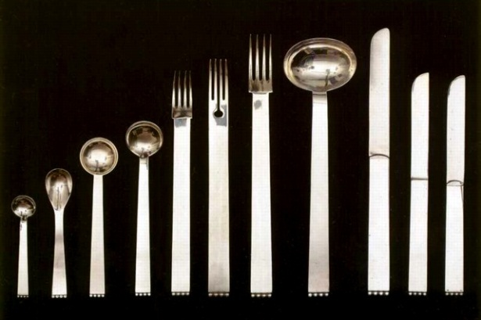

http://www.silverinstitute.org/

Price of Silver 1950-1990

*http://www.artlex.com/ArtLex/s/images/secess _hoffm_cutlery_lg.jpg*

Fun Facts

* Dumps in Asia and islands in the Aegean Sea date back to 3000 B.C. This means that humans learned to separate silver from lead 5000 years ago.
* Silver has been associated with the moon, sea and lunar goddesses. Oftentimes silver has been referred to as “luna” or moon.
* The [Rio de la Plata](http://en.wikipedia.org/wiki/Rio_de_la_Plata) was named after silver (in [Spanish](http://en.wikipedia.org/wiki/Spanish_language), plata = silver), and the country of Argentina is also named after silver.
* In India, foods can be found decorated with a thin layer of silver, known as [Varak](http://en.wikipedia.org/wiki/Varak).
* In folklore, silver was used as a vampire repellant. Silver bullets were believed to be the only way to kill a werewolf.