**THE HONOURS PROGRAM**

The Social Studies Department offers Honours courses in Grades 8-10 as well as an AP Program. Did you know that you can enroll in any Social Studies Honours course? Speak to your Social Studies teacher!

Are you someone who:

* Is curious about, or has an obvious interest in Social Studies?
* Has good critical thinking skills?
* Likes to learn new concepts, skills and strategies quickly?
* Is able to express their ideas clearly & effectively in writing and discussions or debates?
* Is an active citizen? For example:
  + Eager to engage in small or large group activities, discussions or debates
  + Respects diversity
  + Takes responsibility for their own actions
* Is in good academic standing?

**Contact Information:**

Jocelyn Beaton, Department Head

jocelyn.beaton@burnabyschools.ca

**Curricular Competencies**

***(critical thinking in Social Studies)***

In Social Studies, you will LEARN how to:

* Use Inquiry processes & skills
* Assess the significance of different people, places, events, maps, texts, or developments in time (**Significance**)
* Assess the credibility of multiple sources & the adequacy used to justify conclusions (**Evidence**)
* Characterize different time periods in history & turning points that marked different periods in time (**Continuity & Change**)
* Determine which **causes** most influenced decisions & changes & their long- & short-term **consequences** (**Cause & Consequence**)
* Explain different **perspectives** of people, places, issues or events over time (**Perspective**)
* Make ethical judgments and assess the limitations of drawing direct lessons from the past (**Ethical Judgment**)

**Social Studies 8**

Explore the issues, life-changing events & amazing people that helped shape our world between 750-1750. Socials 8 is organized into 4 big ideas: long term change is shaped by cause & conflict; human & environmental factors shape changes in population & living standards; expansion & exploration led to varying consequences for different groups; & changing ideas about the world created tension between people wanting to adopt new ideas & wanting to preserve established traditions.

BURNABY SOUTH Secondary School

AND

THE B.C. PROVINCIAL SCHOOL FOR THE DEAF

**Social Studies 9**

You will explore the issues, events & peoples (between 1750-1919) related to 4 big ideas: emerging ideas & ideologies profoundly influenced societies & events; collective identity was/is “constructed” & can change over time; the physical environment influences the nature of political, social & economic change; and disparities in power alter the balance of relationships between individuals & society.

**Social Studies 10**

Within the time period 1918-present day, you will explore issues, ideas, events & peoples related to 4 big ideas: conflicts have been a powerful force in shaping our contemporary world; the development of political institutions is influenced by economic, social, ideological, & geographic factors; worldviews lead to different perspectives & ideas about developments in Canadian society; and historical and contemporary injustices challenge the narrative and identity of Canada as an inclusive, multicultural society.



**Socials 11 Explorations**

In this course, you may explore and inquire into a range of Social Studies topics including: Asian Studies, Indigenous Studies, Genocide Studies, History, Geography, Psychology, Politics & Government, Social Justice, Law, and/or Philosophy. This might lay the foundation for a more focused pursuit of senior Social Studies subjects.

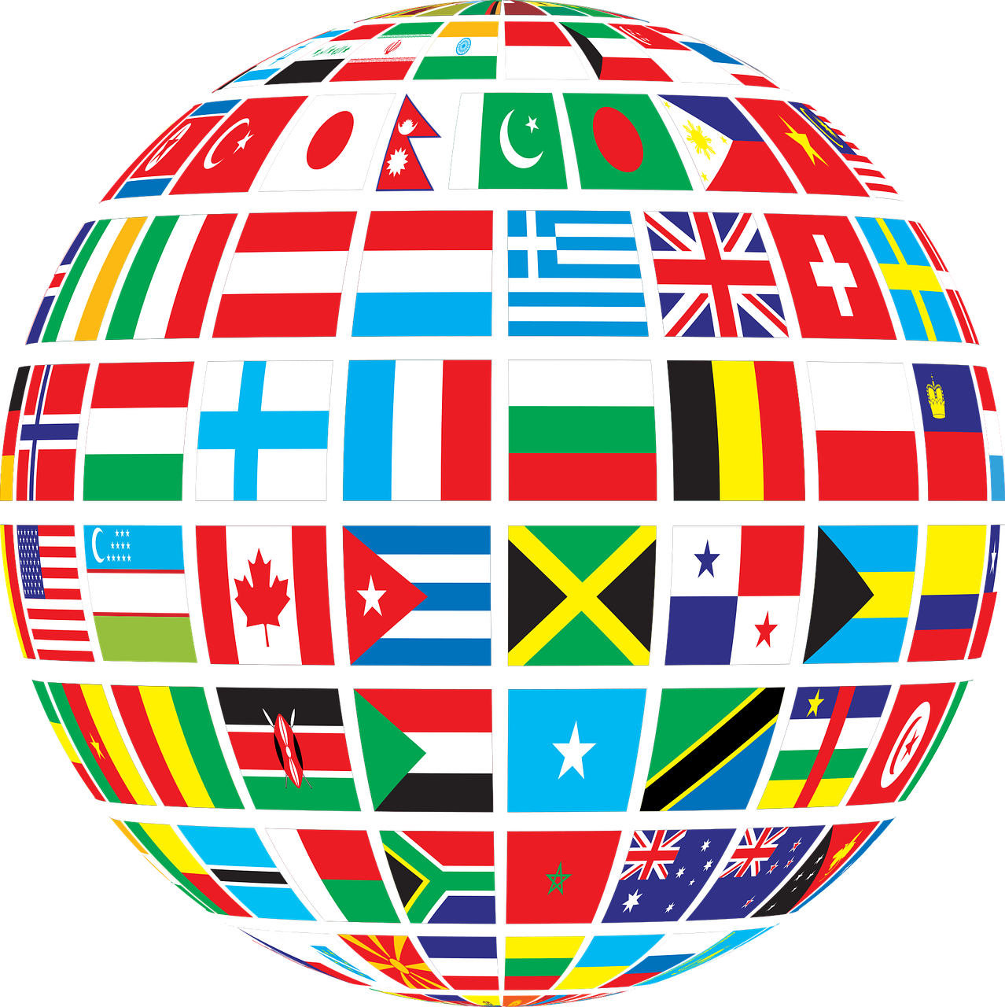****

#### **5455 Rumble street**

**Burnaby, B.C. V5J 2B7**

**Phone: 604-296-6880**

Course Overviews

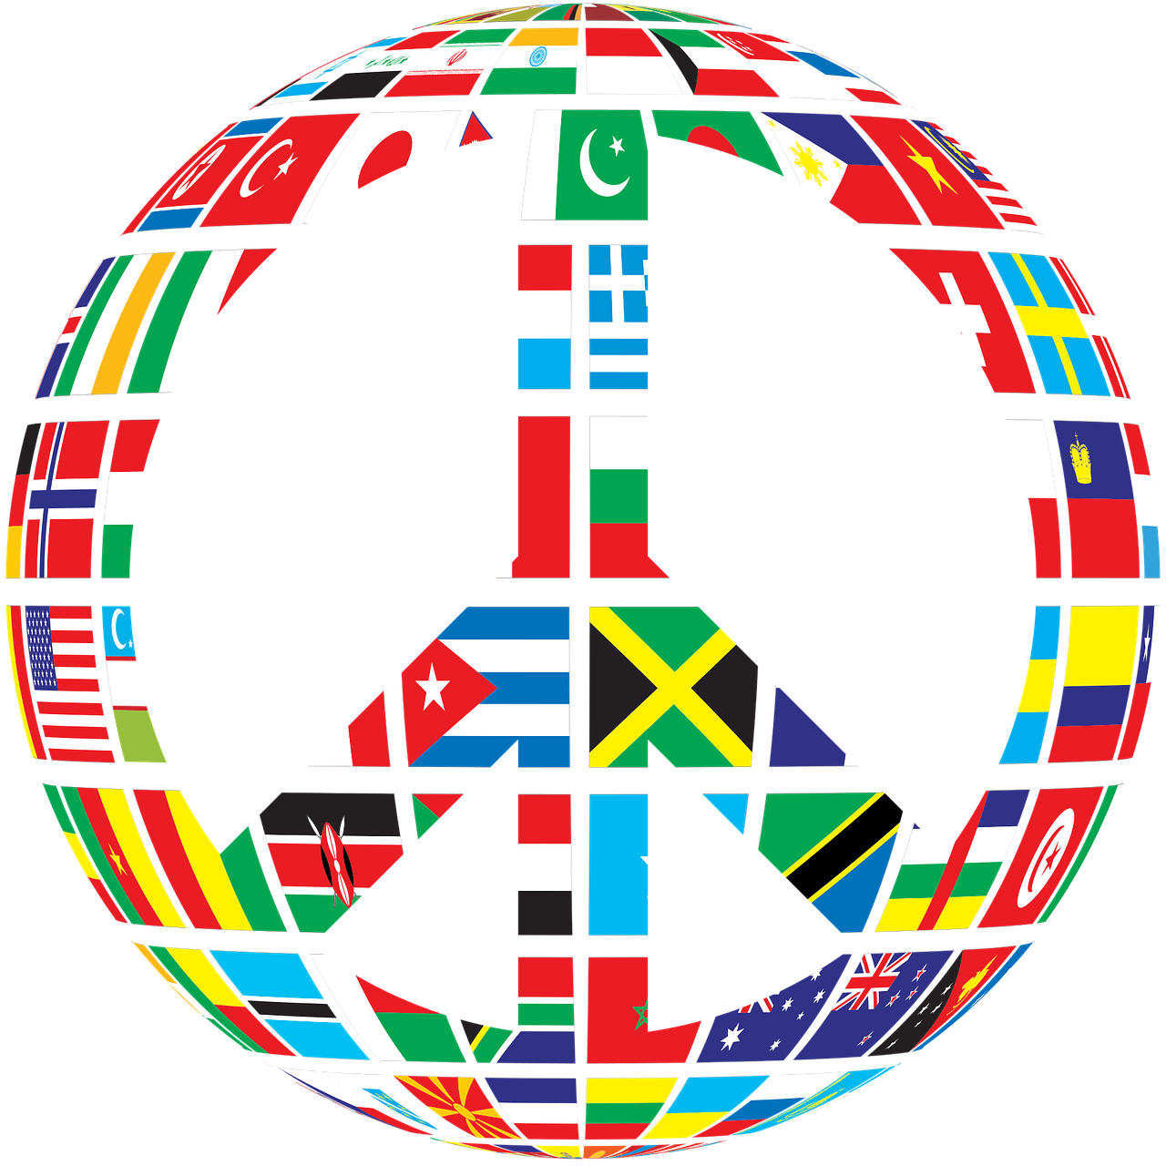

Overview

**Social Studies**

**Department**

**Psychology 12**

Students will learn about human behavior and examine the three main debates and research questions Psychologists continue to study. Students will develop critical thinking skills, as well as applying those skills to real life case studies and engaging activities and experiments.



**Criminology 12**

You will examine the causes and effects of crime as they relate to Canadian society. An analysis of what constitutes a crime (once committed), those who are brought into play & the carried consequences will be examined. Statistics, theories and the media will be included and debated. The course will evaluate whether our judicial system is proactive or reactive?

**Global Intercultural Studies 12**

You will explore the concept of culture & how it shapes our thinking, behaviour, family lives & relationships as well as world cultures, current events, writing, art & film from many cultures. We will learn together through dialogue, discussion & projects. The goal of this class is to help students thrive in a global world, to resist stereotypical thinking & to recognize imbalances of power & inequity.

**AP Human Geography**

The purpose of this course is to introduce the systematic study of patterns and processes that have shaped understanding, use and alteration of Earth’s surface. You’ll use concepts & analysis to examine social organization and its consequences. You will also learn about the methods & tools geographers use in their professional practice. Our study of geography will apply a holistic perspective in examining patterns, places and landscapes, while we find our place in the world.



**AP Psychology**

This course will introduce you to the systematic and scientific study of behavior and mental processes of human beings and animals. You will be exposed to psychological facts, principals, and phenomenon associated with each of the sub fields in psychology. This course offers students the choice of writing the optional AP Exam in May.

**Psychology 11**

This is an activities-based, introductory survey course that introduces the study of human behavior & basic concepts in modern psychology. You’ll explore key questions in Psychology & how psychologists answer these questions. This course promotes critical thinking in a range of group/individual activities.

**20th Century World History**

In this course, students will use critical thinking skills to analyze documents, images, and pop culture as they explore major events in the last century of human history.  Topics include: dictatorships, WWII, the Civil Rights movement, Vietnam, media growth, and the Cold War.  If you've ever wondered how we got here and why, this is the course for you!



**Indigenous StudiesNew**

In this course, you will focus on how the identities, worldviews & languages of the Indigenous Peoples of BC are renewed, sustained and transformed through their connection to the land, the impact of colonialism, rich cultural expressions and self-governance and leadership.

**Physical Geography 12New**

This Social Science course will introduce you to the awe-inspiring physical diversity of our planet. By investigating the earth, you’ll learn the knowledge & skills needed for a dynamic world. The Big Ideas will look at population patterns and how they are influenced by the environment and human activity and how that, in turn, shapes the landscape in a variety of ways.

**Human Geography 12New**

In this course you will learn to analyze data, demographic patterns & & human patterns of interaction with our planet. You will focus on the human & environmental interaction across the globe and how regions around the world are a combination of the dynamic interaction between humans and their environment.

**Law 12**

This course will give you everything you need to know about the Canadian Legal system with a hint of comparison to the American system. This class focuses on statute and case law, the Charter of Rights and Freedoms, and the Criminal and Civil law. Students will need to be aware of current events and follow cases as they are happening. This is an academic elective with profound focus on debate, discussion, reading and writing.



**Social Justice 12**

Students will develop ethical & philosophical reasoning skills by exploring issues of injustice in a local and global context. Students will work to invoke change to become ethical and socially responsible global citizens. Topics include animal rights, media, consumerism, propaganda, child labour, homophobia, women’s rights, racism, global issues, environmentalism and social justice “heroes”