CLC 11 – Who Am I?

The first step of your journey of discovery: Knowing who you are as a person can help you align your yourself to future opportunities, and help you find opportunities that are a good fit for you. As a result, it important to be able to define your strengths, values and interests before you begin your future career search.
For this assignment, we will be using resources on myBluePrint to help define who you are: https://app.myblueprint.ca/.
If you DO NOT have myBluePrint, please create an account AND complete the permission form:
- Visit www.myBlueprint.ca/sd41 and click 'Sign Up'
- Select your school from the drop down and click 'Create Account'
- Select 'Student'
- When prompted, enter your Date of Birth & Pupil Number and complete the sign up steps
- Mandatory: Complete the digital Parent/Guardian Permission Form and upload/attach as “student work” as part of this assignment.

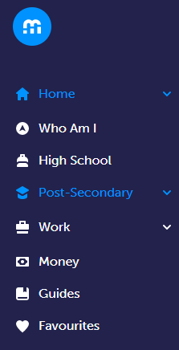
Once you are signed into myBluePrint, click on “Who Am I” on the left sidebar.
Complete the 5 surveys:
- Learning Styles
- Personality
- Interests
- Knowledge
- Motivations

If you have completed one or more of the surveys in CLE10, you can use this as an opportunity to look over your responses and see if there are any changes you need to make - it has been a year since this reflection took place.
Answer the questions below after completing the surveys. Please add details and elaborate on your responses.

Learning Styles
- Looking at your survey results, what type of learner are you? What is your percentage breakdown of the three (visual, auditory and kinesthetic) Learning Styles?

- Are the results what you had expected or already know about yourself? Is there anything surprising about your results?

- It is said that whatever your strongest Learning Styles results are, the best way to learn is to try using all three Learning Style approaches to help our minds master a task. With that said, how can you improve your least relatable (lowest %) Learning Style?

Personality
- What are the 4 letters of your Personality Type:

- Looking at the results from each of the four categories: Energy, Information Gathering, Decision Making, and Lifestyle and Structure, is there a category which you felt was incorrect or did not reflect your Personality Type. Explain.

- Read the overview – are there points in the passage that completely describes you correctly, strongly resonate/connect with, or think “Yes! That’s me!”?

Interests
- What is your Interest Type:

- What are your two Primary Interest traits? Do these traits reflect you as a person? Explain.

Knowledge
- What are your first, second and third Subject Areas?

- Based on your responses, the survey predicted a career area that you may like. What is the career cluster indicated in your results? Are you currently interested in pursuing a career is this area? Explain.

Motivation
- Based on the questions they asked you in the survey, what are some of the factors that are important for you when looking for a career?

- Looking at your results, what is your top/primary Motivation Factor when looking for a career? Do you agree?

- Is there a Motivation Factor that you think is just as important but not listed as your top/primary/secondary factor?

Additional Reflection Questions:

- List 3-5 unique interest/passions/experiences that you feel will likely influence your future path.

- What are your top 5 career choices?

- Are any of the careers listed in the previous question a “dream job” for you?

- Do the career choices you have listed in question 2 connect well/align with the results of the 5 surveys? Explain.

