CLC 11 – LinkedIn Profile Assignment

Please copy and paste the URL for your profile here:

ASSIGNMENT DUE DATE: January 15, 2021

LinkedIn is for anybody and everybody who is interested in taking their professional life more seriously by looking for new opportunities to grow their careers and to connect with other professionals. Put simply, LinkedIn is a social network for professionals. It's like Facebook for your career. LinkedIn has over 260 million active users and over 20 million companies that list jobs through the platform. It is no surprise to find out that 90% of Recruiters / Head Hunters use LinkedIn to contact users with potential opportunities.

However, LinkedIn is not only for job seekers. It's a great way to position yourself as an expert in your industry or even as an influencer! More and more professionals use LinkedIn on a regular basis for both professional and personal development.
In other words, your profile and your activities on LinkedIn have a great impact on your personal brand.

Let’s use donuts to understand how LinkedIn is different from other social media platforms.

I like donuts. | Watch me eat a donut. | Here’s a cool photo of my donut. | Here’s a donut recipe. | I’m listening to “donuts”. | Anyone want a donut?

Donuts on LinkedIn: Build your brand and get hired!

I hope to operate a donut franchise one day. | I’m looking for a job at a donut company. | I have 3 years experience making donuts. | My top skills are donut production and sales. | Here are 3 recommendations from former donut colleagues.
ASSIGNMENT STEPS:
- Watch the LinkedIn “Overview” video
- Watch the LinkedIn “Top 5 Profile To-Do’s” video.
- Visit this website: https://linkedin.com/uas/login click “Join Now.”
- Create your LinkedIn profile. View the LinkedIn Profile Highschool Checklist to properly complete your profile .

HOW TO SUBMIT:
After you complete your LinkedIn profile, your next goal is to set up your profile so that your full profile is available for public viewing. Besides making it easier for us to mark, setting your profile to full public view gives you several advantages:

- Anyone looking for you has a better chance of finding you because of the increased information tied
to your name.
- When you make your profile public, it gets indexed in both the Google and Yahoo! search databases.
This makes your online identity accessible and controlled by your access to LinkedIn.
- You give increased exposure to any companies, projects, or initiatives that you’re working on by
having that credit published on your LinkedIn profile.

When you’re ready to set your profile to Public, just follow these steps:

Web browser on computer/laptop:
- Click on Me on the top bar of your LinkedIn page
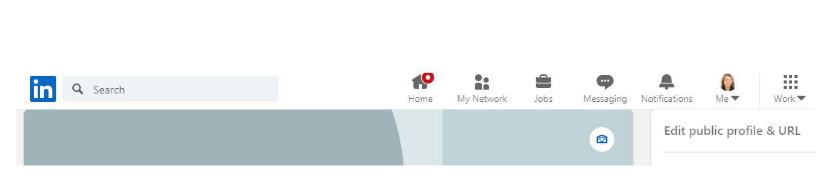
- Select Settings and Privacy
- Select Visibility on the column on the left hand side.
- Select Change next to Edit your Public Profile
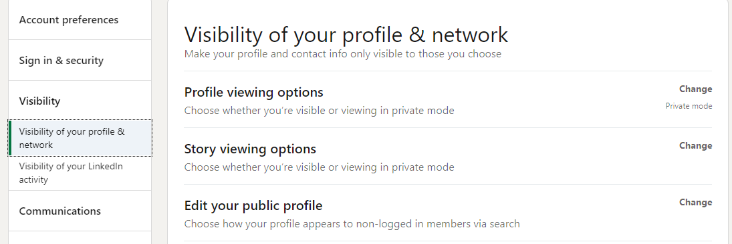
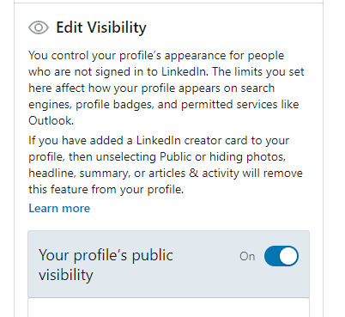
- On the right hand side under Edit Visibility ensure everything is Public. Please note you can change this after we have seen your profile.

- Scroll back to the top and under Edit your custom URL – click on the pencil icon and make sure your custom URL looks like this: www.linkedin.com/in/first name-last name (www.linkedin.com/in/anna-kuang). You may need to include a number if your profile is already in use by someone with the same name.
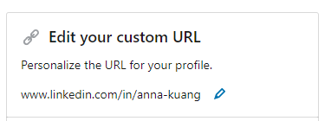

- Submit this assignment to Teams with the URL link at the top of this assignment in the highlighted area.

LINKEDIN PROFILE ASSESSMENT

CRITERIA | EMERGING (1) | DEVELOPING (2) | PROFICIENT (3) | EXTENDING (4)
ONLINE PROFILE | - Description of self includes few details.  - Profile is missing some information. | - Description of self includes few details.  - Profile is missing some information. | - Description of self includes some details.  - Information is listed for almost all categories. | - Thorough, very detailed, description of self.  - Information is listed for all or almost all categories.
EMPLOYABILITY SKILLS | - Some language is not appropriate  - Several grammar and spelling errors; work requires proofreading. | - Language is somewhat appropriate  - Several grammar and spelling errors | - Language is appropriate  - Minimal grammar and spelling errors | - Submitted on time  - Language is sophisticated and professional  - Free of grammar and spelling errors

