CLC 11 – Personal Profile for Post Secondary Applications

What is a Personal Profile?
Admission to some post-secondary schools will evaluate your application based on both your Academic Profile (grades) and your Personal Profile.

The Personal Profile is an important section in your post-secondary application. It is an opportunity for you to share about:
- things that are important to you
- significant achievements in your life
- challenges you have overcome
- academic pursuits
- what you’ve learnt from your experiences
The Personal Profile helps to determine if you are a good fit for the school.

Here is a good video from UBC about the Personal Profile: click here
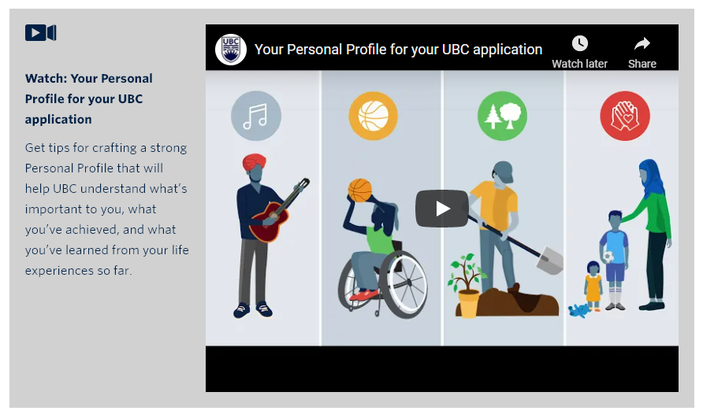

Covid impact on your Personal Profile
Post-secondary schools understand that there are currently limited to no access to extracurricular activities at school or in your own community. You can still share the activities you’ve done across multiple years. You can share examples from any aspect of your life, within your family or smaller community, or challenges you have faced due to covid.

Preparing for the Personal Profile
- Questions will likely require a short essay response (50-200 words).
- Take time to reflect on what you want to write. Don’t just simply list your accomplishments and experiences. They want to see a reflection on what you’ve experienced.
- Be specific. Use details and examples to elaborate on your response.
- Be authentic. Don’t focus on writing what you think they want to hear. Share your unique self.

Who evaluates your Personal Profile?
Trained evaluators will be looking for specific qualities in your responses such as:
- Engagement and accomplishment
  - How do you pursue your interests and manage your responsibilities?
  - What do you do with your time when not in class?
  - What are your significant contributions and accomplishments?
  - Have you demonstrated what these engagements and accomplishments taught you about yourself and/or the world around you?
- Leadership
  - Have you taken responsibilities and activities that allowed you to contribute to your community or benefited those around you?
  - Have you demonstrated what leadership has taught you about yourself and others?
- Substance
  - Do you show reflection?
  - Did you share details and examples?
  - Are your responses superficial, or do you share well thought-out, meaningful and insightful responses?
- Voice:
  - Are you genuine and unique to who you are?
  - Does your voice stand out, our does it sound like many others?

Sample Personal Profile Questions

For your assignment you will start drafting responses to real Personal Profile questions. This will help you get started and thinking about responses you can provide for your future post-secondary application.
- Explain how you responded to a problem and/or an unfamiliar situation. What did you do, what was the outcome, and what did you learn from the experience? (Max 200 words)

- Give us an example of how the pandemic has changed your involvement in the community or group most important to you. What have you learned from this experience? (Max 200 words)

- Tell us about who you are. How would your family, friends, and/or members of your community describe you? If possible, please include something about yourself that you are most proud of and why. (Max 200 words)
- What is important to you? And why? (Max 200 words)

- Describe up to five activities that you have pursued, or accomplishments achieved in one or more of the following areas. Please outline the nature of your responsibilities within these activities. (50 words per description)
  - Club
  - Family/community responsibilities
  - Creative or performing arts
  - Work/employment
  - Athletics
  - Volunteer
  - Service to others
  - Other(s)
- Tell us more about one or two activities listed above that are most important to you. Please explain the role you played and what you learned in the process. You will be asked for a reference who can speak to your response. (Max 200 words)

- Why do you this school is the right choice for you? (Max 200 words – for this question please provide the name of a post-secondary school you are interested in applying for)

