Student’s Home-School Bridge
At home 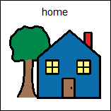
Date: ___________________________________
Please go over these questions at home with Student before bed.
Help him write the answer in so he knows what date it is and practices answering simple ‘wh’ questions.
His EA can ask him the questions at school the next day.

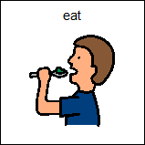 | What did you eat?  I ate ____________________________________________________

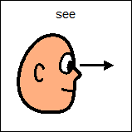 | Who did you see?  I saw ____________________________________________________

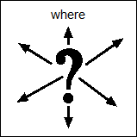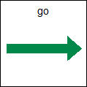 | Where did you go?  I went ____________________________________________________

Student’s Home-School Bridge
At school 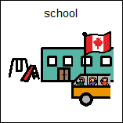
Date: ___________________________________
Please go over these questions at school with Student before he goes home.
Help him circle or write the answer so he knows what date it is and practices answering simple ‘wh’ questions.
His parents can talk to him about the questions at home.

What did you do?

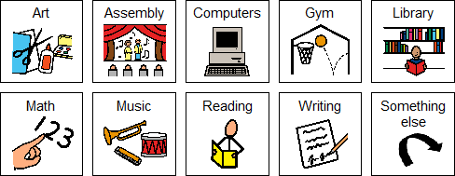

Other:_________________________________________

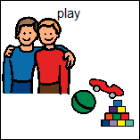 | Who did you play with?  I played with ____________________________________________________

Tell something interesting about your day.

_________________________________________________

