Student’s Home-School Bridge
- Please go over these questions at home with Student in the morning before school.
- They are meant to help start conversation.
- Have him write his answers down or tell you his responses to write down to provide his teacher and EA with more information so they can talk to him about what he did and he can practice his language skills at school.

Date: ____________________________________
Last night at home:
What did you eat?_________________________________________
Where did you go?
What did you do?
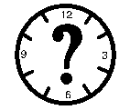When did you go to sleep?___________________________________
Did you get enough sleep? Yes No

This morning, I am feeling…
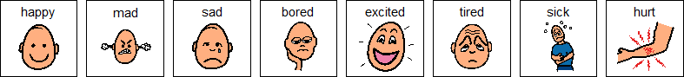

Parent comments:___________________________________________ _____________________________________________________________________________________________________________________
_________________________________________________________
Student’s Home-School Bridge
At school
- Please go over these questions at school with Student at the end of the day.
- They are meant to help start conversation.
- Have him write his answers down to provide his parents with more information so they can talk to him about what he did and he can practice his language skills at home.

Date: ____________________________________
Today at school, I felt…
What did you do today?
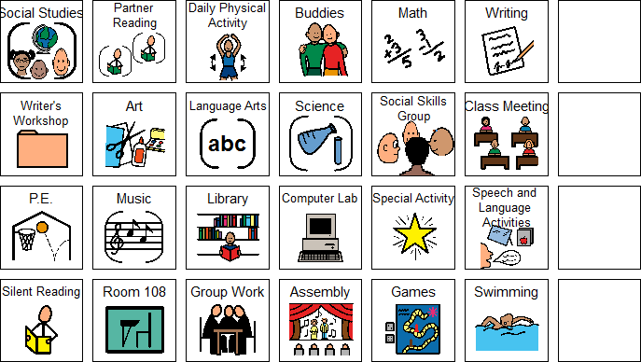
Who did you hang out with?___________________________________________

Write a sentence telling something interesting about your day. ____________________________________________________________________________________________________________________________________________
Reminders/Comments:

