Student’s Home-School Bridge
At home 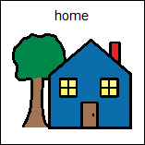
Date: ___________________________________
Please go over these questions at home with Student before bed. Help him to give the answer with the picture choices below. His EA can ask him the questions at school the next day.

What did you eat? What did you drink?

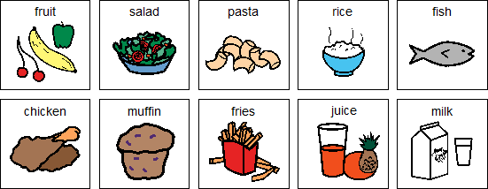

Other:_________________________________________

What did you do?

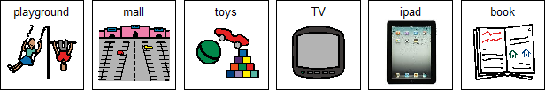

Other:_________________________________________

Student’s Home-School Bridge
At school 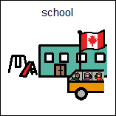

Date: ___________________________________
Please go over these questions at school with Student before he goes home. Help him answering the questions by using his visual schedule and pictures from his peers. His parents can talk to him about the questions at home.

What did you do?

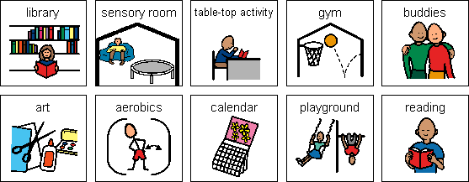

Other:_________________________________________

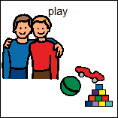 | Who did you play with?  I played with ____________________________________________________

