How To Get Outside Safely in the COVID 19 Era

Transmission of COVID-19 is less likely outdoors, especially if you follow physical distancing rules. Outdoor physical activity makes our immune system more robust, and allows children to move more, play longer and sit less. Under our back to school protocols, we will not be embarking on any official field trips, but you may continue to use school grounds and nearby parks. Check with your administration if you have proper permissions for walking field trips to nearby parks. Burnaby has a website that allows you to check on all closures and precautions in parks.

When in the parks:

- Maximize distance and minimize interaction between students and others outside. Choose places to go that are less popular with the public. Parks like Burnaby Lake or Deer Lake have put one way restrictions on trails, so check before you go. Teach and practice passing protocols with your students before you head to a location with others members of the public present.

- Choose gathering points carefully when you settle your class, make sure that the spot you have chosen has enough room to physical distance students and yourself, and that there is safe passage for other park users.

- Do not use features on which virus may have settled, particularly those that have been in close contact with potentially ill people (ex water fountains).

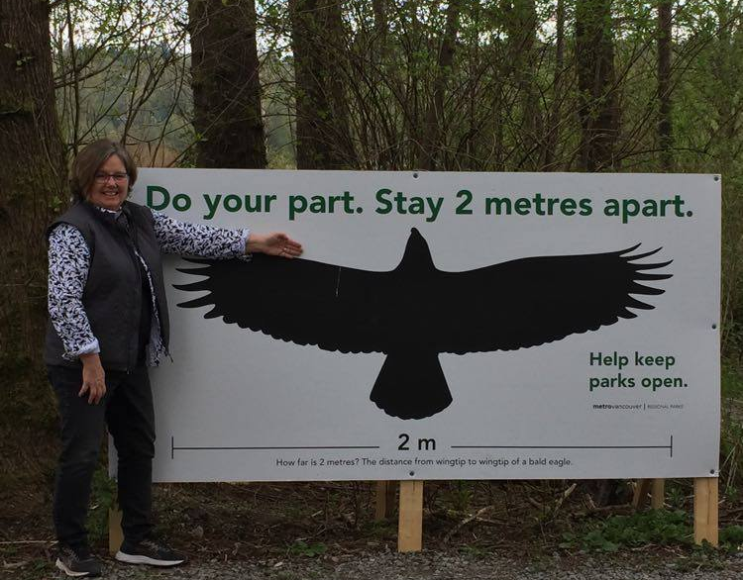
- Encourage school washroom use, however if park washrooms in Burnaby are open, they will be frequently cleaned. Ensure students follow hand hygiene protocols after using washrooms.

- Practice proper hand hygiene - all students should wash hands when returning into the school building.

By the end of this, all of our students should KNOW what 2 meters is.

For further reading: Here are some great tips from Richmond’s Megan Zeni.
Use the chart in the following two pages for ideas to use outdoor learning effectively.

Don’t ask yourself “what can I do outside?”

Ask yourself “DO I HAVE TO DO THIS INSIDE?”

Take outside as much of what you are already doing as can

Topic | Resource
TOP FIVE | Wildsight - Education at home: description  HCTF Education: BC-specific resources for taking students outside  Outside Learning Ideas – Kootenay Boundary Environmental Education  Beetles Project Home: A goldmine of activities, videos, PDFs, strategies  Letting a “wrong” answer stand: Supporting children’s curiosity
Nature Etiquette | Experience Curriculum Maps: Resources for Outdoor Learning created by BC teachers for the Ministry of Education. Ethic of care is part of this!  Leave No Trace: Outdoor ethics and principles.
General Science | Alberta Council Science Hub: Resources for Environmental and Energy Education  Beaty Biodiversity Educator Resources: Biodiversity resources for educators including five minute field trips, discovery-based activities, printable worksheets and more.  CBEEN Online – Columbia Basin Environmental Education Network  HCTF Education: BC-specific resources for taking students outside  Free & Fun : Outdoor learning Activities, Games & Projects For Families
Outdoor Learning | Field Guides: Guides for numerous pacific northwest plants and animals.  Better Environmental Education, Teaching, Learning, & Expertise Sharing (BEETLES): Detailed lesson plans for science and outdoor educators. See “Exploration Routines” and “Focused Explorations” sections.  Burnaby Place Based Learning Blog: a blog from our LEEPSA including activities, lists of plants and animals to know, and resources from Metis herbalist Lori Snyder on Indigenous uses of plants.  Oregon Environmental Literacy Program – University of Oregon Huge hub of resources and other websites (weekly resource sets)  Rethinking Learning Environments: Community as Classroom | David Barnum | TEDxLangleyED (VIDEO)
Mapping | Map It!: description PBS learning resource  Nature Soundmap: description  Chinatown Sound Map: description  Sound Mapping Activities for Students: description  Nature Map your Neighborhood: description  Sunshine Coast Mapping Project: one sentence description  iNaturalist: Record nature observations, share with fellow naturalists, discuss your findings. Great way to contribute to scientific data on local flora & fauna.  Seek: This version of iNaturalist is suitable for younger children.
Invasive Species | Invasive Species Council: May has been proclaimed Invasive Species Action Month (ISAM) by the Province of British Columbia. Many free activities and resources available for early learning through middle school.
Trees | Focus on Forests: A collection of free educational resources for teachers to bring forestry to the classroom and take learning outdoors with the help of lesson plans, tree and forestry facts, scavenger hunts and other activities.  Tree Benefits Calculator
Indigenous | Coyote Science - Canadian, have quite a few West Coast Indigenous topics, feature Indigenous professionals, and are really "accessible" In English or Hul'qumi'num.  Walking Together: - First Nations, Métis, and Inuit perspectives in curriculum
Ocean | VanAqua: one line description  Oceans On-Line: Resources compiled by educators and animal experts at Ocean Wise and the Vancouver Aquarium for kids to learn to care for the ocean – and the animals in it – from the comfort of their living room.  Alaskan Coastal Studies Interpretive videos, biweekly live education series, activity sheets, and lesson plans for outdoor learning. Includes activities to do at home.
Insects | Native Pollinator Identification  Planting to Support Local Pollinators  Building a Bee House webinar: Science/ADST Activity from Let’s Talk Science
Documenting, Reflecting and Journaling | Mindstretchers: downloadable sheets with outdoor diary prompts for early learners.  Sit spots: K-7: From Wildsight resources for observing and journaling.  A Science Notebook Story: Investigating Moon Phases  Stay Connected to Nature prompts for journaling  The Ultimate Guide to Nature Drawing and Journaling
Project Based Learning | BC Green Games: A celebration of environmental action  Studentsdiscover.org Students Discover outdoor units and lessons, most outside. Many projects collect data for university research.  Feathers, Dead Baby Birds, and Eggshells: A Most Authentic Investigation
Teacher Background | https://www.gettingsmart.com/2017/02/what-is-place-based-education/?utm_content=bufferc8ff8&utm_medium=social&utm_source=twitter.com&utm_campaign=buffer  Innovative Learning Environments-ILE, David Instance (OCDE), VOScat  EP02 David Barnum | voicEd
Climate Change | Be The Change Earth Alliance: description

