MATTER GRADE 5 and 6 SUMMARY
Grade Learning Standards (From BCEd Curriculum)
Grade 5
- Solutions are homogeneous mixtures.
- solutions and solubility
- solutions (e.g., apple juice, coffee) that can be separated through distillation, evaporation, and crystallization
- solubility of solids, liquids, and gases (e.g., salt [solid], honey [liquid], carbon dioxide [gas in water makes pop])
- properties of solutions: concentration, pH, etc.
- dissolving: process of forming a solution

Grade 6
- Everyday materials are often mixtures
- heterogeneous mixtures
- suspensions (e.g., salad dressing), emulsions (e.g., milk), colloids (e.g., aerosols)
- separated using a difference in component properties
- density (e.g., centrifuge or settling, silt deposits in a river delta, tailings ponds, Roman aqueduct settling sections)
- particle size (e.g., sieves, filters)
- historical and current First Peoples use of separation and extraction methods (e.g., eulachon oil, extraction of medicines from plants, pigments, etc.)

WHAT DO Grade 5’s and 6’s need to know about matter?
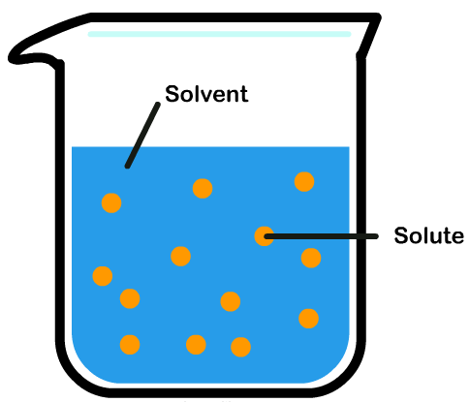
Solutions are mixtures that usually involve a fluid (gas or liquid) and one or more other component (solid, liquid or gas). Solutions appear to be pure substances, but are actually just very good mixtures, mixed at the particle level.
Solubility is a property that explains how well one thing can dissolve or mix in another. Something may be soluble in water but not in alcohol or oil, or vice versa. Water is a very good solvent, because it can dissolve ionic compounds (compounds with a metal and non-metal component) like SALT (which has a positive and negative atom). Water molecules have a polarity to them—a slightly negative part (the oxygen atom) and slightly positive parts (the hydrogen atom). Therefore water can also dissolve other polar substances.
Covalent (substances made entirely of non-metals) non-polar (uncharged) substances cannot dissolve in water.
Solutions can be more concentrated if they have more solute and less solvent. They can be dilute if they have more solvent.
Solutes are the solid part of the solution. They can be recovered by crystallization and evaporation (letting the solvent disappear). Liquids can be separated from solution by distillation. Other properties, such as density, particle size, etc can be used to separate heterogeneous solutions.

CURRICULAR COMPETENCIES
Questioning and predicting-explore a sustained curiosity about a scientific topic; -make observations in familiar or unfamiliar contexts; identify questions to solve through inquiry and make predictions about the findings of the inquiry.
Planning and conducting-with support, plan investigations to answer questions or solve problems; decide which variable should be changed and measured for a fair test; -choose appropriate data to collect; -collect data using appropriate measures and tools, including digital technologies; use equipment safely.
Processing and analyzing data and information-construct and use a variety of methods to communicate information, indlucing tables, graphs and digital technologies; identify patterns and connections in data; compare data with predictions and develop explanations for results; -demonstrate an openness to new ideas and consider other alternatives.
Evaluating-evaluate whether a test is fair; identify possible sources of error; 0-suggest improvements to investigations; -identify assumptions and given information in secondary sources; understand and appreciate evidence; -identify social and ethical implications of results of investigations
Applying and innovating-contribute to the care of myself and others through personal or collaborative approaches; design projects; generate new or refined ideas when problem sovling
Communicating- communicate and represent scientific understanding in a variety of ways, such as diagrams and more complex reports, using digital technologies; -express and reflect on experiences of place.

WHY IS IT IMPORTANT?
Why can some paints be cleaned easily in water while others need a special cleaning solution? Why does the honey in your cupboard crystallize after it’s been there for a while? Can you turn it back into a liquid? Make tea in hot water and in cold water and observe.
KEY VOCABULARY
Solution -A homogeneous mixture where one substance called the solute is fully dissolved into another substance called the solvent. For example, a solution is formed when salt dissolves into water to make the solution salt water.
Soluble- (of a substance) capable of being dissolved in some solvent (usually water) indissoluble,
Solute- a solute is a substance dissolved in another substance, known as a solvent.
Solvent- A solvent is the component of a solution that is present in the greatest amount. It is the substance in which the solute is dissolved. Examples: ​ The solvent for seawater is water.
Emulsion an emulsion is a heterogenous mixture containing tiny particles of one liquid suspended in another, they are not completely dissolved.
Suspension- In chemistry, a suspension is a heterogeneous mixture of a fluid and solid particles
Colloid- colloid is a mixture in which one substance of microscopically dispersed insoluble particles is suspended throughout another substance. (**They don’t need to know this, but someone will ask)
Concentration-the ratio of solute in a solution to either solvent or total solution
Separation- A separation process is a method that converts a mixture or solution of chemical substances into two or more distinct product mixtures.
Crystallization- When a product is made as a solution, one way to separate it from the solvent is to make crystals. This involves evaporating the solution to a much smaller volume and then leaving it to cool. As the solution cools, crystals form
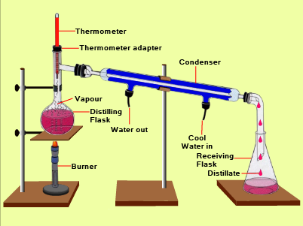
Filtration- This technique is used to separate an insoluble solid from a liquid. It can be used to obtain a product that is free from unreacted chemicals, by-products or solvent.
Evaporation-where heat is used to evaporate the solvent, leaving the solute behind.
Distillation- Distillation is used to purify a compound by separating it from a non-volatile or less-volatile material. Because different compounds often have different boiling points, the components often separate from a mixture when the mixture is distilled.

SOME INQUIRY QUESTIONS
- How can you separate oil from water? (topical and connects to SS current events)
- How are separation and combining techniques used in cooking? Art? Industry?
- How does temperature affect dissolving?
- How can we get fresh drinking water from salt water?
- What separation techniques were used by First Nations?
- How can we make the biggest crystals?

SUGGESTED PROVOCATIONS/ACTIVITIES/EXPERIMENTS
Bring in a bowl of Bits ‘n Bites and a jug of Kool-Aid… Ask “How are these the same, and how are they different?” (a great way to support an understanding of homogeneous and heterogeneous mixtures).
Experiments like the M & M one from the Inquiry In Action (link below) or Chromatography (candy, markers, traditional dyes) can explore solutions. Experiments exploring dissolving can investigate ways to increase the rates or how effective different solutes are. Examine the pH of different substances using home-made cabbage juice indicator: https://www.thoughtco.com/making-red-cabbage-ph-indicator-603650
Grow crystals: https://www.thoughtco.com/how-to-grow-great-crystals-602157 Encourage inquiry by having the students investigate different compounds (salt, alum, Epsom salts) to make crystals, or by varying the temperature of the water, the amount of solute, the time…
Make a solar still to show distillation (salt water to fresh water): https://teachbesideme.com/simple-science-making-solar-still/ Or better yet, have students choose their own problem and research, test and refine a method to separate the parts.
Use cooking, such as making ice tea from crystals, observe and discuss how it dissolves. Use cooking also to show the differences between emulsions, suspensions and colloids.

CROSS-CURRICULAR CONNECTIONS
Social studies/environment—separating trash; cleaning water; separating oil and water; obtaining fresh water.
Art: making pigment; cleaning paint; solvents and solutes.
ADST: devising separation techniques
Literature: Here’s a great set of resources on Books, Movies and Chemistry: https://www.acs.org/content/acs/en/education/students/highschool/chemistryclubs/activities/chemistry-books-movies.html

INDIGENOUS PERSPECTIVES
Find out about natural Aboriginal dyes and try using them with paper chromatography.
Make natural dyes using Native berries and plants; cooking Maple syrup; making tea…(FNESC resource has detailed information on this—Unit 2 at http://www.fnesc.ca/wp/wp-content/uploads/2015/08/PUBLICATION-61496-Science-First-Peoples-2016-Full-F-WEB.pdf
You can also work on preparing and eating some traditional recipes (mixtures) – such as Salmon Soup, Herring Roe on Kelp, Soap Berry Ice Cream. Contact with an Aboriginal elder might help this.
Study how oolichan grease was separated: https://www.youtube.com/watch?v=6RRFVXs4f7I
RESOURCES
This is a great chemistry resource with detailed background and several different series of inquiries that deepen as your students learn: http://www.inquiryinaction.org/pdf/InquiryinAction.pdf
And these resources from Comox School District (Also include some French): https://portal.sd71.bc.ca/group/wyhzgr4/Pages/default.aspx

