MATTER GRADES 2, 3, 4 SUMMARY
Grade Learning Standards (From BCEd Curriculum)
Gr 2
- Materials can be changed through physical and chemical processes.
- physical ways of changing materials:
- warming, cooling, cutting, bending, stirring, mixing
- materials may be combined or physically changed to be used in different ways (e.g., plants can be ground up and combined with other materials to make dyes)
- chemical ways of changing materials:
- cooking, burning, etc.
Gr 3
- All matter is made of particles
- matter is anything that has mass and takes up space
- atoms are building blocks of matter
Gr 4
- Matter has mass, takes up space, and can change phase
- phases of matter are changed by the effect of temperature on particle movement
- solids, liquids, and gases change with heating (e.g., boiling point, melting point [melting chocolate]) and cooling (e.g., freezing point [making ice cream]), and these physical changes are reversible
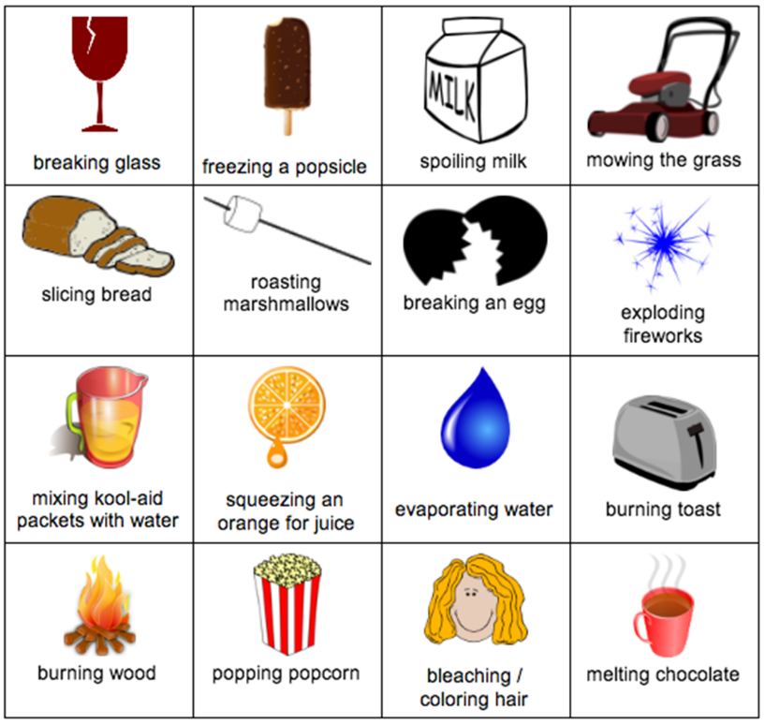
WHAT DO Grade 2, 3 & 4 ’s need to know about Matter ?
Grade 2’s will need to understand the difference between a physical change and a chemical change. Physical changes only change the appearance of a substance, not its chemical composition. Chemical changes cause a substance to change into an entirely new substance with a new chemical formula. Chemical changes are also known as chemical reactions. The “ingredients” of a reaction are called reactants, and the end results are called products.
Which of the events at left is a physical change and which is a chemical change?
Grade 3’s can learn that all matter is made up of very small, smaller than microscopic, particles called atoms. Simple particle theory says that all matter is made up of extremely tiny particles - atoms or molecules - that are always moving. Let's see how these particles change from one state of matter to another.
Which moves us on to Grade 4. Grade 4 students need to understand the difference between solids, liquids and gases in terms of how the particles interact, how they can move, and how heat changes that.
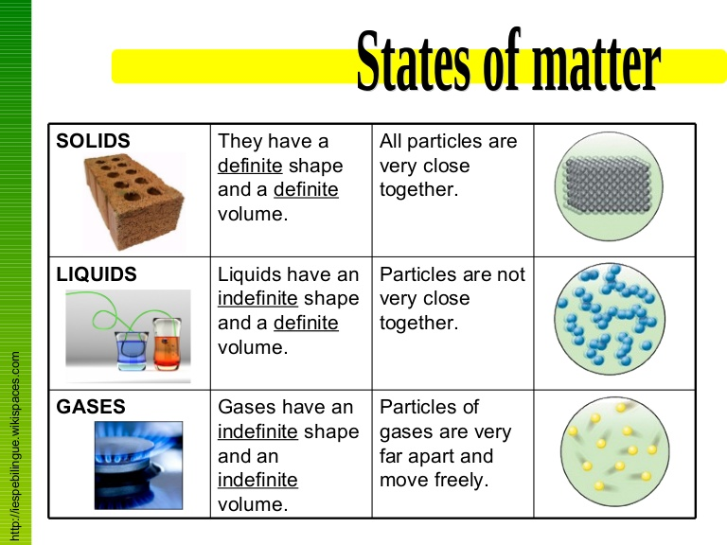
CURRICULAR COMPETENCIES
Questioning and predicting-identify questions about familiar objects and events that can be investigated scientifically; -make predictions based on prior knowledge
Planning and conducting-plan and conduct an inquiry to answer questions; consider ethical responsibilities when conducting an experiment; -use appropriate tools to make observations, making formal measurements; -collect simple data
Processing and analyzing data and information-sort and classify data using drawings or tables that are provided; -use tables, simple graphs and other formats to show simple patterns and trends; -compare results with predictions
Evaluating-make simple inferences based on results and prior knowledge; -reflect on the fairness of a test; -appreciate evidence; -identify simple environmental implications of my own and others’ actions.
Applying and innovating-contribute to caring for myself, others, the school and neighbourhood; co-operatively design projects; -transfer and apply learning to new situations; -contribute new ideas or refine ideas when problem solving
Communicating-communicate and represent scientific understanding in a variety of ways, such as diagrams and simple reports, using digital technologies; -express and reflect on experiences of place.

WHY IS IT IMPORTANT?
Chemistry is everywhere in the world around you! It's in the food you eat, clothes you wear, water you drink, medicines, air, cleaners... you name it. Chemistry sometimes is called the "central science" because it connects other sciences to each other, such as biology, physics, geology and environmental science.
A solid understanding of matter can help us cook better, choose household products better and read ingredient and warning labels. Future careers in medicine, technology, food prep, horticulture and many other fields require a strong understanding of matter.
KEY VOCABULARY

Physical change-a change in state or form but does not create new substances
Chemical change-a change from a reaction that creates new substances
Mass-the amount of matter in a sample
Volume-the space a sample takes up
Heating-adding thermal energy
Cooling-removing thermal energy
Mixing-
Combining-joining together
Cooking-preparing food using heat
Burning-causing material to produce fire
Particles-a shorthand way to refer to atoms or molecules
Atoms-the smallest amount of an element; consists of a nucleus surrounded by electrons
Molecules-particles composed of two or more atoms bonded together
Phase-the state of matter, also solid, liquid, gas
Solid-state of matter that retains its own shape and volume
Liquid-state of matter that takes the shape of its container, but retains its own volume
Gas-state of matter that takes the shape and volume of its container
Plasma—a 4th state of matter, ionized gas that interacts with electricity and magnetism.**Not in Elementary curriculum, but some kid will ask.
Melting-change of state from solid to liquid
Solidifying/Freezing-change of state from liquid to solid
Boiling-change of state from liquid to gas, using heat energy
Evaporating-slower than boiling, change of state from liquid to gas
Condensing-change of state from gas to liquid

SOME INQUIRY QUESTIONS
- What is the difference between physical change and chemical change?
- When leaves change colour, is it a physical or chemical change?
- How can I speed up/slow down a chemical reaction?
- How can I change one state of matter to another?
- How can I stop matter from changing state?
- What everyday processes use chemical reactions?
- What processes used traditionally by Indigenous people use chemical reactions?

SUGGESTED PROVOCATIONS/ACTIVITIES/EXPERIMENTS
Consider starting your investigations of matter by looking around you: Starting from matter in the classroom (i.e. the legs of the desk could be sawed off to lower for a student but what do we do instead?, we could break chalk in half, we can freeze water to make ice cubes, can plug in the kettle to create steam/tea, open the window to cool the air, mixing powder paints with liquid). Moving to matter outside your window, in the parking lot, on the field (i.e taking air out of tires, adding air to bike tires, physical changes of moving objects around the school). Begin with place-based physical changes which students notice. Investigation of different types of matter.
This site has lots of example of things to make to investigate matter. https://www.thoughtco.com/top-chemistry-projects-604170
But don’t forget to think about setting up the vocabulary and understanding to discuss these products from a scientific level. Also, how can you add an inquiry component? What can they do to vary the procedure to produce bigger crystals or better slime? Get them involved in experimental and design thinking.
Science world has a great list of hands-on activities to get students thinking about states of matter and how they can be explored by Grades 2-4 students: https://www.scienceworld.ca/resources/units/states-matter

In this lesson, you are introduced to the concept that temperature causes molecules and atoms to move faster and farther apart, which in turn causes the change from solid to liquid, and liquid to gas. This experiment allows you to experience the effects of increased temperature on air inside a balloon. http://sciencenetlinks.com/student-teacher-sheets/balloon-and-bottle/
Does temperature have an effect on how quickly dissolved gas escapes from club soda? In this activity, students heat and cool carbonated water to find out whether temperature has an effect on how fast the dissolved gas leaves carbonated water. http://www.inquiryinaction.org/classroomactivities/activity.php?id=19
CROSS-CURRICULAR CONNECTIONS
Painting involves important chemical changes—when paint dries, it is a chemical change.
Where do chemical and physical changes happen in everyday life—cooking is definitely an excellent example, and baking is one way to connect ADST skills to science.
HPE also involves physical and chemical changes.
The study of water and geography can be linked to matter, particularly to water. Water is the only substance that occurs in liquid, solid and gas forms on our planet. How is that important?
INDIGENOUS PERSPECTIVES
- Explore and learn about how Aboriginal people use steam to shape canoes as part of the building process.
- Explore and learn about the temperature/phases of snow and ice and how the Inuit build igloos.
- Explore making Bentwood Boxes and cooking in them.
- Explore Steam Pit cooking.
- Explore drying and smoking Salmon.
- Explore making tea using FNESC Science First Peoples Resource
RESOURCES
Bill Nye the Science Guy Atoms & Molecules 18:03 https://www.youtube.com/watch?v=JcZNWVtUqDU
Bill Nye the Science Guy on Heat 2:05 https://www.youtube.com/watch?v=f1eAOygDP5s
Fun way to explore Viscosity with Kids: http://www.mykidsy.com/blog/2014/05/fun-way-to-explain-viscosity-tochildren/
Crash Course Kids Particle video: https://www.youtube.com/watch?v=npv74D2MO6Q
Information for teachers about matters, mixtures and changing states of matter http://www.ducksters.com/science/chemistry/
Physical and Chemical change http://studyjams.scholastic.com/studyjams/jams/science/matter/changes-of-matter.htm
This is a great chemistry resource with detailed background and several different series of inquiries that deepen as your students learn: http://www.inquiryinaction.org/pdf/InquiryinAction.pdf
And these resources from Comox School District (also includes some French): https://portal.sd71.bc.ca/group/wyhzgr4/Pages/default.aspx

