GRADE 5 SUMMARY DRAFT
Grade 5 Learning Standards (From BCEd Curriculum)
- Properties of simple machines
- levers, wedge, inclined plane, wheel and axle, pulley, and screw and their force effects
- force effects include changing direction and multiplying force
- Machines:
- constructed
- combinations of simple machines form complex machines
- found in nature
- the lever is the basis of nearly every aspect of the musculo-skeletal system (biology tie in)
- Power is the rate at which energy is transferred
- examples include students racing up a hill, machine power ratings, motors
WHAT DO Grade 5’s need to know about FORCES?
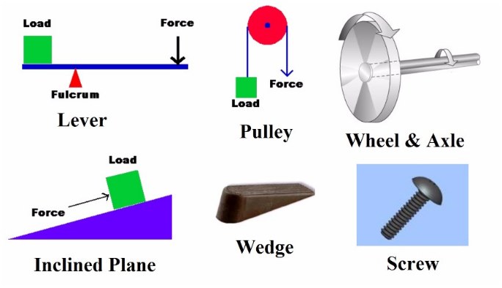
Grade 5’s need to be able to identify simple machines and give examples from nature and household items of simple machines. For each of these machines, they should be able to identify the force effects of the simple machine—does it multiply force (make work easier); does it multiply distance (send objects further); or does it change direction? It may do a combination of these things.

Students should also be able to see that combinations of simple machines form complex machines.
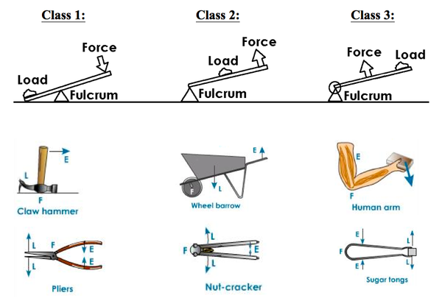
Students can be given an in depth inquiry to study the different types of simple machines. For example, there are 3 classes of levers—identify the force effects and examples of each type; there are many types of pulley systems, identify how to set up different pulley systems and how they work.
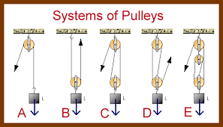

In terms of power, students should understand power is the rate at which work is done. Examples would include racing up a hill—the fastest runner has the most power; car engine power comparisons; motor power.

CURRICULAR COMPETENCIES
Questioning and predicting—can students generate their own questions? Are they testable by simple experimentation?
Planning and conducting—can they design and plan an experiment? Can they change one thing at a time?
Processing and analyzing data and information—can they record data and see patterns
Evaluating—can they draw conclusions from their data?
Applying and innovating—can they improve their design? Can they critique the designs of others to help improve them?
Communicating—can they talk, write and draw about their learning?

WHY IS IT IMPORTANT?
Simple machines form the core of many inventions that make work easier or allow people to do more work. Combinations of machines make up many of the complex machines in our society. The force effects are ways to describe the benefits of using simple and complex machines.

KEY VOCABULARY
Force: the measurement of a push or pull on an object. Force is a vector measured in newtons.
Simple machine: a basic mechanical device for applying a force and doing work
Wheel and axle: It uses a wheel with a rod attached in the middle as an axle to help it to lift or move loads
Ramp: an inclined plane
Pulley: simple machine that uses a wheel with a groove in it and a rope
Wedge: if you put two inclined planes back to back, you get a wedge. A wedge is a simple machine used to push two objects apart
Screw: A screw is a special kind of inclined plane. It's basically an inclined plane wrapped around a pole. Screws can be used to lift things or to hold them together.
Lever: a straight rigid object like a board or a bar which pivots on a turning point called a fulcrum
Load force: the amount of force that results on the load, or thing you are trying to move
Effort force: the amount of force that you have to put into the machine
Force Effects: the way a simple machine changes the force used
Multiplying force: a force effect which increases the load force compared to the effort force
Multiplying distance: a force effect where the distance the load is moved is greater than the distance the effort force is applied
Changing direction: a force effect where the effort force is in a different direction from the load force
Complex machine: a machine using more than 1 simple machine to do a task
Power: Power is a measurement of the rate at which energy is used

SOME INQUIRY QUESTIONS
- Which simple machine has contributed the most to humans?
- How can we control how much energy is lost in each transfer in a complex machine?
- What tool would be best to lift a heavy load, like a washing machine?
- Which simple machine turns a Ferris wheel?
In-depth inquiry: Invite students to choose one simple machine and learn in-depth about it, creating a model.
SUGGESTED PROVOCATIONS/ACTIVITIES/EXPERIMENTS
Provide opportunities for students to discover and play using simple machine basic tools and/or Lego… Build a lever; build a pulley, build any of the simple machines. Investigate the different types of pulleys. Go on a walk and see how many simple/compound machines you can find. Go to the playground and identify as many simple machines as you can.
Sharing clips from Wallace and Gromit movies/pictures of rides at Disneyland – spot and describe the simple and compound machine. Have students find examples of simple machines at home; simple machines and sports.
Have students design a Rube Goldberg machine (see many videos before) or go with a simple marble run but challenge students to speed up or slow down the marble.
CROSS-CURRICULAR CONNECTIONS
Great connections with ADST are available here in making different machines or creating activities.
There are many wonderful examples of art that incorporate simple machines: https://www.teachingchannel.org/video/teaching-simple-machines
Talk about movement of muscles and body through the lens of simple machines to connect with PHE. Also, different sports use different types of simple machines (ex. Hockey sticks, tennis rackets).
Talk about some important inventions and uses of simple machines through history to connect with Social Studies.
For literature connections, find simple machines in their favourite stories: https://www.brighthubeducation.com/elementary-school-activities/86165-simple-machines-in-childrens-literature-webquest/
INDIGENOUS PERSPECTIVES
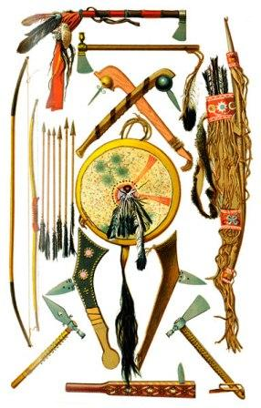
https://www.warpaths2peacepipes.com/native-indian-weapons-tools/atlatl.htm
Aboriginal tools: -canoes and paddles – how they move over water… significance of “paddles up” when entering another’s territory -moving or transporting objects through coastal waterways; transportation http://firstpeoplesofcanada.com/fp_groups/fp_nwc4.html
-dog sleds – moving over snow and ice - throwing (hunting tools: bows and arrows, snares, deadfalls and harpoons); pressing eulachon for oil -fishing (tools: nets, underwater traps, bones, wood hooks, harpoons and cedar fishlines) ;stone sledgehammer for splitting wood
http://firstpeoplesofcanada.com/fp_groups/fp_nwc3.html
Place-based learning opportunities: -attempting to move heavy objects outdoor using people power (push and pull) -construct a travois: a type of sled formerly used by North American Indians to carry goods, consisting of two joined poles dragged by a horse or dog. -relate sun compass to homemade compass experiments
RESOURCES
https://www.scienceworld.ca/resources/units/forces
Bill Nye video clip Simple Machines
https://www.youtube.com/watch?v=yOxc3Bmr60A
Cardboard Automata are a playful way to explore simple machine elements such as cams, levers, and linkages, while creating a mechanical sculpture https://www.exploratorium.edu/pie/downloads/Cardboard_Automata.pdf
Simple Machines Design Project Guide http://www.sciencecompanion.com/wp-content/uploads/Simple-Machines-DigitalSamplerWEB.pdf
Simple Machine Challenge: How do simple machines make work easier? Students are challenged, using everyday objects, to create simple machines to complete specific tasks. http://education.nationalgeographic.org/activity/simple-machine-challenge/
http://www.explorit.org/scienceonline/teacher-resources/TERP_Simple_Machines.pdf
Simple Machine Project/Challenge
https://www.nationalgeographic.org/activity/simple-machine-challenge/
This too Shall Pass - Rube Goldberg Machine (3:53)
https://www.youtube.com/embed/qybUFnY7Y8w 75
Chain Reaction Ideas & Inventions
https://www.youtube.com/watch?v=cv5WLLYo-fk
Honda Rube Goldberg Commercial (2:27)
https://www.youtube.com/watch?v=YWk9N92-wvg
Isaac Newton vs. Rube Goldberg (1:09) https://www.youtube.com/watch?v=HnnMOx9_eBY&list=PLbpi6ZahtOH6jB4qX482tqpT8gJEt iNgf
Awesome Simple Machine Project - example explained by a grade 5 student. https://www.youtube.com/watch?v=lhPrP6Sbmng
A Guide to Simple Machines This will link you to a collection of links that could be beneficial in teaching scientific concepts that simple machines provide.
http://www.thomasnet.com/articles/machinery-tools-supplies/simple-machine-guide

This resource from SD71 has many examples and also materials in FRENCH:
https://portal.sd71.bc.ca/group/wyhzgr4/physics/grade5/Pages/default.aspx

