FORCES GRADE K-2 SUMMARY DRAFT
Grade K + 2 Learning Standards (From BCEd Curriculum)
Kindergarten
- Properties of familiar materials
- colour, texture (smooth or rough), flexibility (bendable or stretchable), hardness, lustre (shiny or dull), absorbency, etc.
- fabric, wood, plastic, glass, metal/foil, sand, etc.
- Effects of pushes/pulls on movement
- how things move (e.g., bounce, roll, slide)
- effects of size, shape, and materials on movement
Grade 2
- Types of forces
- contact forces and at-a-distance forces:
  - different types of magnets
  - static electricity
- balanced and unbalanced forces:
- the way different objects fall depending on their shape (air resistance)
- the way objects move over/in different materials (water, air, ice, snow)
- the motion caused by different strengths of forces
WHAT DO Primary Students need to know about Forces?
K
Forces are a push or a pull
The words to describe different types of movement.
The qualities of materials affect how they move.

Gr 2
Magnets move objects through magnetic force. It is invisible. It can move from one magnetic object to another. The force can pass through nonmagnetic materials. A magnet’s force is strongest at its poles (north/south). Magnets can attract and repel. A compass needle has magnetic force and points north. Consider all the ways we use magnets.
A static electricity spark is an electrostatic discharge (ESD) or sudden flow of electric current across an air gap, heating the air to high enough temperatures to cause it to glow. The size of the spark depends on the separation of the sources of electrical charges and their potential difference in voltage. A spark may be only a few millimeters, several meters or even kilometers in length. The amount of heat and noise created depend on the size of the spark.

CURRICULAR COMPETENCIES
Questioning and predicting: I can ask questions about forces that are on-topic
Planning and conducting: I can experiment with materials and make changes to what I do
Processing and analyzing data and information: I can make and record simple observations
Evaluating: I can make a simple conclusion about my observations
Applying and innovating: I can build new and interesting constructions using what I know about forces
Communicating: I can talk, write and draw about my understanding of forces.

WHY IS IT IMPORTANT?
Forces are all around us. Observation of how things move in nature can lead to technology for helping people move through nature. One example is snowshoes – a technological development that is based on the observation and pattern recognition of the ways in which lynx and rabbits move through the snow.
KEY VOCABULARY (definitions to come)
K
Force: a push or a pull
Push: moves an object away from the force
Pull: moves an object towards the force
Bounce: move quickly up, back, or away from a surface after hitting it
Roll: motion of a ball
Slide: moving along a surface while keeping in contact with it
Gr 2
Gravity: (for Gr 2’s): the force that pulls objects towards the earth
Friction: the rubbing force that slows sliding objects down
Contact force—a force that must touch an object to affect it (hitting an object, rolling it, etc)
At-a-distance force—a force that can affect an object without touching it (ex. Magnetism, gravity, static electricity)

SOME INQUIRY QUESTIONS
What is the relationship between the height of a ramp and the distance a marble or ball will travel?
What is the relationship between the material of a ramp and/or ball and the distance the ball will travel?
What kinds of forces speed things up?
What kinds of forces slow things down?
What are other effects of forces?
How is the effect of a magnet on an object different than the effect of a push or pull?

SUGGESTED PROVOCATIONS/ACTIVITIES/EXPERIMENTS
K
Make a maze using lego. Use marbles, small balls, or other objects. Observe how the objects move through the maze. Use language such as roll, slide, bounce, etc. Build the maze on a flat surface, then try it on a vertical surface and compare the objects movements. Change the size or shape of the object and compare the movements.
Build a pom pom drop. Use toilet rolls and tape to create a vertical structure to drop a pom pom through. Observe the movement of a pom pom through the structure. If changes are made to the structure, how does this change the object’s movement?
Using paper plates and some wooden blocks, create a spiral maze. Watch how a variety of objects move through the maze. Ramp kits are also available at the DLRC.
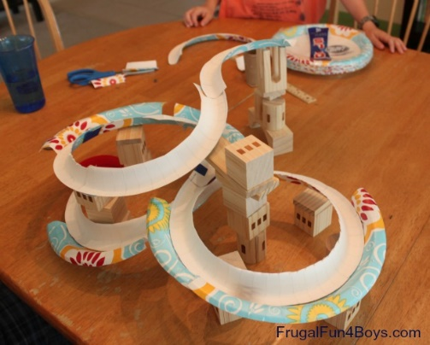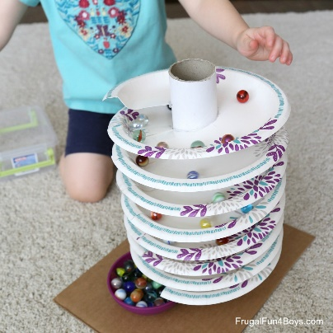
Gr 2
Magnet car races can be fun and can explore the connection between magnet forces, North and South poles, attract and repel: https://sciencekiddo.com/magnet-powered-car/
The way different objects fall depending on their shape (air resistance) -parachute challenges – Parachute Design and drop activity (Science World) https://www.scienceworld.ca/resources/activities/parachute-design-and-drop
Motion can be caused by different strengths of forces. Make an air cannon to try out
https://www.scienceworld.ca/resources/activities/air-cannon (this site has a good video to show how to make them)
This site has more detail and variety: http://www5.sd71.bc.ca/literacy/wp-content/uploads/2015/09/Air-Cannon-Challenge.pdf

CROSS-CURRICULAR CONNECTIONS
You can use an art activity to discuss pushes and pulls:
Bowling (or almost any sport) can be discussed in terms of how the force is applied, how the object moves, pushes and pulls.
Nature: look at falling leaves—how does their shape affect how they fall? What forces are acting on them? Can an ant lift a brick?
Kite building can make connections to literature, art, ADST and outdoor explorations. You will also learn about weather! Here are instructions for a simple kite (but forget about that points thing!): https://www-tc.pbskids.org/fetch/parentsteachers/activities/pdf/FETCH_CrazyAboutKites_AG.pdf
INDIGENOUS PERSPECTIVES
Aboriginal peoples used canoes as a method of travel. Look at a variety of paddles and their shapes to explore how different paddle shapes helped propel the canoe through the water. Kids could make canoe models and explore how they move through the water. Describe using vocabulary words.
The Inuit Thought of It: Amazing Arctic Inventions is available through LRC or school libraries. Discuss how snow crossing technology has been used and perfected over thousands of years in many different cultures. Explore snowshoes, skis, dog sleds, and snowmobiles in the context of force and motion.
Different tools are used for throwing (hunting tools: bows and arrows, snares, deadfalls and harpoons); for pressing eulachon for oil; for fishing (tools: nets, underwater traps, bones, wood hooks, harpoons and cedar fishlines); stone sledgehammer for splitting wood.

http://firstpeoplesofcanada.com/fp_groups/fp_nwc3.html

Place-based learning opportunities:
Attempting to move heavy objects outdoor using people power (push and pull)
Finding places where understanding force is important—example felling trees; crossing snow or water; chopping wood; digging a hole.
Playground equipment can be used to find different types of forces, balanced and unbalanced, and to try out some friction experiments (how to go faster/slower down the slide, for example).

RESOURCES
On Ramps:
https://www.pre-kpages.com/science-kids-exploring-ramps-friction/
On using cars to draw:
http://www.housingaforest.com/drawing-with-cars/
TES is a great place to get lesson demonstrations:
https://www.tes.com/teaching-resource/teachers-tv-lesson-starters-pushing-and-pulling-6085142
Dr Brian Cox on gravity and resistance:
https://www.youtube.com/watch?v=E43-CfukEgs
Veritasium on misconceptions about falling objects (good for teachers to watch):
https://www.youtube.com/watch?v=_mCC-68LyZM
Thanks to SD71 for many ideas and for their longer resource, which can be found here: https://portal.sd71.bc.ca/group/wyhzgr4/physics/grade2/Documents/sd71_web_Physics_g2.pdf

