GRADE 6 FORCES SUMMARY DRAFT
Grade 6 Learning Standards (From BCEd Curriculum)
- Newton’s three laws of motion
- first law: objects will stay stopped or in constant motion until acted upon by an outside force
- second law: only an unbalanced force causes acceleration
- third law: every force has an equal and opposite reaction force

- Effects of balanced and unbalanced forces
- balanced forces are equal and opposite forces (e.g., sitting in a chair)
- unbalanced forces are unequal; one force is larger (e.g., race cars on different ramps, mousetrap cars, rockets)
- in daily physical activities
- examples of effects of balanced and unbalanced forces in school sports and physical education activities
- Force of gravity
- gravity is the force of attraction between objects that pulls all objects toward each other
- on Earth, gravity pulls objects toward the centre of the planet (e.g., falling objects, egg drop)
WHAT DO Grade 6 ’s need to know about Forces?
For Newton’s laws, students should understand how to apply them to everyday objects. For example, an object with balanced forces is not necessarily at rest—unbalanced forces are required to CHANGE the motion or shape of an object, but if an object is already in motion, then unbalanced forces are required to slow and stop it.
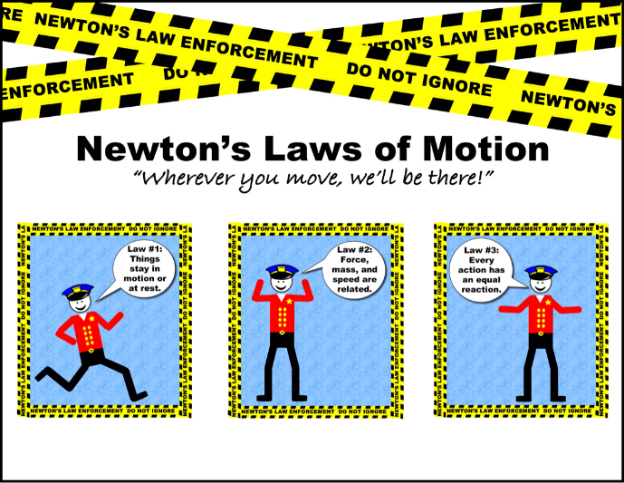
Newton's first law states that every object will remain at rest or in uniform motion in a straight line unless compelled to change its state by the action of an external force. This is normally taken as the definition of inertia. The key point here is that if there is no net force acting on an object (if all the external forces cancel each other out) then the object will maintain a constant velocity. If that velocity is zero, then the object remains at rest. If an external force is applied, the velocity will change because of the force.
The second law explains how the velocity of an object changes when it is subjected to an external force. The law defines a force to be equal to change in momentum (mass times velocity) per change in time. Newton also developed the calculus of mathematics, and the "changes" expressed in the second law are most accurately defined in differential forms. (Calculus can also be used to determine the velocity and location variations experienced by an object subjected to an external force.) For an object with a constant mass m, the second law states that the force F is the product of an object's mass and its acceleration a:
F = m * a
For an external applied force, the change in velocity depends on the mass of the object. A force will cause a change in velocity; and likewise, a change in velocity will generate a force. The equation works both ways.
The third law states that for every action (force) in nature there is an equal and opposite reaction. In other words, if object A exerts a force on object B, then object B also exerts an equal force on object A. Notice that the forces are exerted on different objects. The third law can be used to explain the generation of lift by a wing and the production of thrust by a jet engine.
There are great ways to show the forces in everyday activities such as sports, forms of transportation, different types of work and lifting.
I can statements:
- I can describe Newton’s 3 laws of motion.
- I can describe the effects of balanced and unbalanced forces.
- I can give examples of each of Newton’s 3 laws
- I can describe how Newton’s laws explain how the important forces in the universe work.
- I can plan investigations to answer questions and solve problems.

CURRICULAR COMPETENCIES
Questioning and predicting—can students generate their own questions? Are they testable by experimentation?
Planning and conducting—can they design and plan an experiment? Can they control variables and change one thing at a time?
Processing and analyzing data and information—can they record data and see patterns? Can they find research and determine the bias and point-of-view of the research?
Evaluating—can they draw conclusions from their data and the data from other researchers?
Applying and innovating—can they improve their design? Can they critique the designs of others to help improve them?
Communicating—can they talk, write and draw about their learning in increasingly sophisticated ways?

WHY IS IT IMPORTANT?
Newton’s 3 laws come into play in almost every aspect of our lives—walking, biking, driving; lifting and moving objects; designing structures. In addition, understanding these laws has been essential for getting into space!
KEY VOCABULARY
Balanced: when equal and opposite forces act on an objectno motion
Unbalanced: when unequal forces act on an objectmotion or change
Acceleration: increasing speed
Deceleration: decreasing speed
Friction: the action of one surface rubbing against another
Gravity: the attraction between two objects
Resistance: to push against something
Equal: the same amount of force
Opposite: forces that cancel each other out
Reaction: an effect on an object
Kinetic: energy of movement
Velocity: speed and direction of an object
Potential: stored energy
Conservation: energy isn’t created or destroyed, it is conserved

SOME INQUIRY QUESTIONS
- What are Newton’s 3 Laws of Motion and what can we learn from them?
- Are all objects in motion acted upon by unbalanced forces? Are only unbalanced forces the cause of motion?
- How are balanced and unbalanced forces evident in your life and activities?
- How do Newton’s 3 laws of motion affect sports activities I’m involved in?
- How do airplanes fly compared to helicopters and gliders?
- Why do things fall down and not up?

SUGGESTED PROVOCATIONS/ACTIVITIES/EXPERIMENTS
To design a successful airplane, engineers had to master the balance and control of four forces: lift, gravity, thrust and drag, also known as the "four forces of flight". By adjusting these forces, pilots are able to speed up, slow down, lift off and land their aircraft. This module is designed to demystify each of these forces and examine how they all contribute to flight. https://www.scienceworld.ca/resources/units/flight
Steve Spangler Science experiments on forces and motion. There are many to choose from that demonstrate Newton’s 3 Laws and the effects of forces. http://www.stevespanglerscience.com/lab/categories/experiments/forces-and-motion/
Physics of NHL Hockey:
https://www.nbclearn.com/portal/site/learn/lesson/777868e2a6b0b310VgnVCM10000075c1d240RCRD
https://www.steampoweredfamily.com/activities/physics-activities/
Playground Physics App for iPad:
https://www.youtube.com/watch?v=xlpuE9E9gbo
https://www.education.com/activity/article/Playground_Physics_fifth/
Tons of lessons for the app:
https://noticing.nysci.org/apps/playground-physics/
https://www.scienceworld.ca/tags/newtons-laws
The European Space Station has some good videos to illustrate the 3 laws.
https://www.youtube.com/watch?v=Q0Wz5P0JdeU&list=PLcrcGmQRudzfyLG1K-5oaurr6QWJIMmLI
Exploring gravity in the playground:
https://astrosociety.org/edu/publications/tnl/38/playgrnd.html
https://www.scienceworld.ca/resources/units/forces
pHet is a great on-line resource for simulation labs:
https://phet.colorado.edu/en/simulations/category/physics/motion

CROSS-CURRICULAR CONNECTIONS
Literature connections—see DLRC resource list.
Art connections—these kinetic sculptures are a great way to discuss the integration of art and physics…how do Newton’s laws apply? https://www.youtube.com/watch?v=chxzDjZlLCw
PE—see above for discussions of the applications of Newton’s laws to the areas of sports equipment. This can also apply to body movements in areas such as dance and gymnastics which don’t have equipment.

INDIGENOUS PERSPECTIVES
Play some Indigenous sports games and discuss Newton’s laws:
Kneel Jump: https://www.youtube.com/watch?v=k5cizbqhP1c
Push Back: https://www.youtube.com/watch?v=6Vfj_Rowufo
Sling Ball: https://www.youtube.com/watch?v=cjm0zzc4S6E
Connect Newton’s 3 Laws of Motion to Aboriginal Ways of Knowing/culture – possible inquiry topics: drumming; dancing; Hunting - bow and arrow; Fishing – Newton’s Third Law - action/reaction.

RESOURCES
To go more in-depth understanding about forces, try this website:
http://www.physicsclassroom.com/class/newtlaws/Lesson-2/Types-of-Forces
NASA has a good explanation of the laws (some of which is included above):
https://www.grc.nasa.gov/www/k-12/airplane/newton.html

Thanks to SD71 for their work, which also has lots of video links and RESOURCES IN FRENCH:
https://portal.sd71.bc.ca/group/wyhzgr4/physics/Grade6/Documents/sd71_web_Physics_g6.pdf

