Earth and Water: GRADE K-2 SUMMARY
Grade K-2 Learning Standards (From BCEd Curriculum)
Kindergarten
Daily and seasonal changes affect all living things.
• What daily and seasonal changes can you see or feel?
  - temperature: cold, hot, cool, warm
  - cloud cover: clear, cloudy, partly cloudy, foggy
  - precipitation: rain, snow, hail, freezing rain
  - wind: calm, breezy, windy
- How are plants and animals affected by daily and seasonal changes?

Grade 1 (see also document on Space Science)
- seasonal rounds: Seasonal rounds refers to a pattern of movement from one resource-gathering area to another in a cycle that is followed each year
- local patterns: the relationship of local weather to the four seasons in terms of temperature, cloud cover, precipitation, and wind
Grade 2
- water sources:
  - oceans, lakes, rivers, wells, springs
  - the majority of fresh water is stored underground and in glaciers
- water conservation: fresh water is a limited resource and is not being replaced at the same rate as it is being used
- water cycle: The water cycle is driven by the sun and includes evaporation, condensation, precipitation, and runoff. The water cycle is also a major component of weather (e.g., precipitation, clouds)
- connection to other systems: cultural significance of water (i.e., water is essential for all interconnected forms of life)

WHAT DO Grade K- 2 ’s need to know about Earth and Water?
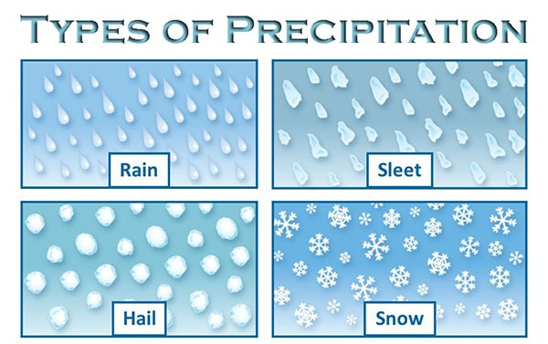
Students should learn about the names and characteristics of the seasons, and the seasonal effects on plants and animals. They should develop words to describe temperature (hot, warm, cool, cold); types of clouds (low, middle, high; fluffy, dark, partly cloudy); of precipitation: rain, snow, light rain, heavy rain; wind.
It is never too early to start talking about the difference between WEATHER (what is happening today/this week) with CLIMATE (the long term—more than 1 year pattern that happens in an area). Make sure they understand that just because it is snowing today, it doesn’t mean that our average temperature isn’t increasing.

Grade 2 students should be able to describe the water cycle with respect to the STATES of the water (liquid, solid, gas) and how the water evaporates from the ocean and lakes to form clouds and condenses to produce rain or snow. They should understand that water flows down hill from glaciers in the mountains to creeks and rivers to the ocean. They should understand where our fresh drinking water comes from.
CURRICULAR COMPETENCIES
Questioning and predicting-ask questions, make simple predictions about familiar objects & events
Planning and conducting-make exploratory observations of the local environment based on senses, make simple measurements (perhaps using non-standard units)
Processing and analyzing data and information-discuss observations; represent observations by drawing, compare observations and predictions; moving towards identifying simple patterns and connections.
Evaluating-compare my observations with those of others; consider the environmental consequences of my actions
Applying and innovating-I can take part in caring for myself, family, classroom and school; apply learning to new situations; introduce new or refined ideas
Communicating-I can share my scientific understanding orally, in drawing and moving towards writing; I can express and reflect on personal experiences of place

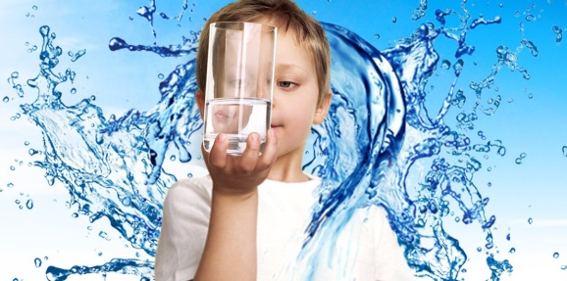
WHY IS IT IMPORTANT?
Seasons are important for our ecosystems, including food production. Seasonal changes can be identified by changes in animals and plants.
The objects in the sky help us understand the size and significance of earth.
Water is the most central compound to life on earth, providing many functions. Clean, fresh drinking water is essential for life. The water cycle maintains life on earth. Although we are very lucking in British Columbia to be blessed with plentiful fresh water, that is not the case in the rest of the world.
KEY VOCABULARY

Seasons: each of the four divisions of the year (spring, summer, autumn, and winter) marked by particular weather patterns and daylight hours, resulting from the earth's changing position with regard to the sun.
Clouds: a visible mass of water vapor floating in the atmosphere
Sun: the star at the center of our solar system
Wind: the natural movement of air, caused by temperature differences
Temperature: a measure of how hot or cold something is
Water: a colorless, transparent, odorless liquid that forms the seas, lakes, rivers, and rain and is the basis all living things
Ice: water frozen into a solid
Snow: frozen water that falls to the ground as flakes
Rain: water that falls from clouds
River: a large natural stream of water flowing into the sea, a lake, or another such stream
Lake: a large body of fresh (not salty)water surrounded by land
Ocean: the whole body of salt water that covers nearly three fourths of the surface of the earth
Precipitation: rain, snow, sleet, or hail — any kind of weather condition where something's falling from the sky.
Condensation: water which collects as droplets of liquid from the water vapor in the air
Evaporation: water vapor that goes into the air from liquid water
Solid: a substance that stays the same shape and volume whether in a container or not
Liquid: a substance that flows and takes the shape of a container but keeps its own volume
Gas: a substance that takes the shape and volume of its container

SOME INQUIRY QUESTIONS
- How do seasons affect living things
- How much water do we use (including for growing food, washing clothes, etc) every day?
- How do the seasons change?
- Where can we find fresh water?
- How does water cycle through the environment?
- What can water be? (How many uses and functions does water have in our lives and in the environment?)

SUGGESTED PROVOCATIONS/ACTIVITIES/EXPERIMENTS
Gr K-1
Daily Changes: Observe weather patterns by using thermometers, rain gauges, describing clouds (use this cloud viewer: https://www.windows2universe.org/teacher_resources/cloud_viewer_web.pdf) . Adding in a Record and look for patterns in our local weather and sky. Wind, rain, shadow and sunny day play for creating real life experiences. Engage students by going on “I Wonder” walks in the local area as seasons change (wetland, river, creek, forest, field). Look for signs for each season. Have students describe things they notice using their senses. Students can sketch the local area. This could be done as seasons change and children should review and compare previous sketches. Students can make terrain maps of the area surrounding the school. Notice which creatures and plants are observable during each season. How are plants and animals affected by daily and seasonal changes?
On a rainy day, go on a walk to your local area and watch where rain water goes and what it does. Students can observe puddle formations, what happens when you dam the water (relate this to beavers, natural dams in rivers and streams due to logs/sticks, human made dams for electricity). Go for walks during windy days, sunny days, etc. and observe the effects of the weather on our clothing, on animals we are able to observe. Use magnifying glasses, binoculars to make observations as well.
Make observations of the appearance of the moon and stars at night; sunrise/sunset, cloud formations as weather and /or seasonal indicators. Events that occur in the local sky such as fog, wind changes, storm watching, snow and other weather. Create drawings based on these observations. Do this over a period of a few days so changes can be noted.
Coastal BC Rainfall activity from Science World: https://www.scienceworld.ca/resources/activities/rainfall
Build a variety of landscape models for the local areas. Which animals and plants are evident in each type of landscape? Make predictions about why.
Using a sand table, pack down the sand as hard as possible, pour in water. Have students make observations of what happens. Repeat with soil, gravel and notice differences and similarities .

Grade 2
The Water Cycle a natural recycling process: the water cycle is a major component of weather Science World Experiments – Making Rain, Micro Water Cycle (needs small live plants), Water Cycle Circuit , Cloud in a bottle.
Science world water filtration challenge (good for inquiry): https://www.scienceworld.ca/resources/activities/water-filtration-challenge
Consider using the water cycle game and resources from Project Wet: https://www.projectwet.org/
Water testing materials can be obtained from the Safe Drinking Water Foundation: https://www.safewater.org/
You might take a water cycle field-trip or a visit to the local reservoirs: http://www.metrovancouver.org/events/school-programs/K-12-field-trips/watershed-field-trips/Pages/default.aspx
Here are some maps and information about water from Natural Resources Canada:
http://www.nrcan.gc.ca/earth-sciences/geography/atlas-canada/selected-thematic-maps/16888#distributionofwater
CROSS-CURRICULAR CONNECTIONS
There are lots of literature. Some books:
All the Water in the World by George Ella Lyon
Did a Dinosaur Drink This Water? by Robert E. Wells
Clean Water For Elirose by Ariah Fine
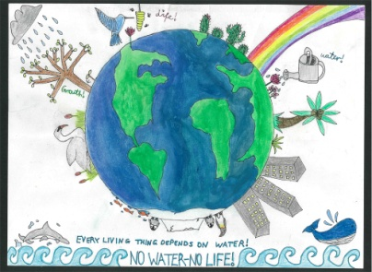
This last book brings in some global social studies perspectives—looking at the availability of clean water in other places and how other children might need to work to get water.
https://wellawareworld.org/projects Features some information on holding a water well walk or a shower strike to raise money for wells in Africa and to bring awareness. This can work in health and fitness into your discussions of water. Don’t forget also that some First Nations communities in BC (in surpisingly urban locations https://www.cbc.ca/news/canada/british-columbia/semiahmoo-first-nation-water-surrey-1.4761039) and across Canada do not have access to fresh drinking water.
Consider getting involved in the Great Canadian Shoreline Clean Up as a way of connecting students to their neighbourhood waterways and environmental stewardship: https://www.shorelinecleanup.ca/

Water is often represented in art and sometimes is used to make art. Take a look at this UNESCO handout for images and ideas: http://www.unesco.org/new/fileadmin/MULTIMEDIA/FIELD/Venice/pdf/special_events/bozza_scheda_DOW_8_1.4.pdf

INDIGENOUS PERSPECTIVES
This seasonal rounds kit is a great resource and integrates social studies and science:
https://www.openschool.bc.ca/elementary/my_seasonal_round/index.html

Mouse Celebrates Winter Solstice http://www3.sd71.bc.ca/School/abed/resources/staffresources/elementary/Pages/Mouse-Celebrates-the-Winter-Solstice.aspx
Emphasize the importance of “stewardship” of the land: the value of natural resources, sustainability and protecting the earth. First Peoples have a relationship with nature: the land, air, water, animals and plants. They value and respect the earth, taking only what is needed and giving thanks for all they have.
Storm Boy by Paul Owen Lewis: In the storm-tossed seas along the rugged Northwest Coast, a Native boy is thrown from his canoe into a great mystery which follows the rich mythic traditions of the Native cultures of this area. Cloudwalker by Roy Henry Vickers: In this legend, a Gitksan Indian hunter tries to catch a group of swans and is carried away by the birds and dropped on the clouds. He wanders with a cedar box of water and spills the contents and when he returns to earth he finds lakes and rivers which weren't there before. Morning On The Lake by Jan Bourdeau Waboose: In the first of three linked stories, a young boy and his grandfather set out in a birchbark canoe early one spring morning.
Water is life to many Indigenous communities, and getting fresh water is a struggle.
RESOURCES
A great little video by Bill Nye, explain the reasons for the seasons. https://www.youtube.com/watch?v=KUU7IyfR34o
Weather: https://scied.ucar.edu/webweather/clouds/cloud-types
Precipitation (Language a bit high level, good for teacher background):
https://www.youtube.com/watch?v=SesRrocIFtc
Interactive water cycle:
https://www3.epa.gov/safewater/kids/flash/flash_watercycle.html
A great list of water resources:
http://www.valueofwater.ca/teaching-resources/classroom-lessons/
Water can be:
https://www.youtube.com/watch?v=ljq0dokh-Sw
Plip and Plop explain the water cycle:
https://www.youtube.com/watch?v=Xzy6a4KNgKk
Project Wet (many activities including the colour versions of the water cycle game).
https://www.projectwet.org/what-we-do/publications
Science World Water Cycle Activities (nice and simple):
https://www.scienceworld.ca/resources/activities/water-cycle-circuit
https://www.scienceworld.ca/resources/activities/water-cycle-game
Natural Resources Canada info on water:
http://www.nrcan.gc.ca/earth-sciences/geography/atlas-canada/selected-thematic-maps/16888#climatechange
Teach BC also has a range of resources, search Weather or Water:
https://teachbc.bctf.ca/

RESOURCES IN FRENCH
https://portal.sd71.bc.ca/group/wyhzgr4/earthspace/kindergarten/Documents/sd71_web_maternelle_terre_espace.pdf
https://portal.sd71.bc.ca/group/wyhzgr4/earthspace/Grade1/Documents/sd71_web_1e_La_terre_et_l%27espace.pdf
https://portal.sd71.bc.ca/group/wyhzgr4/earthspace/grade2/Documents/sd71_web_2e_La_terre_et_l%27espace.pdf
Safe Drinking Water Foundation: https://www.safewater.org/french-education/

