Grade 7 Learning Standards (From BCEd Curriculum)
Grade 7
• geological time:
- the geologic time scale categorizes the time periods of Earth’s geologic history
- ages of rocks and fossils can be determined by both relative and absolute methods
• climate change affects:
- the interconnectedness of plants and animals, and their local environment
- e.g., changes to harvesting dates, changes to schedules due to early/later ripening and runs, lowered water levels in creeks, rivers and lakes, change in humidity impacts the ability to preserve salmon, etc.
• impacts of humans:
- humans are capable of changing Earth’s landscape, climate, and systems
- efficacy of sustainable practices
• Physical records: ice flow data, fossil record, etc.
• local First Peoples knowledge of climate change: oral history, change in traditional practice (e.g., the timing of harvest has been impacted by climate change), etc.

WHAT DO Grade 7’s need to know about the Geological Time Scale and Climate Change?
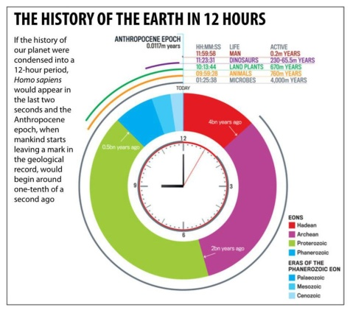
This topic links very well with the Evolution unit in Grade 7, and so the Geological Time Scale and Evolution may be taught at the same time. Key understanding is the DEPTH of the timeline, and how recently humans have been a part of the scene. Having students create an adding machine tape timeline, or a toilet-paper timeline, or even using the school hallway as a giant timeline is a strong activity for understanding this scale.
Students should understand that the dates have been established by relative dating of the layers of rock and radioactive dating of fossils and rock layers.
In terms of climate change, students should understand how the green-house effect works (CO₂ holds heat in the atmosphere) and that this has been undeniably linked via scientific experimentation to human use of fossil fuels. They should know some of the key pieces of evidence that support the scientific conclusion that human-caused climate change is unequivocal: data about temperature and precipitation from ice cores; experiments that have demonstrated the heat-trapping properties of CO₂; CO₂ measurements over the last 50 years; ocean temperature and pH measurements; Arctic and Antarctic ice and glacier measurements; sea level changes. All of these can be found in more detail at the links below.
Figure 1 Graphic from: http://myscienceacademy.org/2012/10/08/the-history-of-the-earth-in-12-hours/
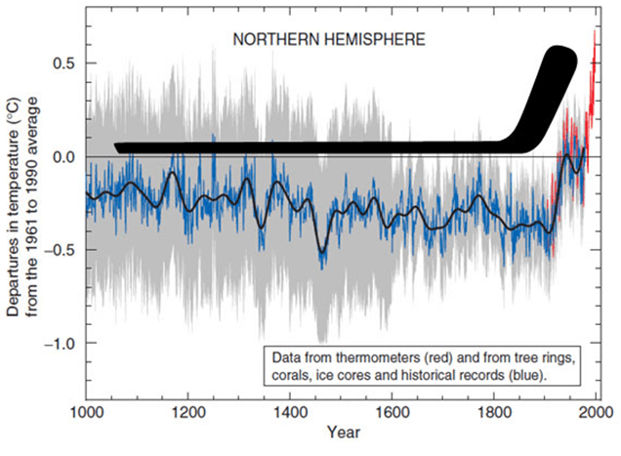
Students should also know the effects of climate change on weather—warming, more extreme weather, change in dispersal of precipitation and drought. They should also be aware of effects on the ocean—warming, acidification and movement of species.
Figure 2 The "hockey stick" graph of temperature over the last 1000 years
Students should know what sustainability is, and how Indigenous knowledge provides us with ways to subsist and thrive in a sustainable fashion. Students should also learn some personal and global ways that climate change can be addressed to reduce its impacts. Importantly, this needs to be taught with hope, and with the understanding that personal AND governmental action have the ability to reduce, mitigate and adapt to the changes in climate. Do NOT use any resources denying the existence of climate change. They are generally provided to schools via oil companies, and they are contrary to our provincial curriculum.

CURRICULAR COMPETENCIES
Questioning and predicting—can students generate their own questions? Are they testable by experimentation?
Planning and conducting—can they design and plan an experiment? Can they control variables and change one thing at a time?
Processing and analyzing data and information—can they record data and see patterns? Can they find research and determine the bias and point-of-view of the research?
Evaluating—can they draw conclusions from their data and the data from other researchers?
Applying and innovating—can they improve their design? Can they critique the designs of others to help improve them?
Communicating—can they talk, write and draw about their learning in increasingly sophisticated ways?

WHY IS IT IMPORTANT?
Understanding the deep time and the slow rate of geological change is key to really grasping biological evolution as well.
Knowing about climate change as a serious scientific issue helps students make personal and political decisions. In the very near future, our students will be a part of the solution to CO₂ pollution and climate change.
KEY VOCABULARY

Geological time: the succession of eras, periods, and epochs of the earth’s 4.6 billion year history
Relative dating: determining the age of a fossil or landform by examining the layers of rock it is found in
Radioactive dating: determining the age of a sample by using the decay of radioactive elements
Billion years ago
Million years ago
Era: the major segments of geologic time, marked as Paleozoic, Mesozoic and Cenozoic
Period: divisions of Eras
Fossil: a trace or remains of an ancient animal or plant
Sedimentary rock: rock formed from eroded sediments
Greenhouse gas: a gas that increases the ability of the atmosphere to hold and capture heat; examples: CO₂, H₂O, methane, ozone, N₂O
Acidification: when CO₂ dissolves in water, it creates an acid, changing the pH of oceans, lakes and rivers
Climate: the weather conditions in an area in general or over a long period.
Adaptation: actions that seek to reduce the vulnerability of social and biological systems to relatively sudden change and thus offset the effects of global warming
Mitigation: efforts to reduce or prevent emission of greenhouse gases

SOME INQUIRY QUESTIONS
- When did life begin on earth?
- How is the geological time scale dated?
- How do fossils form?
- What do fossils tell us?
- Do scientists agree that climate change is caused by humans?
- How is climate change affecting Canada?
- Is Canada’s/British Columbia’s/Burnaby’s climate plan enough?
- How does climate change affect…the oceans…the forests…the Arctic…Pacific Islands…human built structures…farming…etc. etc.
- What project can we do to mitigate or adapt to climate change?

SUGGESTED PROVOCATIONS/ACTIVITIES/EXPERIMENTS
Making a geological time scale…this can be done in a variety of ways—on toilet paper or adding machine paper. This resource has a good way to move through the lessons: http://www.dynamicearth.co.uk/media/1514/geological-timeline-pack.pdf
This viewer on the Geological Timescale is a good resource: https://www.hhmi.org/biointeractive/earthviewer
Learn about fossils and make a simulated fossil with info from this website:
https://www.pbslearningmedia.org/resource/ess05.sci.ess.earthsys.lp_funfossils/fun-with-fossils/#.WwbelfkrK9I
Climate change:
Bill Nye and National Geographic have a series called Climate 101:
https://www.youtube.com/watch?v=3v-w8Cyfoq8
Here are 3 excellent experiments to explore climate change:
https://pmm.nasa.gov/education/sites/default/files/lesson_plan_files/climate%20change%20inquiry/Climate%20Change%20Inquiry%20TG.pdf
The FNESC First People’s Science has an excellent unit on climate change, starting with climate change as a current event and then looking at the important impacts of climate change on salmon. (Unit starts on page 121 of guide):
http://www.fnesc.ca/wp/wp-content/uploads/2015/08/PUBLICATION-61496-Science-First-Peoples-2016-Full-F-WEB.pdf

The Environmental Youth Alliance does workshops and has many projects:
https://eya.ca/our-programs/

High School students in Burnaby organize via the Burnaby Youth Sustainability Network—consider involving Grade 7’s in this and the annual Do It Green conference:
https://www.facebook.com/thebysn/

City of Burnaby has some resource and ideas for projects:
https://www.burnaby.ca/City-Services/Policies--Projects---Initiatives/Environment.html

CROSS-CURRICULAR CONNECTIONS
If you do some of the Geological Time Scale activities by having the students calculate distances and times, there are good math cross-overs here.
Math as well is involved in examining and understanding climate change data, including the famous “hockey stick” graph: https://www.theatlantic.com/technology/archive/2013/05/the-hockey-stick-the-most-controversial-chart-in-science-explained/275753/
Lots of intersections are possible with Social Studies as you study climate change and how the earth has changed geographically over time. You can also investigate current events such as extreme weather caused by climate change, or how countries are working to mitigate and adapt to climate change. The student climate strike in Europe is also a good current event to discuss.
Read the Little Hummingbird by Michael Nicoll Yahgulanaas or show the video: https://www.youtube.com/watch?v=naj6zZakgEg

Jill Pelto is an artist and scientist whose work combines data, images and landscapes: http://www.jillpelto.com/gallery/

There are many more artists addressing climate change: https://artistsandclimatechange.com/

INDIGENOUS PERSPECTIVES

At a recent First Ministers Conference, Prime Minister Trudeau and the premiers recognized “the importance of traditional ecological knowledge in regard to understanding climate impacts and adaptation measures.” Explore how local and regional First Nations are providing understanding of and preparing adaptation to climate change. Background information can be found here: https://www.thestar.com/news/canada/2016/03/12/canada-seeks-traditional-aboriginal-knowledge-on-climate-change.html

A global look at climate impacts:
https://intercontinentalcry.org/listening-rain-indigenous-perspectives-climate-change/

You might investigate how some First Nations are dealing with climate change:
https://www.retooling.ca/xatstull_first_nation.html

As mentioned above, the FNESC First People’s Science has an excellent unit on climate change, starting with climate change as a current event and then looking at the important impacts of climate change on salmon. (Unit starts on page 121 of guide):
http://www.fnesc.ca/wp/wp-content/uploads/2015/08/PUBLICATION-61496-Science-First-Peoples-2016-Full-F-WEB.pdf

RESOURCES

This PBS site is excellent for Evolution and the Geological Time Scale:
http://www.pbs.org/wgbh/evolution/

Science World has some good activities for exploring climate change:
https://www.scienceworld.ca/resources/activities/exploring-greenhouse-effect

https://www.scienceworld.ca/resources/activities/biological-timescale

Environment Canada has plenty of information and resources:
https://www.canada.ca/en/services/environment/weather/climatechange.html

Even in the face of a hostile US administration, NASA has developed excellent informative resources for the study of climate: https://climate.nasa.gov/

Additionally, the NOAA has done the same:
http://www.noaa.gov/education/education-resource-collections

IN FRENCH:
https://portal.sd71.bc.ca/group/wyhzgr4/earthspace/grade7/Documents/sd71_web_7_terre_espace.pdf

https://www.canada.ca/fr/services/environnement/meteo/changementsclimatiques.html

