Grade 3-4-5 Learning Standards (From BCEd Curriculum)
Grade 3
- landforms: mountains, hills, plateaus, valleys, riverbeds, deltas, glaciers, etc.; oral narrative about landforms

Grade 4 (SPACE SCIENCE COVERED IN EARTH AND SPACE HANDOUT)
Grade 5
- the rock cycle
- local types of earth materials: include mineral, rock, clay, boulder, gravel, sand, soil
- interconnectedness: everything in the environment is one/connected (e.g., sun, sky, plants and animals) and we have a responsibility to care for them
- First Peoples knowledge of sustainable practices
- BC Resources and sustainable practices

WHAT DO Grade 3-4-5 ’s need to know about Earth and Water?
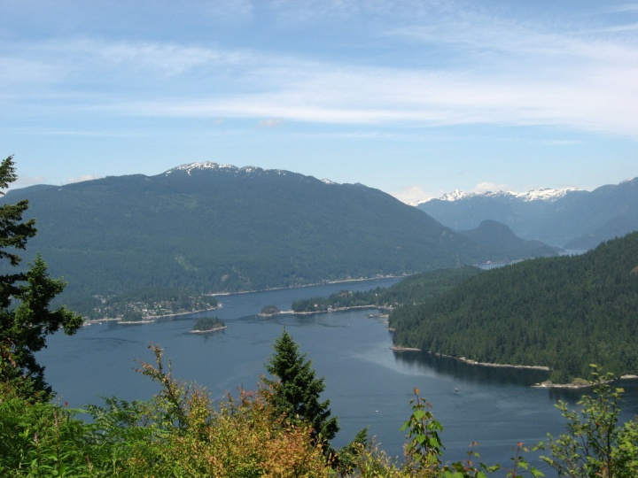
Grade 3’s should understand: weathering is the breakdown of rock into tiny pieces, which can happen from water, ice, movement of animals or chemical interactions. Erosion is the movement of those broken down materials by wind, water or glaciers to new places. The breakdown and movement of materials is what causes land-forms to be created.
Figure 1 Landforms visible from Burnaby Mountain
Watershed: An area, usually defined by elevated ridges within which all water flows into the
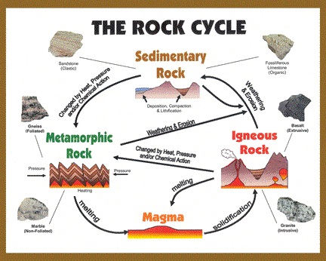
same catchment area such as a river or lake. A drainage basin collects water at the lowest elevation. Landforms are important to the Indigenous peoples and settler living in an area, as they determine the availability of food and materials and the sustainability of life in a given area. Landforms have been given names by people, and many places and landforms in BC have Indigenous names in addition to English language names.

Grade 5 students should understand that: minerals are pure substances; rocks are made up of more than one mineral. Minerals can be identified by unique characteristics including colour, streak, magnetism, hardness, reactivity to acids. There are several mineral kits available from the DLRC to perform tests and identify minerals.
Figure 2 The rock cycle is a key learning outcome
It is also important to know the rock cycle: rocks are weathered, eroded, then reformed by heat and pressure. Sedimentary rocks are formed from sediments placed under strong pressure; metamorphic rocks are other types that have been formed from heat and great pressure (but not quite enough heat to melt); igneous rocks are minerals that melted then cooled.
Mineral resources are important components of our structures, buildings and devices. Mining and other means of resource extraction have impact on the surrounding communities and should be examined in terms of sustainability.
CURRICULAR COMPETENCIES
Questioning and predicting-identify questions about familiar objects and events that can be investigated scientifically; -make predictions based on prior knowledge
Planning and conducting-plan and conduct an inquiry to answer questions; consider ethical responsibilities when conducting an experiment; -use appropriate tools to make observations, making formal measurements; -collect simple data
Processing and analyzing data and information-sort and classify data using drawings or tables that are provided; -use tables, simple graphs and other formats to show simple patterns and trends; -compare results with predictions
Evaluating-make simple inferences based on results and prior knowledge; -reflect on the fairness of a test; -appreciate evidence; -identify simple environmental implications of my own and others’ actions.
Applying and innovating-contribute to caring for myself, others, the school and neighbourhood; co-operatively design projects; -transfer and apply learning to new situations; -contribute new ideas or refine ideas when problem solving
Communicating-communicate and represent scientific understanding in a variety of ways, such as diagrams and simple reports, using digital technologies; -express and reflect on experiences of place.

WHY IS IT IMPORTANT?
Understanding the geography around us is key to talking about some very significant environmental issues like water use, resource extraction and pollution. Additionally, understanding where our materials come from helps students make sustainable choices. Knowledge of the rock cycle helps students understand the cyclical nature of materials on our planet.
KEY VOCABULARY

Weathering: the process where rock is dissolved, worn away or broken down into smaller and smaller pieces
Erosion: happens when rocks and sediments are picked up and moved to another place by ice, water, wind or gravity.
Chemical weathering: when rocks are broken down and chemically altered, for example by acidic water in the environment.
Physical weathering: rocks being slowly broken down or broken apart mechanically by pressure, temperature, water and ice
Biological weathering: rocks being broken down by plants, animals and microbes.
Minerals: pure substances that make up the earth’s crust.
Rocks: a piece of the earth’s crust, made of one or more minerals.
Resources: materials or substances such as minerals, forests, water, and fertile land that occur in nature and can be used for subsistence and/or economic gain
Colour: the colour of a mineral
Streak: the colour a rock or mineral leaves on an unglazed white tile
Hardness: a description of how hard it is to scratch a given mineral or rock, ranging from 1 (talc) to 10 (diamond)
Rare: not usually found
Common: easy to find
Metamorphic: rocks or minerals that have been transformed under great heat and pressure
Igneous: rocks or minerals that have been formed from melted magma or lava
Sedimentary: rocks or minerals that have been formed from eroded sediments under pressure.
Heat: energy from the movement of molecules and atoms
Pressure: force applied over an area

SOME INQUIRY QUESTIONS
- How is the shape of the land changed by environmental factors?
- What are landforms? How can I identify them?
- Who named places in BC? Should they be renamed?
- What landforms do we have in our local area?
- What is the difference between minerals and rocks?
- How can I identify rocks?
- What rocks and minerals are valuable?
- How long does the rock cycle take? Can we stop it?
- What effect does mining have on the environment?
- What are renewable vs. non-renewable resources?
SUGGESTED PROVOCATIONS/ACTIVITIES/EXPERIMENTS
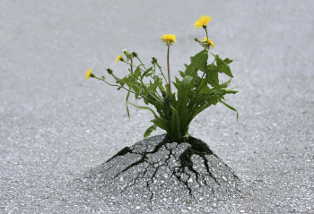
Go for a walk outside the school and identify landforms in your neighbourhood and that are visible. Look for signs of weathering and erosion around your school (can even be of asphalt or other human- made structures).
Use a landscape map (available from MetroVancouver) to examine the topography of the lower mainland including rivers, creeks, mountains, the Fraser River delta, valleys, glaciers and other land forms. If your school doesn’t have one, use this website: http://www.maplandia.com/canada/british-columbia/greater-vancouver-regional-district/burnaby/#large
Consider a watershed field trip (or check out the resources): http://www.metrovancouver.org/events/school-programs/K-12-field-trips/watershed-field-trips/Pages/default.aspx
Figure 3 A dandelion breaking through asphalt demonstrates biological weathering.
Great simple activities here to understand weathering of all types:
https://d32ogoqmya1dw8.cloudfront.net/files/sp/mnstep/activities/Rusty_Rock.docx.doc
Erosion labs and activities:
http://teacher.scholastic.com/dirt/erosion/tguide.htm
http://teacher.scholastic.com/dirt/erosion/lab.htm
http://www.kids-earth-science.com/volcano-science-experiment.html
Chocolate chip mining is a chance to talk about resource extraction/sustainability: Chocolate Chip Mining Activity introduces learners to the economics of mining while developing skills in math, science, problem solving, decision making and language arts.
http://www.acgc.ca/09/images/file/resources/G2-ChocChipMine.pdf
Obtain various rock and mineral samples (or use a kit from the DLRC) and explore their properties. Use the Mohs’ hardness scale: http://www.newworldencyclopedia.org/entry/Mohs_scale_of_mineral_hardness

Simulate the rock cycle using crayon shavings:
https://serc.carleton.edu/sp/mnstep/activities/34972.html

Play a rock cycle game:
https://www.nasa.gov/sites/default/files/rockingtherockcycle.pdf

CROSS-CURRICULAR CONNECTIONS
Art is a natural cross curricular connection—landscapes offer a chance to talk about different land-forms while observing them and drawing their characteristics. http://blog.hellobc.com/12-of-british-columbias-greatest-artists/
Social studies—current events about resource conflicts, mining, pollution.
ADST—using and reusing different materials. Engineering—using plants to stabilize slopes, etc.
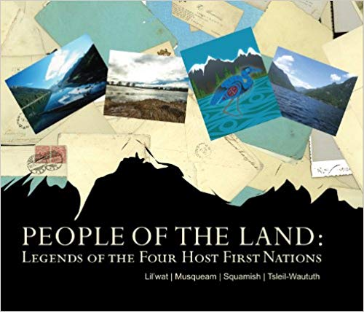
Figure 4 Widely available in the district
INDIGENOUS PERSPECTIVES
“People of the Land: Legends of the Four Host First Nations (FHFN) Lil’wat | Musqueam | Squamish | Tsleil-Waututh is a book based on oral story telling available in most school libraries, as it was an Olympic project from 2010. It includes stories and also many pictures of important landmarks in the four “host nation” territories.
Tsleil-Waututh nation—read about the history of the Tsleil-Waututh on their website: https://twnation.ca/our-story/
Shallow Waters- a song by Ta’Kaiya Blaney https://www.youtube.com/watch?v=LkjIkuC_eWM
Current events—explore conflicts between resource extraction and First Nations in BC.

Discuss current issues around place names in BC:
https://thetyee.ca/News/2013/05/27/Peoples-Geography-BC/
Explore the story of the Frank Slide and how settlers ignored the warnings from Indigenous peoples in the area. Documentary about this available from the NFB: On the Edge of Destruction: The Frank Slide Story.
RESOURCES
Erosions effects:
https://www.youtube.com/watch?v=ZNJe6hrdL3M

Ask Billy...What is Erosion YouTube Video link: informative clip that explains erosion with animated flair (5:09) https://www.youtube.com/watch?v=G5Rp9MJJGCU

Weathering and Erosion Crash Course: https://www.youtube.com/watch?v=R-Iak3Wvh9c

Erosion lab – a visual of how to explain erosion to your class,
https://www.youtube.com/watch?v=ZNJe6hrdL3M

Teacher background on weathering and erosion: http://slideplayer.com/slide/7462377/

Exploring landforms and bodies of water for kids: https://www.youtube.com/watch?v=BsqKTJtK_vw

Learning about Landforms: https://www.youtube.com/watch?v=KWTDmg8OI_Y

Tsunamis (please preview): http://www.kidsgeo.com/geography-for-kids/0146B-tsunamis.php

Rock cycle:
https://www.learner.org/interactives/rockcycle/rockdiagram/

Background info on rocks and minerals:
http://www.clcnwi.com/file_download/inline/31788b45-bea4-4891-aa5e-32cd872e7a7c

Sustainability lessons (large bank, available for searching):
http://resources4rethinking.ca/en/home

Posters and resources from Newfoundland:
http://www.nr.gov.nl.ca/nr/mines/outreach/forteachers.html

RESOURCES IN FRENCH
https://portal.sd71.bc.ca/group/wyhzgr4/earthspace/grade3/Documents/sd71_web_3e_La_terre_et_l%27espace.pdf
https://portal.sd71.bc.ca/group/wyhzgr4/earthspace/grade5/Pages/gr5earthfrenchteacher.aspx

