SPACE GRADE 6 SUMMARY DRAFT
Grade 6 Content Learning Standards (From BCEd Curriculum)
The solar system is part of the Milky Way, which is one of billions of galaxies.
- the overall scale, structure, and age of the universe
- the position, motion, and components of our solar system in our galaxy
  - planets, moons, asteroids, meteors, comets, etc.
  - First Peoples perspectives regarding aurora borealis and other celestial phenomena
  - extreme environments including contributions of Canadians to exploration technologies (e.g., Canadarm, Newt Suit, VENUS and NEPTUNE programs)
WHAT DO Grade 6’s need to know about space?
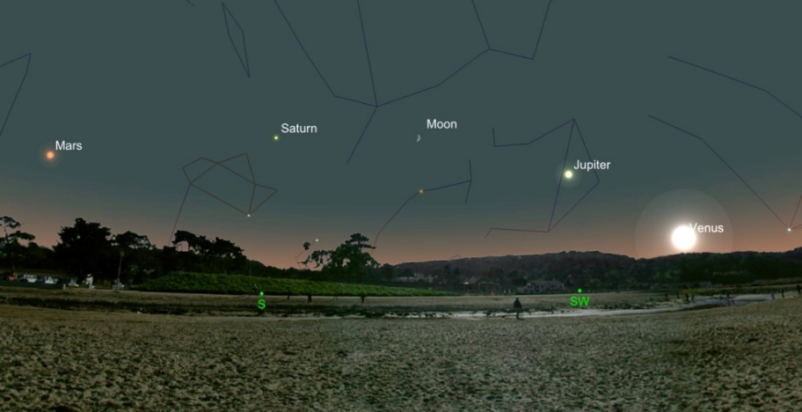
Grade 6 students need to be able to describe the objects in our solar system and the scale of distances between these objects. These objects are the 8 planets, moons, asteroids, meteorites, meteors, comets and the Sun as our closest star. Details of these objects may be explored by personal interest. My favourite mnemonic for the planets has had to be adjusted due to Pluto’s demotion: My Very Excellent Mother Just Served Us Nachos!
Grade 6 students should distinguish between extreme environments on Earth and in our solar system and describe the characteristics of extreme environments on Earth and in our solar system.
Grade 6 students should be able to explain what a galaxy is, understand there are different types of galaxies and that our galaxy is the Milky Way.
Grade 6’s should compare and contrast First People’s myths and stories which explain seasonal change, aurora borealis, patterns of stars, and length of day with similar stories from other cultures. Once myths and stories are understood, Grade 6’s should be able to see how First Peoples and people in other cultures could use this information to structure their lives.
Through personal inquiry, Grade 6’s can explore an area of interest regarding Canadian contributions to exploration technologies (Canadarm, Newt suit, Venus, and Neptune programs).
CURRICULAR COMPETENCIES
Questioning and predicting
Planning and conducting
Processing and analyzing data and information
Evaluating
Applying and innovating
Communicating

WHY IS IT IMPORTANT?
Being able to discuss and identify things in the night sky is a good connection to place, but also a universal connection to other people.
Space and the objects in space are significant in many parts of arts and entertainment. As well, they open the doors to many areas of technology and careers.
It always impresses a date if you can identify a few constellations!
KEY VOCABULARY (include definitions)
SOME INQUIRY QUESTIONS
- What are the relationships between Earth and the rest of the universe?
- What is an extreme environment?
- What extreme environments exist on Earth or in our galaxy?
- Each student chooses an organism to learn about how they survive/meet their basic needs through each season – how it adapts and changes with the seasons.
- Should we spend money on space exploration while we have so many problems on earth?
- What does a colony on Mars need to survive?
- Is Pluto a planet?
- How can we build a better model of the solar system/galaxy/other objects?

SUGGESTED PROVOCATIONS/ACTIVITIES/EXPERIMENTS
Make a model to demonstrate the distances and sizes to scale in the solar system. (See many suggested links in resources below).
Use this water balloon experiment to understand escape velocity: https://www.teachengineering.org/activities/view/cub_mars_lesson04_activity1
This computer simulation (free site—pHet—is great) shows gravity and orbits: https://phet.colorado.edu/en/simulation/gravity-and-orbits
Have students construct a planisphere (starwheel) to assist in observing the night sky: https://www.skyandtelescope.com/astronomy-resources/make-a-star-wheel/
Consider a research inquiry to explore space and extreme environments; or provide an opportunity for students to investigate some Canadians and their contributions to space technology ... Students may choose to do some research about a Canadian person or a technological contribution.
CROSS-CURRICULAR CONNECTIONS
Poetry is one great place to find reference to astronomy. As the webpage, Ask an Astronomer says, “Poets have found inspiration in astronomy like many aspects of nature. Throughout history, poetry has included countless references to the beauty, rhythm, harmony, and chaos of the cosmos.
Astronomical objects and phenomena can be the subjected to personification or detailed natural description. The orbits of the planets and the Earths motion through space are often described by their clockwork cycles. The stars are filled with stories and shapes as every early civilization in history has created a unique cultural connection to the night sky.”

The same is true for other areas of the arts too. Try moon painting: https://www.youtube.com/watch?v=SB937wohehY&feature=youtu.be

Teaching Astronomy Through Art by Sharon Jeffus is also a good resource.

INDIGENOUS PERSPECTIVES
My Seasonal Rounds is an integrated Socials and Science Unit with many activities and resources: https://www.openschool.bc.ca/elementary/my_seasonal_round/teacher_area.html
First Nations star stories (not much Coast Salish, however): http://explorecuriocity.org/Explore/ArticleId/3545/sky-frogs-space-turtles-3545.aspx
https://www.slideshare.net/jessidildy/122-aboriginal-astronomy
Investigations of Indigenous astronomical stories are finding that they are scientific: https://www.cbc.ca/news/technology/science-first-nations-oral-tradition-converging-1.3853799
RESOURCES
Earth and sun distance demo activity (note 65 ft = 20 meters): https://sunearthday.nasa.gov/2007/materials/solar_pizza.pdf
Constellations crash course video: https://www.youtube.com/watch?v=BbzCA0Lgf3Y
Scale of the solar system: use beads or “Farmer’s Market” to make a model of the solar system: http://marsed.asu.edu/sites/default/files/stem_resources/Solar_System_Size_Beads_5-8_Lesson_08_2013.pdf
Scale of the solar system using toilet paper: https://astrosociety.org/edu/family/materials/toiletpaper.pdf
Explore how objects in the solar system interact via gravity (this site also has lots of other great resources): https://www.lpi.usra.edu/education/explore/solar_system/activities/bigKid/planetPull/
The Night Sky Guy on Facebook is an excellent Canadian resource for sky events.
Field trip—MacMillan Space Centre has field trips catered for Gr 6’s. They will also bring an observatory to your schools if you can get funding.
The Royal Astronomical Society of Canada has a local branch with tons of resources: https://rasc-vancouver.com/resources-2/
Starry Nights, field trips, an opportunity to win a free telescope and other events/resources at SFU’s Trottier Observatory: https://www.sfu.ca/science/alumni-community/trottierobservatory.html
If you really want to get into some inquiry (or some of your students do), you can engage with the databases and do some citizen science:
http://voyages.sdss.org/
https://www.zooniverse.org/projects/klmasters/galaxy-zoo-3d
Free computer planetarium to demo many concepts: http://stellarium.org/

Suggested Intergalactic Travel project from SD71: https://portal.sd71.bc.ca/class/5jc8zyt/Pages/default.aspx

