SPACE GRADE 4 SUMMARY DRAFT
Grade 4 Learning Standards (From BCEd Curriculum)
The motions of Earth and the moon cause observable patterns that affect living and non-living systems.
- Earth’s axis, rotation, and orbit: Earth’s axis, rotation, and orbit cause changes locally:
  - day and night: animals are nocturnal (active at night) and diurnal (active during day)
  - annual seasons: plants and animals respond to the seasons (drop leaves, change colour)
- the effects of the relative positions of the sun, moon, and Earth:
  - phases of the moon, tides, etc.
  - tides affect living organisms
  - lunar and solar eclipses
- local First Peoples perspectives: teachings and stories about the sun and the moon

WHAT DO Grade 4’s need to know about Space?
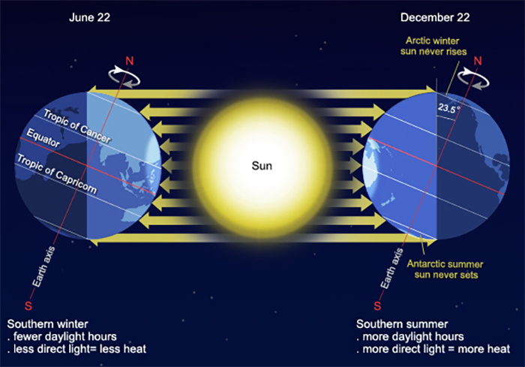
The most important thing is for Grade 4 students to understand that the earth is round, that it rotates once every 24 hours (causing day and night) and revolves in orbit around the Sun once every 365 ¼ days (causing the seasons). What is the evidence that the earth is round? Many, many things including: how shadows differ in different locations; how ships appear over the horizon; the fact that during lunar eclipses, the earth’s shadow is always a circle, which is not what you would expect if it was a plane. (See link under resources for more info).
Why do we have seasons in the temperate areas and not so much in the tropical areas? (Also, what tropical means…between the tropics of Cancer and Capricorn, which are the northern and southern limits of where the sun is every directly shining on the earth).
The tilt of the Earth's AXIS is the most important reason why seasons occur. We have hot summers and cold winters because of the tilt of the Earth's axis. The tilt of the Earth means the northern hemisphere will lean towards the Sun (Summer) or lean away from the Sun (Winter) 6 months later. Leaning towards the sun causes sunlight to hit the earth more directly, and therefore the heat absorbed is greater.
Understanding our solar system has helped us to understand seasons and tides. We can use tidal information to predict flooding along the Fraser River for example. We can use tidal patterns and infer from these patterns the impact that high and low tides have in different seasons. First Nations use knowledge of the seasons in all of their food gathering activities.
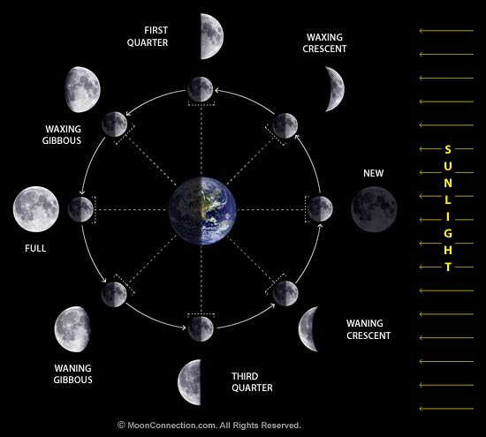
Grade 4’s need a good knowledge of how the Sun, moon and earth interact –students should be able to explain the phases of the moon and the reason for seasons. One important thing to notice is that exactly one half of the moon is always illuminated by the sun. ... So the basic explanation is that the lunar phases are created by changing angles (relative positions) of the earth, the moon and the sun, as the moon orbits the earth.
High tides and low tides are caused by the moon. The moon's gravitational pull generates something called the tidal force. The tidal force causes Earth—and its water—to bulge out on the side closest to the moon and the side farthest from the moon. These bulges of water are high tides.
As the Earth rotates, your region of Earth passes through both of these bulges each day. When you're in one of the bulges, you experience a high tide. When you're not in one of the bulges, you experience a low tide. This cycle of two high tides and two low tides occurs most days on most of the coastlines of the world. See video links in the resources below for more detail on how to explain this.
CURRICULAR COMPETENCIES
Questioning and predicting
Planning and conducting
Processing and analyzing data and information
Evaluating
Applying and innovating
Communicating

WHY IS IT IMPORTANT?
Seasons, weather and climate all relate to significant areas of our lives—such as growing food, playing outside, travel, etc. Knowing tides and how they work is important for sailors, navigators and fisherpeople. Being able to discuss and identify things in the night sky is a good connection to place, but also a universal connection to other people.
Space and the objects in space are significant in many parts of arts and entertainment.
It always impresses a date if you can identify a few constellations!
KEY VOCABULARY (include definitions coming soon)
SOME INQUIRY QUESTIONS
- How do seasons and tides affect living and non-living things?
- What changes are caused by the movements of Earth and the moon?
- Why does the moon look larger on the horizon?
What is meant by harvest moon? Hunter moon? Super moon? Blue moon?
- Could humans survive on the moon?
- How are the sun, earth and moon related to tides?
Why are there different high tides in different areas?
- What is a king tide? Where and when do they happen and how do they affect the lower mainland?
It might be good to have students look at the website http://curious.astro.cornell.edu/for-teachers , as it suggests many kinds of inquiries and places to look for information (since astronomy isn’t easily done by experiment alone).

SUGGESTED PROVOCATIONS/ACTIVITIES/EXPERIMENTS
Seasonal observations—have the students make observations about plants, animals, the sky, water, tides the air…whatever they are interested in over the seasons. This video reviews the seasons for them: https://www.youtube.com/watch?v=D6yQ8-M8rmU This video has some information about tides: https://www.youtube.com/watch?v=5ohDG7RqQ9I
Seasons lesson plan: https://www.keslerscience.com/seasons-lesson-plan-complete-science-lesson-using-5e-method-instruction/
Tree shadows…use this video to spark some conversation about what is happening with the sun and the length of the tree’s shadows: https://www.youtube.com/watch?v=SXTg-079UP8
Have students observe the moon over the course of a month keeping a journal (Sept, Oct or May, June are best). http://static.nsta.org/connections/elementaryschool/200809MoonJournal.pdf
Follow up by teaching moon phases with this cookie activity http://www.pawneeschools.com/vimages/shared/vnews/stories/4e6199b98dd88/PhasesoftheMoonCookieActivityFREE-1.pdf or this viewer http://www.scienceteachingjunkie.com/2013/03/clearest-way-to-teach-moon-phasesever.html or this fabulous model: https://www.youtube.com/watch?v=M3XrMw6iM0g
Use this NASA picture of the day to spark discussion (or find a list of celestial events, like this picture has): https://apod.nasa.gov/apod/ap180925.html
Try out this dance of the moon and oceans: https://www.lpi.usra.edu/education/explore/marvelMoon/activities/whatIf/dance/

CROSS-CURRICULAR CONNECTIONS
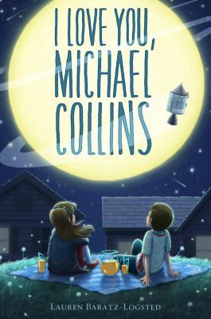
Poetry is one great place to find reference to astronomy. As the webpage, Ask an Astronomer says, “Poets have found inspiration in astronomy like many aspects of nature. Throughout history, poetry has included countless references to the beauty, rhythm, harmony, and chaos of the cosmos.
Astronomical objects and phenomena can be the subjected to personification or detailed natural description. The orbits of the planets and the Earths motion through space are often described by their clockwork cycles. The stars are filled with stories and shapes as every early civilization in history has created a unique cultural connection to the night sky.”

The same is true for other areas of the arts too. Try moon painting: https://www.youtube.com/watch?v=SB937wohehY&feature=youtu.be

Teaching Astronomy Through Art by Sharon Jeffus is also a good resource.

Literature: Especially for 2019, the 50th anniversary of the Moon Landing, the book I Love You, Michael Collins by Lauren Baratz-Logsted would be a great read while you are studying astronomy.
INDIGENOUS PERSPECTIVES
As Wilfred Buck, Manitoba Cree educator, writes: “All cultures on Mother Earth have their own understandings of the stars. No matter where one was located on Earth, all one has to do was look up into an evening sky and a myriad of stories can be revealed. As human beings made sense of their world and established a sense of belonging, stories were told and connections between people and the environment were established.”
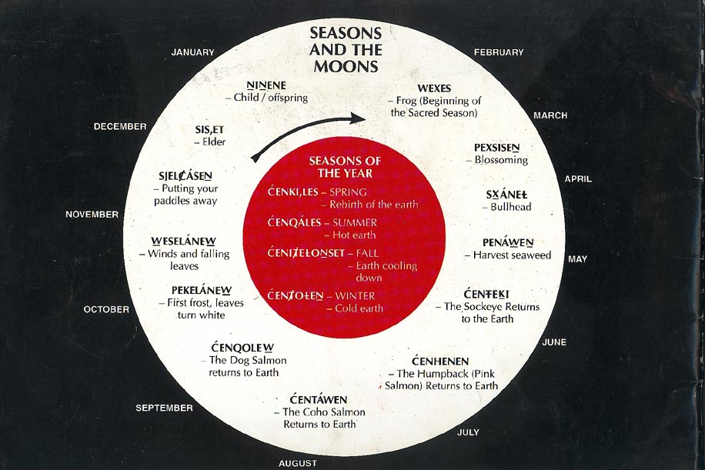
My Seasonal Rounds is an integrated Socials and Science Unit with many activities and resources: https://www.openschool.bc.ca/elementary/my_seasonal_round/teacher_area.html
First Nations star stories (not much Coast Salish, however): http://explorecuriocity.org/Explore/ArticleId/3545/sky-frogs-space-turtles-3545.aspx
This excellent Coast Salish resource, the 13 Moons of the Wsanec (Saanich), has good support that looks at the different cycles of the moon and the activities that are appropriate during that moon. The ultimate objective is to have students understand the relationship between each moon, the environment and First Nations activities, and relating it to their own lives.
https://www.slideshare.net/jessidildy/122-aboriginal-astronomy
RESOURCES
Field trip—to any beach area (ex Barnet Beach) to explore the tide and its changes. Put a stick at the tideline at the beginning of your visit and then observe every 30 min – 1 hour.
Field trip—MacMillan Space Centre has field trips catered for Gr 4’s. They will also bring an observatory to your schools if you can get funding.
This is a great place to first probe your own misconceptions then get some great lessons about the moon and also the seasons: http://www.learner.org/teacherslab/pup/index.html
Evidence that the earth is round (students can gather some of this themselves, it is a great discussion and reasoning topic):
https://www.popsci.com/10-ways-you-can-prove-earth-is-round#page-3
Eclipse on-line interactive activity: http://highered.mheducation.com/sites/007299181x/student_view0/chapter9/eclipse_interactive.html#
The Royal Astronomical Society of Canada has a local branch with tons of resources: https://rasc-vancouver.com/resources-2/
Starry Nights, field trips, an opportunity to win a free telescope and other events/resources at SFU’s Trottier Observatory: https://www.sfu.ca/science/alumni-community/trottierobservatory.html
Free computer planetarium to demo many concepts: http://stellarium.org/

SD71 has this resource (includes French) https://portal.sd71.bc.ca/group/wyhzgr4/earthspace/grade4/Pages/gr4earthteacher.aspx

