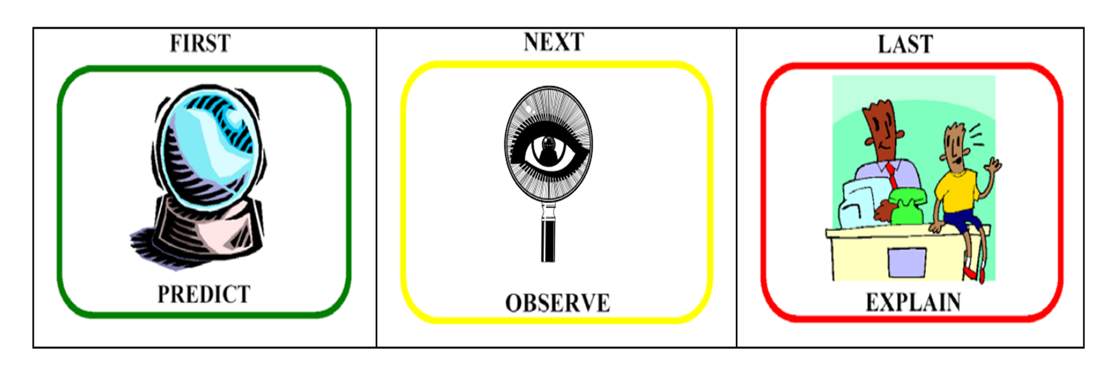

|  |  |  |  |
| --- | --- | --- | --- |
| **CONVECTION** |  |  |  |
| **RADIATION** |  |  |  |
| **CONDUCTION** |  |  |  |