SCIENCE INVESTIGATION
1. Predict  What do you think will happen…if…then… Include a well-labelled diagram. | 4. Explain  Point form reasons for the results…compare to your prediction…explain why they are the same or different.
2. Explain  A point-form explanation of WHY you made the prediction above | 3. Observe  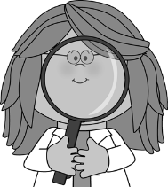  Do your experiment/watch the demonstration. What information should you collect and record?

