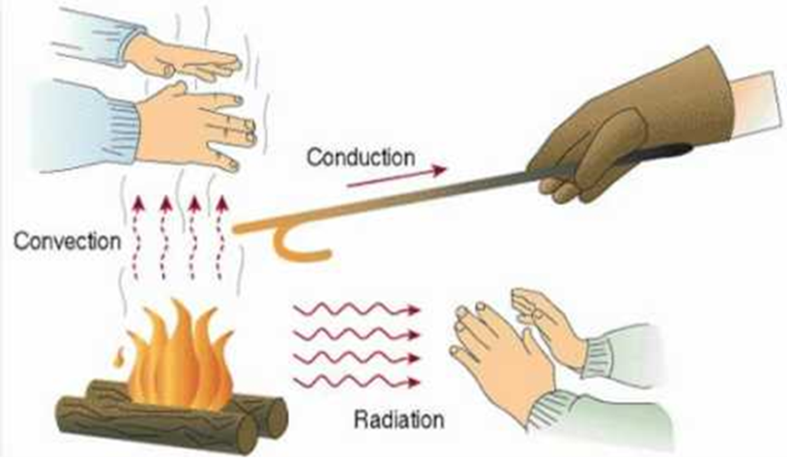
What is your design?

Time | Temperature
Start
1 min
2 min
3 min
4 min
5 min
6 min
7 min
8 min
9 min
10 min
HYPOTHESIS: Which material will be the best insulator?

PREDICTION: How will you know?

RESULT: What happened? Did the result support your hypothesis?

What questions do you have about insulators after doing this activity?

How would you improve your container next time?

