GRADE 7 ENERGY SUMMARY
Grade 7 Learning Standards (From BCEd Curriculum)
Electricity:
- is generated in different ways
- ways of generating electricity including the use of wind, water, coal, geothermal, and solar energy
- with different environmental impacts
Electromagnetism:
- the electromagnetic force is responsible for both electricity and magnetism
- moving or changing a magnetic field relative to a wire produces electric current (e.g., electricity generation by a turbine)
- an electric current passing through a wire produces a magnetic field (e.g., constructing a simple electromagnet using a wire, iron nail and battery)

WHAT DO Grade 7’s need to know about Electricity and Magnetism?
The electromagnet force, along with other forces such as gravity and friction, is one of the foundational forces governing the universe. In today’s world, the use of electricity is an integral part of our daily lives (light, heat, computers, TV, and other devices).
Grade 7 students will be moving on to high school in grade 8. Understanding electricity and magnetism allows students to explore electives (and possible careers) based on these fundamental forces.
This science topic can be a pathway to careers in the trades. Below is a suggested content sequence for teaching the topics in this unit.

Magnetism

The first recording of magnetism was made by ancient Greek and Chinese scientists who discovered that certain minerals could attract iron and also that when suspended from a string, would always line up pointing in the same direction. These rocks became known as lodestones, and were used as the first directional compasses because they would always point north.

The three main metals that are magnetic are iron, nickel and cobalt. Magnetism is a property of the electrons in the atoms of these substances. An electron spins on its axis, producing a magnetic field. If it spins in one direction, the north pole will be on top and the south pole on bottom. And if it spins in the opposite direction, the poles will be reversed. In atoms containing many electrons, most of the electrons will pair up, with their spins opposite each other, producing magnetic fields that cancel each other out. However, in magnetic metals, like iron, many of the electrons remain unpaired, spinning in the same direction, and giving the atoms magnetic properties.

Magnetic materials have a north and south pole to them (or they should be more accurately called the north-seeking pole, as this will point north, and the south-seeking pole. If you break a magnet in half, it will become two magnets, each with a N and S pole. This will happen no matter how small you break the pieces. Magnetic fields are 3 dimensional around the magnet, and can be visualized with iron filings.

Static Electricity

Sometimes when two different materials come into close contact, for example, felt rubbing against a balloon or two air masses in a storm cloud, electrons may be transferred from one material to the other. When this happens, one material ends up with an excess of electrons and becomes negatively charged, while the other ends up with a deficiency of electrons and becomes positively charged. This accumulation of imbalanced charges on objects results in the phenomena we commonly refer to as static electricity. Static electricity is the build up of charge in one place. Static cling in laundry and lightning are two examples of static charge. (You may need to review the parts of the atom here).

Direct Current

Current electricity occurs as a result of the movement of electrons through conductive materials. Electric circuits need a SOURCE of electricity (generally a battery); a conductor (usually wire made of copper or an alloy of nickel and chromium) and a device or load (light, motor, resistor). Circuits may also include switches (to control flow) and instruments to measure the amount of flow (current—measured by an ammeter) or the force on the electrons (voltage—measured by a volt-meter).
Symbols for electrical circuits:
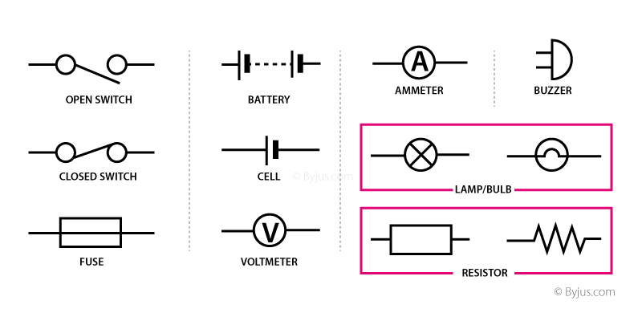
Simple circuits may be series, where there is only one path for electrons:

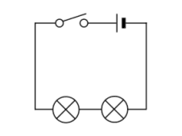

Or parallel, where there are two or more paths:

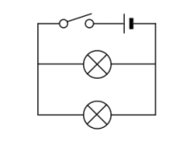

Using batteries gives us direct current, where the electricity flows in one direction.

Alternating current
Household electricity runs on alternating current, which means the current reverses flow. In Canada, most of our household circuits run on 120 V power that alternates direction 60 times per second (60 hz).

This alternating current is produced by a variety of generators. In BC, most of the electricity is generated using hydroelectricity.

Generators use magnets and wire to move electrons using some other force of energy.
Electromagnets use current and coils of wire to generate a magnetic field.
CURRICULAR COMPETENCIES
Questioning and predicting—can students generate their own questions? Are they testable by experimentation?
Planning and conducting—can they design and plan an experiment? Can they control variables and change one thing at a time?
Processing and analyzing data and information—can they record data and see patterns? Can they find research and determine the bias and point-of-view of the research?
Evaluating—can they draw conclusions from their data and the data from other researchers?
Applying and innovating—can they improve their design? Can they critique the designs of others to help improve them?
Communicating—can they talk, write and draw about their learning in increasingly sophisticated ways?

WHY IS IT IMPORTANT?
We use electricity in every part of your life. You heart is both an electrical device and a pump. Most of our food is preserved or cooked using electricity (in a fridge/stove/microwave, toaster). Rooms are lit with electricity. Computers, phones, and headphones use this source of power. How are the different forms of electricity created or generated, transmitted, and used?
KEY VOCABULARY
Electron- A basic subatomic particle found in all atoms, electrons carry electricity by flowing from one atom to the next in a conductive material.
Battery- A device that stores and produces electricity from chemical cells.
Charge- This is a basic characteristic of matter that is based on the balance of protons (positive charge) and electrons (negative charge). The standard unit for electric charge is the coulomb.
Static- The build up of an electric charge on the surface of an object. The charge remains in one area rather than flowing to another area.
Current- Electric current is the flow of electric charge through a material. The standard unit for electric current is the ampere
Circuit- An electric circuit is a collection of electronic components connected by a conductive wire that allows for electric current to flow.
Magnet- a device that attracts iron and produces lines of force
Pole-the ends of the magnet where the field is the strongest
Field- The magnetic influence produced by electric currents and magnetic materials.
Conductor- A material that allows the free flow of electric charge. Copper wiring is the most widely used electrical conductor
Insulator- A material in which an electronic charge does not flow freely and does not conduct the flow of electric current
Source-Where electricity is produced.
Load-A device in a circuit that uses electricity
Electromagnet- A device that creates electricity from the interaction between magnetic fields and electric currents.
Motor-A device that converts electricity into mechanical energy.
Generator-A device that converts other forms of energy (via mechanical) into electrical energy
AC-- An electric current that reverses direction on a periodic basis. It is widely used to transport power on power lines
DC- A type of current that only flows in one direction (unlike AC which periodically reverses direction).

SOME INQUIRY QUESTIONS
- How is electricity generated?
- What is the relationship between electricity and magnetism?
- What happens if the electricity goes off in our community and stays off for two days, one week, or longer? How might our response to this situation differ from other countries around the world?
- What creatures use magnetic fields to navigate?
- What creatures create their own electric power? (explore electric eels and bioluminescence)
- What would happen if the Earth’s magnetic field changed? Is that going to happen soon?
- What kinds of careers use an understanding of electromagnetic forces?
- Can I build a motor?
- Can I build a wind, solar or other generator?
SUGGESTED PROVOCATIONS/ACTIVITIES/EXPERIMENTS
Magnets can be played with to determine south and north poles, and to try out different materials for their magnetic field. Magnetic fields can be visualized by placing a magnet (use different types) under an acetate sheet and sprinkling iron filings on top. Objects made of magnetic metals may become temporarily magnetized by stroking them along a magnet in one direction.
Static electricity can be demonstrated and explored using many common objects. Balloons and hair are a good example. Students can try different combinations of fabric and plastic or other objects to see if they can build up a static charge. This is best accomplished on a dry day.
Students can build simple circuits using kits (can be obtained by going to BC Hydro seminar, or by borrowing from t he DLRC). You can also DIY by using Squishy Circuits (http://squishycircuits.com/recipes/) and some LED bulbs from old Xmas lights. Snap Circuits are kits that can be used to make circuits. You can also do on-line circuit simulations from pHet https://phet.colorado.edu/en/simulation/circuit-construction-kit-dc-virtual-lab
Science World has a number of projects that students can do to build simple circuits for games: https://www.scienceworld.ca/resources/units/current-electricity

Students can make a simple electromagnet and experiment with the strength of the magnet depending on the number of coils of wire and the strength/number of batteries.

Students can investigate non-polluting ways to generate electricity. Hydro, solar, wind and biofuel are all renewable resources. Students can even build model generators. http://www.re-energy.ca/docs/wind-turbine-cp.pdf

CROSS-CURRICULAR CONNECTIONS
Social studies—this is an excellent place to discuss the pros and cons of various forms of energy. An exploration of all the stakeholders in things like the Kinder Morgan. fracking or Site C debates would be useful, and could incorporate inquiries about all the energy transformations involved. Geographic concerns could also be explored by looking at possibilities for solar, hydro, wind and wave energy as clean technologies.
Art—how is electricity involved in art?
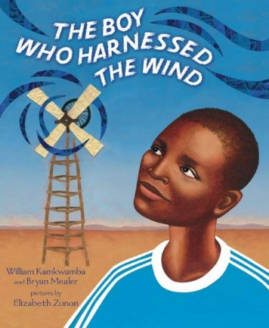
Books—there are good biographies of some early inventors of electricity. Benjamin Franklin, Nicolai Tesla and some students may be interested in more modern inventors like Elon Musk. A great novel study for your class is The Boy Who Harnessed the Wind.
ADST—have students build and design their own games or build and design their own electricity generators.
INDIGENOUS PERSPECTIVES
Many Indigenous communities are leading the way in developing alternative energy projects:
Explore how renewable energies are being used to power First Nations communities.
http://www.cbc.ca/news/indigenous/indigenous-owned-company-renewable-energy-first-nations-1.4066524

Also explore how major energy megaprojects are affecting First Nations.
https://globalnews.ca/news/1728749/everything-you-need-to-know-about-the-site-c-dam/

RESOURCES
Study jams has a number of videos on this topic: http://studyjams.scholastic.com/studyjams/jams/science/energy-light-sound/electricity.htm
How magnetism works: https://www.youtube.com/watch?v=MZtTVsIOA9c
National Geographic Explorer magazine has a great issue on this…May 2016. Articles are written at 4 different reading levels.
Some static electricity lessons: http://sciencenetlinks.com/lessons/static-electricity-2/
References:
The Physics Hypertextbook: https://physics.info
SD71 Science Info (this is a great source of info for all science areas and includes some resources in French):
https://portal.sd71.bc.ca/group/wyhzgr4/physics/grade7/Pages/Gr7physicsteacher.aspx

