Math/Science Staff Development
Elementary Opportunities
Learning Teams
Building STEAM—these sessions will help Gr 6-9 teachers design experimental units/lessons for their classes with the curricular competencies in mind. The fall group will meet Oct 11 after school/Oct 25 for ½ day/Dec 3 after school. We are hoping that schools that want to participate will send 2-3 teachers or 2 teachers and an admin. This session will be repeated in the spring. E-mail Donna.Morgan@burnabyschools.ca if you are interested in being part of this learning team.
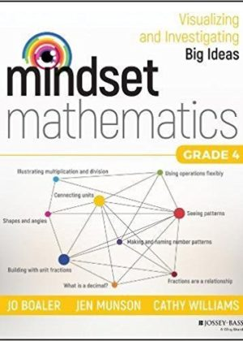
Closing the GAPS—Grade 4 Math and LSS. This team will focus on in classroom support and other interventions for Grade 4 math teachers. Ideally, schools will send 2-3 teachers in Gr 4 or Gr 4/combined classes and an LSS staff. We will use Jo Boaler’s resource to dive into making math engaging, dynamic and successful for all our learners. E-mail Donna.Morgan@burnabyschools.ca if you are interested in being part of this learning team.
Science Fair/Celebration—Would you like to lead your students through project development culminating in a school based then district Science Fair/Celebration? This can help you achieve most of the curricular competencies in Science, and is available to teachers in Grades K-7. Sign up on the staff development portal.
Professional Development Sessions
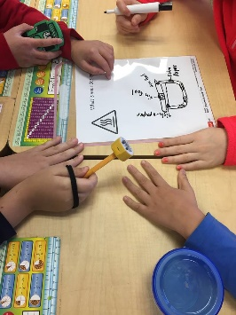
Science Through an Inquiry Lens

These after school Pro-D sessions will provide a look into the Elementary Science Curricular threads, how student understanding is built up, and what types of activities you can do to facilitate structured, controlled, guided and free inquiry. We will look at ways to incorporate Indigenous perspectives into science lessons, related books and stories, and how to get outside.

Hand-outs with links and suggestions for resources will be given out. A light supper will be served. Sign up for as many as you like! They will take place in the SuperLabs at Burnaby Central, Moscrop and Alpha Secondary Schools. Book your spot on the staff development calendar after June 26. https://learn.sd41.bc.ca/events-calendar
Math 101—An intensive series involving 3 afterschool dinner sessions and one half-day with Carole Fullerton (on the Nov 23 Pro-D day). For those teachers who would like to deepen their understanding of the math curriculum and how children learn. One set will be for Primary Teachers, focusing on building number sense, hands on activities, building and assessing skills. The other set is for Intermediate teachers, who would like to strengthen their students’ understanding by looking for creative activities and routines in mathematics. Sign up at the staff development calendar.
Book Clubs
Number Talks—choose the book appropriate to your level, and join a 3 session book club to learn about and implement a number talk routine in your K-12 classroom. Sign up at the staff development calendar.
Mathematical Mindsets—Jo Boaler’s book to transform our thinking about math is a game changer for many teachers who have avoided math or who worry about their own confidence in the curriculum. Join a book club to explore Jo’s ideas and feel great about math and about how ALL our students CAN learn math. Sign up at the staff development calendar.
Special Events
Math Games Night—now that we are moving away from homework, what can parents do with their kids to practice numeracy? Many games have fun mathematical reasoning components. Why not put on a parent games night at your school? I will work with you to set up the night, and I will bring the games and hand-outs that include games parents can take home. E-mail Donna.Morgan@burnabyschools.ca to set it up.
Talk With Our Kids About Money: I’m looking for a school to pilot a session for parents and teachers to tie in with TWOKAM day in April. A good approach to the new financial literacy topics.
Coming in Spring 2019:
Using Mathology: (Pearson little books and activity sets) in English and French.
Assessment in Science (3 sessions in January/Feb). These will be posted on the staff development calendar in December.
Carole Fullerton: save a ½ day of Pro-Growth for Carole Fullerton’s session May 8.
Argument Driven Inquiry Book Club: a session for Gr 5-12 teachers to use the ADI book and develop science lessons and labs that get students to dive into their scientific reasoning.
Be the Math Teacher You Wish You’d Had Book Club: this was so popular we will run it again in spring 2019.
Science and Literacy Learning Team: explore how fiction and non-fiction books can be combined with your science curriculum to enrich learning and engage students. Open to K-12 teachers.

