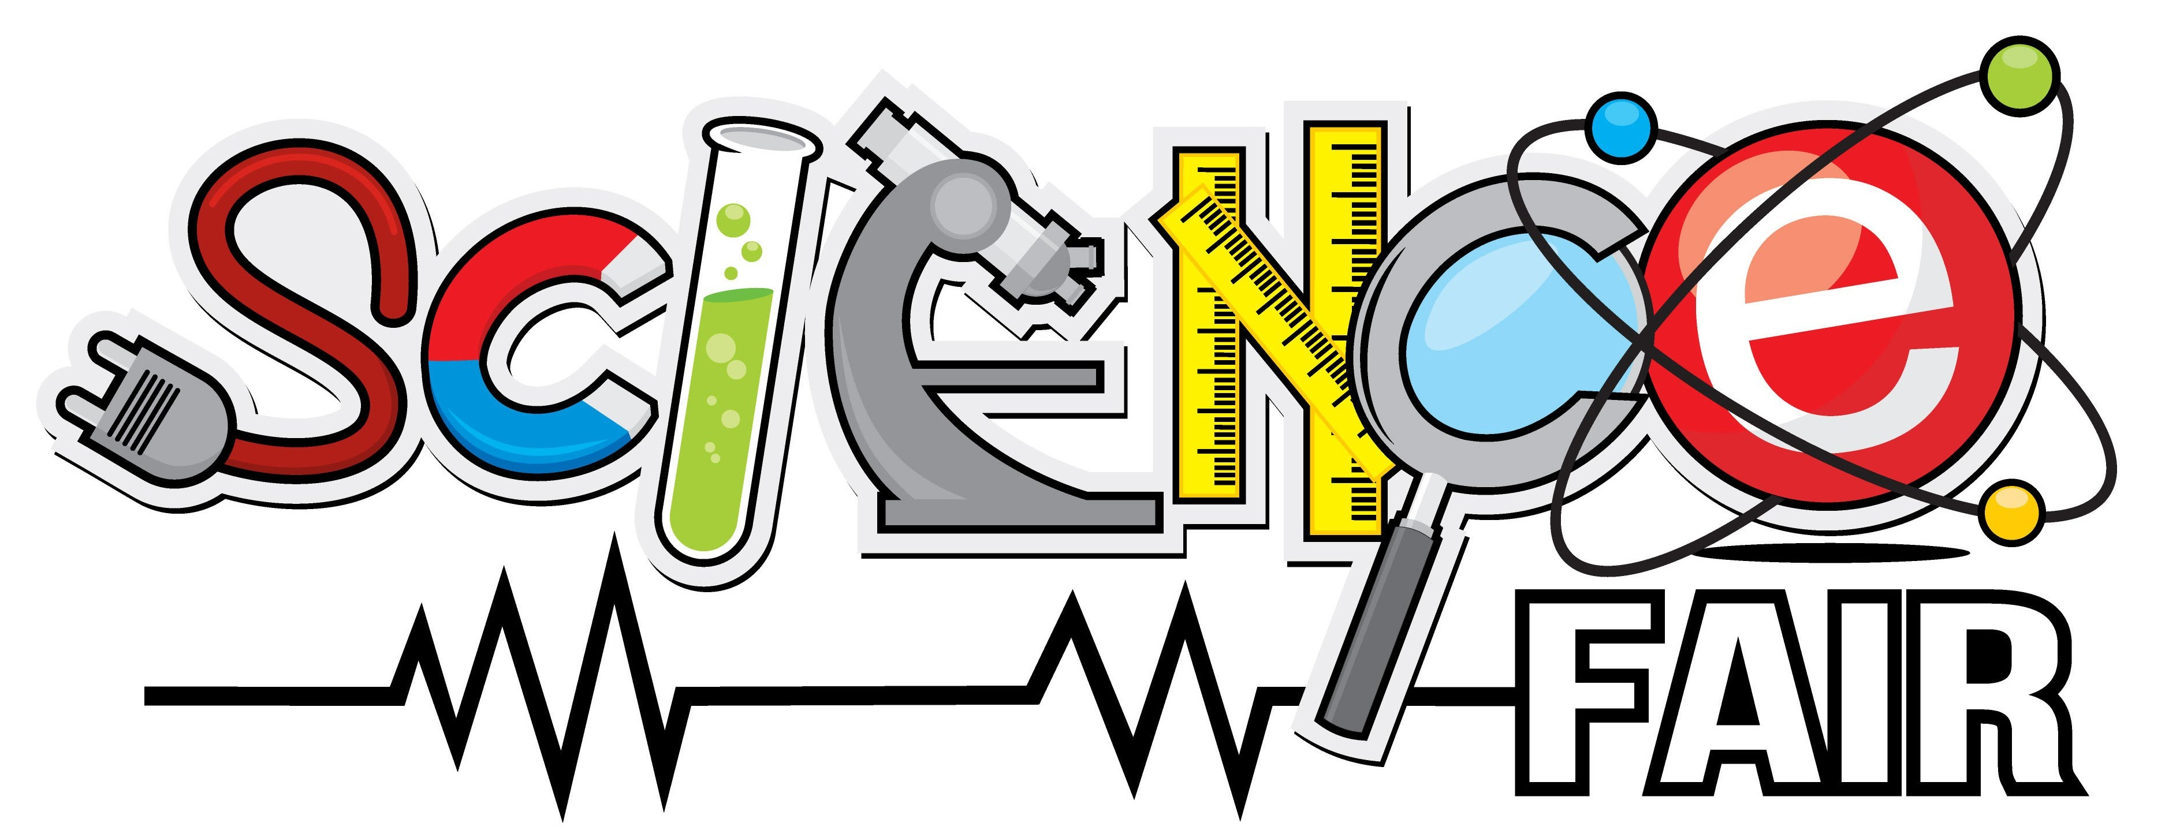Science Fair/Celebration

What is a Science Fair/Celebration?
The Science Fair is your opportunity to do an independent project into any topic in science that you choose. You will carry out the investigation and complete a report and display of your project. On [INSERT DATE] the in-class Science Fair presentations will take place. The results of your investigation will be displayed and assessed.

What kind of project can I do?
You can pick a topic from any branch of science from life sciences, matter, force and motion, energy, earth and space science, engineering, inventions, environmental science, and so on. We will find resources through the school and public library and from on-line science sites.
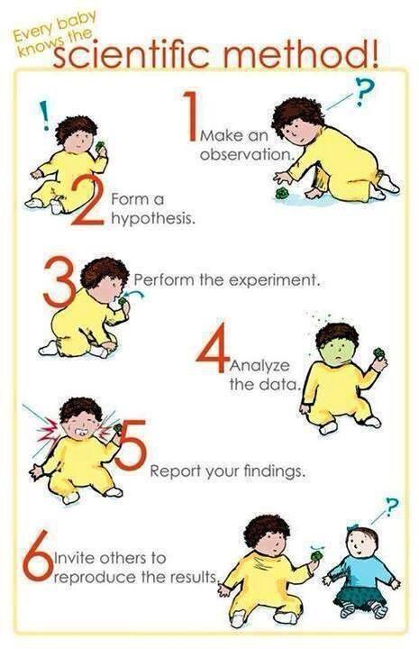
The main purpose of the science fair is for you to learn and practice scientific inquiry, how to design an experiment, and using scientific method.

The steps for a science fair are:

- Choose a question
- Research your question.
- Design an experiment to test your question.
- Carry out your experiment.
- Record your results and obeservations.
- Make a conclusion.

All of this will be recorded in a diary or log, which will be checked by your teacher r. You will then write up the results in a final report, discuss your findings, make a conclusion and make a display that can be set up on a table on Science Fair day. Be prepared to talk and answer questions about your project.

Can I work with someone else?
Science fair projects may be done individually or in pairs.

What kind of background research should I do?
It is important that you have plenty of background information on your topic. This will allow you to design a good investigation and to answer any questions asked by your audience. As well, you need to write a report on your experiment and include a bibliography (list of reference books). [You are expected to have at least 7 different references from at least three different types of source (types include: encyclopaedia, periodicals, internet, books, personal interviews, television, newspapers).]

Levels of Experiments

Basic Experiment: Answer a question by designing an experiment that tests one thing [variable factors]. For example: study the amount of rusting of metals (dependent variable) under different temperatures (independent variables).

More Challenging experiment: Increase the number of variables. For example: study the amount of rusting of metals (dependent variable) under different temperatures and humidity levels (independent variables).

What makes a good question? A question is a good question if:

- We will have to think hard to answer it
- We won’t find the answer just by looking at a website
- There is no one “correct” answer but many possible answers
- We will have to have good reasons for our answer
- We are really curious about it and want to find out more
- We haven’t really thought about this before
- We feel strongly about this question
- It makes us think of more questions


What makes a good experiment? An experiment is good if:

- We test the question being asked, and only the question being asked
- We get clear results
- We have controls to compare results
- We get results that can be measured or described
- We have done it more than once to check the results (multiple trials)
- Anybody else can easily repeat it

The Finished Product
The finished product of your science fair includes a journal, a report and a display.

The Journal
Your journal will be a detailed record of work on your [Science Fair/Celebration project]. This records your research and experimentation. You will be asked to hand in your log book to your science teacher frequently between the time the science fair is assigned and the day of the fair. Teachers will comment in and initial your book.

The Report
Your report should be approximately [500 words, double-spaced on three pages]. Graphs and charts can be added to illustrate the main point of your report. The parts of the report are:
Introduction: Why did you choose your topic? What did you learn during your background research?
[Hypothesis: An if/then statement about what you are investigating./
Question: What question are you investigating?]*depending on grade level
Procedure: How did you carry out your investigation?
Prediction: What will you expect the results to be if your hypothesis is correct?
Results: Show your results, using tables and diagrams where possible.
Discussion &
Applications: What do your results mean? How could they be used and applied in the world?
Conclusions: Did your work support your hypothesis? Why or why not?
[Bibliography: Your references written up in an approved format.]

The Display
Your exhibit should look like the one below. 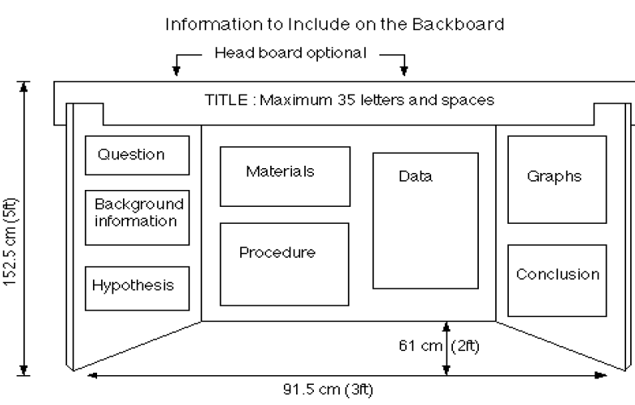

Timeline

To be determined by teacher

Suggested Lessons/Timeline
Introductory Lesson
Library/Computer Lab Class for Exploration
Idea Development Hand Out and Research Plan
Present Ideas to Class
Library/Computer Lab Class (or 2) for Research
Experiment Conducted
Rough draft of written report
Work on Display
Practice presentation

