Science Fair: Idea Development and Research Plan (Due:---)

Name: _________________________________________ Name: _________________________________________

Question ideas: Brainstorm 3 possible good questions that might be answered through experimentation: e.g. “What is the most effective way grow plants?”
From the list of question ideas you generated above, select one question that you want to develop further. Circle that question.

Variables (factors) that might influence the question being studied: Refer to the question you circled above. Brainstorm as many factors as you can that might be explored in your question. e.g. “Type of soil”, “amount of water”, “Size of the container”, “light source”, “amount of fertilizer”, “brightness of the light”, etc, etc, etc.

In one experiment, the effect of only one factor (variable) should be studied at a time. All other factors must be controlled (kept constant). From the list of variables you generated in the previous section select and circle one variable to investigate to your research question.

Independent and Dependent Variables
An independent variable is the factor the SCIENTIST changes.
A dependent variable is the factor the SCIENTIST measures after changing the independent variable.
For example:
How does the amount of fertilizer affect plant growth (height)?
The amount of fertilizer is CHANGED by the SCIENTIST and the plant growth is MEASURED. Therefore, the amount of fertilizer is the INDEPENDENT variable and the plant growth is the DEPENDENT variable.
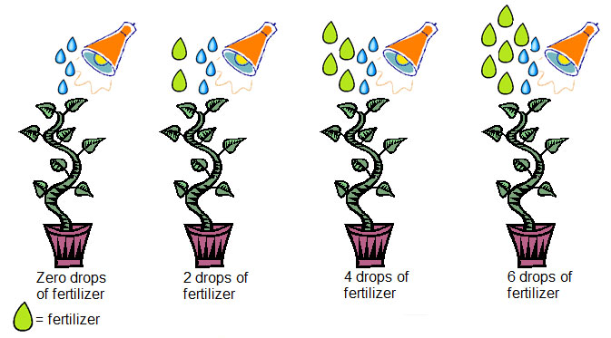
Notice that the only change is to the amount of fertilizer. The amount of water and the type of pot and light STAY THE SAME>

Also notice that the first pot has NO FERTILIZER. This is called the CONTROL. It is the one with NO TREATMENT to compare your other plants to.

Research Plan for Your Science Fair: Controlled Experiment

- In one or two sentences, state your Question:
_______________________________________________________________________________________________________________
_______________________________________________________________________________________________________________
_______________________________________________________________________________________________________________

- What is the Independent Variable in your investigation? (What will YOU change?)
_______________________________________________________________________________________________________________

C) What is the Dependent Variable in your investigation? (What will you measure or observe)
_______________________________________________________________________________________________________________

- What is your HYPOTHESIS or BEST GUESS for what how your independent variable affects your dependent variable?
________________________________________________________________________________________________________________

- List the factors that you need to keep the same:
_______________________________________________________________________________________________________________
_______________________________________________________________________________________________________________
_______________________________________________________________________________________________________________

E) Prediction: What do you think the results might be? Explain your reasons (why do you think the results might turn out this way?)
_______________________________________________________________________________________________________________
_______________________________________________________________________________________________________________
_______________________________________________________________________________________________________________

F) Measurement and Observations:
What measurements will you make?

What other observations will you make?

G) How will you show your results? (data tables, charts, graphs, diagrams, photos, etc etc etc)

H) How will you set up the experiment in order to ensure that your results are consistent and accurate?

I) Draw a diagram of your experiment.

J) What equipment will you need? Will you need to borrow any equipment from the school, if so, what?

