Ice Cream Scoop
This is a really nice task as it is open to everyone, can be solved in different ways and can also extend to work in combinatorics – a nice way of organizing counting. Ask students to work on this task in groups, and to display their results on posters. Often we name students’ different approaches and strategies.

Material
Pencils and Paper
Manipulatives

Task Instruction
In shops with lots of ice-cream flavors there are many different flavor combinations, even with only a 2-scoop cone. With 1 ice-cream flavor there is 1 kind of 2-scoop ice cream, but with 2 flavors there are 3 possible combinations (eg vanilla/vanilla, chocolate/chocolate, and vanilla/chocolate).
- How many kinds of 2-scoop cones are there with 3 flavors?
- How many kinds of 2-scoop cones are there with 4 flavors?
- What about “n” flavors?
- Create a poster that represents your group’s thinking.

LINK: https://www.youcubed.org/tasks/ice-cream-scoop/

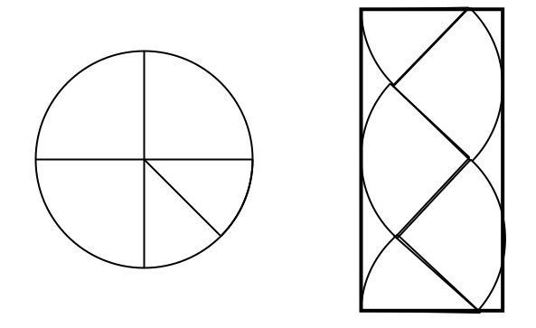
Finding Pi
D
A

Material
- Paper
- Compass/something to make a circle with a radius between 2 and 4 inches (or use templates provided)
C
BA
- Scissors
- Glue

Task Instruction
- Construct (or cut out) a circle with a radius of 2 – 4 inches
- Fold the circle into quarters and cut along the folds
- Cut one of the quarters into eighths, two equal parts
- Glue the pieces onto a piece of paper and draw the rectangle (as figure above)
- The rectangle, ABCD has approximately the same area as the circle.
- Calculate the area of rectangle ABCD
- Construct (or cut out) another circle congruent to your first circle
- Fold the circle into eighths, or eight equal sectors
- Fit the circle pieces into a rectangle
- Calculate the approximate are by determining the area of the rectangle.
- Repeat the steps for a congruent circle cut into 16 sectors.
- Which estimate do you think is more accurate? Why?
Going Further
- AB is approximately half of the circumference, 2πr, why? This means AB = πr
- Why does BC = r?
- The area of rectangle ABCD is
Area ABCD = AB x BC = πr x r = πr²

LINK: https://www.youcubed.org/tasks/finding-pi/

Graphing Stories
This task can be done with a range of ages to practice graphing and then discuss and evaluate them.

Material
Pencils and Graph paper hand-out

Task Instruction
Give students each a hand out. Show the video from graphing stories (http://graphingstories.com/). Have them graph the stories. Then share and discuss the graphs.

Ramps

Ramps can provide inquiries for students from K-12. Whether you use the ramp kits available at the DLRC or just use rulers with marbles, there are many inquiries to do.

Materials

Ramps and balls or carts or trucks or even an assortment of other objects from the classroom.
Roller Coasters book set is available from DLRC (From Picture Perfect Science)

Task Instruction

Look at the ramp and ball provided. What is the relationship between the height/angle/material of the ramp and the speed or distance of the ball? How can students explore and then reflect with this equipment?
See over for an example of an inquiry about parking on a hill.

LINKS: http://static.nsta.org/files/PB281Xweb2.pdf

Thermal Energy
Thermal energy is HEAT. Content ideas for this topic include: what is heat? How does heat move? What is conduction, convection and radiation? How can we prevent heat from moving?

Materials(to be developed into a DLRC kit by January)
Cooking thermometers
Plastic containers
Insulating materials
Ice cubes
Hand warmers (these are non-toxic)
Special metal plates

Task Instruction
Plates: place an ice cube on each of the plates. PREDICT. Then OBSERVE. EXPLAIN why you think those results happened.
Thermometers: Take the temperature of your clasped hands. Then rub your hands together for 1 minute, take the temperature again. What does this tell us about heat?

Use the digital thermometers to explore what happens to the material in the hand warmers. Open a package up and shake the inner bag. Cut open the inner bag and put materials in a cup. Measure the temperature over time.

Insulators: take a look at the materials provided for insulation (wool and cat-tail fluff). How might you use the containers and the thermometers to design and test an insulation system? FIRST NATIONS CONNECTION: These two materials were used by First Nations as insulation.

Links: http://blogs.sd38.bc.ca/sd38mathandscience/2016/01/23/grade-3-science-thermal-energy/

Cabbage Juice Indicator

A simple solution of cabbage juice can be used as a great natural, non-toxic acid/base indicator.

Materials

Cabbage juice (see link below for instructions)
Various household chemicals
A known acid and a known base
SAFETY GLASSES

Task Instruction

Put on the safety goggles. Pour a half cup of the cabbage juice into the little shot cups provided. Add a drop or two the known acid or base to the container. Test the unknown substances. What might you test in the environment with these indicators? Could you develop your own acidity (pH) scale?
Further Inquiries: What other materials can be used to detect acidity? Are there any Indigenous plants that do so?

LINK: https://www.stevespanglerscience.com/lab/experiments/red-cabbage-chemistry/

