Ice Cream Scoop
This is a really nice task as it is open to everyone, can be solved in different ways and can also extend to work in combinatorics – a nice way of organizing counting. Ask students to work on this task in groups, and to display their results on posters. Often we name students’ different approaches and strategies.

Material
Pencils and Paper
Manipulatives

Task Instruction
In shops with lots of ice-cream flavors there are many different flavor combinations, even with only a 2-scoop cone. With 1 ice-cream flavor there is 1 kind of 2-scoop ice cream, but with 2 flavors there are 3 possible combinations (eg vanilla/vanilla, chocolate/chocolate, and vanilla/chocolate).
- How many kinds of 2-scoop cones are there with 3 flavors?
- How many kinds of 2-scoop cones are there with 3 flavors?
- What about “n” flavors?
- Create a poster that represents your group’s thinking.

LINK:

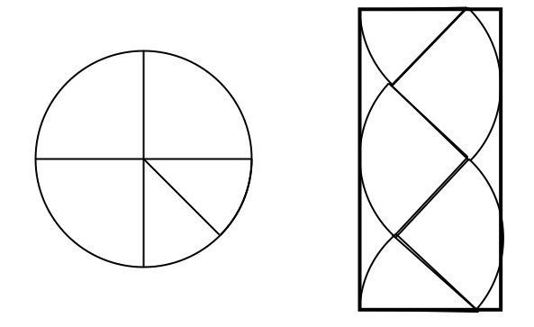
Finding Pi
D
A

Material
- Paper
- Compass/something to make a circle with a radius between 2 and 4 inches (or use templates provided)
C
BA
- Scissors
- Glue

Task Instruction
- Construct (or cut out) a circle with a radius of 2 – 4 inches
- Fold the circle into quarters and cut along the folds
- Cut one of the quarters into eighths, two equal parts
- Glue the pieces onto a piece of paper and draw the rectangle (as figure above)
- The rectangle, ABCD has approximately the same area as the circle.
- Calculate the area of rectangle ABCD
- Construct (or cut out) another circle congruent to your first circle
- Fold the circle into eighths, or eight equal sectors
- Fit the circle pieces into a rectangle
- Calculate the approximate are by determining the area of the rectangle.
- Repeat the steps for a congruent circle cut into 16 sectors.
- Which estimate do you think is more accurate? Why?
Going Further
- AB is approximately half of the circumference, 2πr, why? This means AB = πr
- Why does BC = r?
- The area of rectangle ABCD is
Area ABCD = AB x BC = πr x r = πr²

Graphing Stories
This task can be done with a range of ages to practice graphing and then discuss and evaluate them.

Material
Pencils and Graph paper hand-out

Task Instruction
Give students each a hand out. Show the video from graphing stories (http://graphingstories.com/). Have them graph the stories. Then share and discuss the graphs.

Ramps

Ramps can provide inquiries for students from K-12. Whether you use the ramp kits available at the DLRC or just use rulers with marbles, there are many inquiries to do.

Materials

Ramps and balls or carts or trucks or even an assortment of other objects from the classroom.
Roller Coasters (From Picture Perfect Science)

Task Instruction

Look at the ramp and ball provided. What is the relationship between the height/angle/material of the ramp and the speed or distance of the ball? How can students explore and then reflect with this equipment?

Woodbugs

Getting outside is a great way to study biology. These little creatures are easy to find and maintain (see link), and can be picked up anywhere you can lift up a paver or a log or a piece of damp cardboard.

Materials
Woodbugs
Choice chambers (plastic trays or petri dishes)
Materials to alter the conditions of the trays (water, light, cardboard, salt, sand….etc)

Task Instruction

Construct a choice in the choice chambers. Place 5 or so woodbugs (gently, they are living and we want to free them outside after) in the middle. What conditions do they like?

LINKS:
http://www.ingridscience.ca/node/68

Cabbage Juice Indicator

A simple solution of cabbage juice can be used as a great natural, non-toxic acid/base indicator.

Materials

Cabbage juice (see link below for instructions)
Various household chemicals
A known acid and a known base
SAFETY GLASSES

Task Instruction

Put on the safety goggles. Pour a half cup of the cabbage juice into the little shot cups provided. Add a little of the known acid or base to the container. Test the unknown substances.

LINK: https://www.stevespanglerscience.com/lab/experiments/red-cabbage-chemistry/

Simple Circuits and Pin Hole

This very simple set of electrical materials from BC Hydro can be used to explore circuits and light (using the pin hole plate)

Materials

Batteries and holders
Wires with alligator clips
Bulbs (from recycled fairy lights)
Plate with holes

Task Instruction

Create circuits using the materials.

OR

Use a plate with a pinhole to project images onto a white background. What happens with 1 vs. 2 vs. 3 lights? How are the images created? What happens to the image as you move the pinhole or the screen?

https://schools.bchydro.com/

Here is a bit more sophisticated take on pinhole viewing:
https://funsizephysics.com/use-light-turn-world-upside/

