Slinky Drop

Intermediate Science

- Force (Gravity, Tension, Newton’s Laws)

- Energy transfer (potential to kinetic) as slinky drops

Videos listed below can be found at the following link:

http://blogs.sd41.bc.ca/science/youtube-videos/

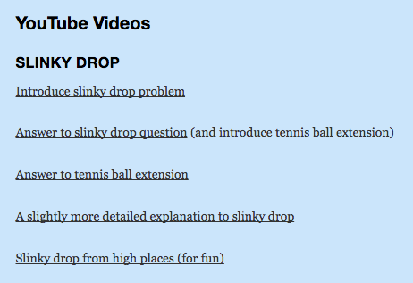

1) Show video: ‘Introduce slinky drop problem’

- Will bottom end fall first?

- Will top end fall first?

- Will both ends fall together?

- Will ends approach each other and meet in the middle?

2) After the video introduces the problem,

a) have each student predict how the slinky will drop – record their prediction
(may want to use PEOE template provided)

b) in groups of 2 or 3, have students drop a slinky and do their best to observe and see what happened
- this will be difficult as it drops very quickly
- if cameras are available, you can record the drop and see if the recording is helpful
- have each student record their observation

note: to help protect the slinky from damage:
i) drop slinky so the bottom is approx. 30 cm (or less) above the floor
ii) hold the top end so approximately 1 cm of the top is compressed together

c) Show video: ‘Answer to slinky drop problem’

- have students reflect upon the activity

- the video will also ask an extension question (tennis ball tied to the slinky)
- have students predict answer to this extension
- show video ‘Answer to tennis ball extension’

note: you may want to use the other two videos as well

- A slightly more detailed explanation to slinky drop
- Slinky drop from high places (for fun)

