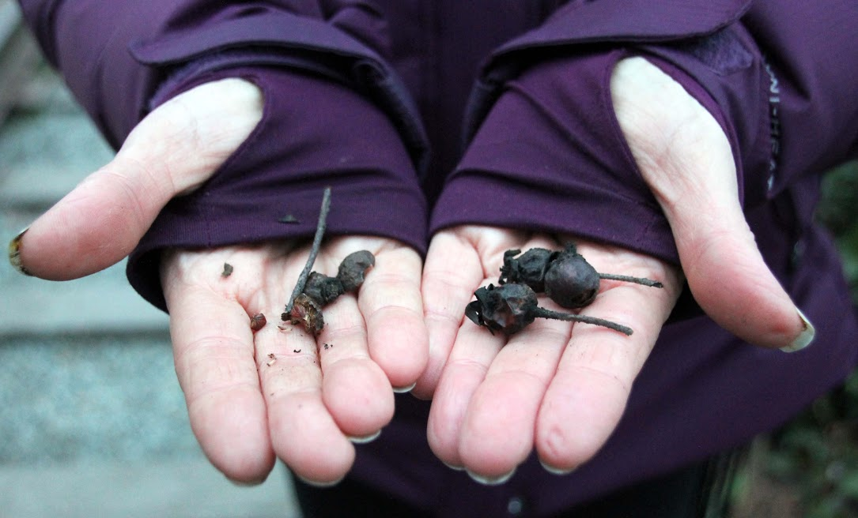
Indigenous Plant Workshops

“The path to a sustainable existence must start with a fundamental reimagining of the ethical, economic, political and spiritual foundations upon which society is based, and that this process needs to occur within the context of a deep local knowledge of place. The solutions to many of our ecological problems lie in an approach that celebrates, empowers and nurtures the cultural, artistic, historical and spiritual resources of each local community and region, and champions their ability to bring those resources to bear on the healing of nature and community.
“Schools and other educational institutions can and should play a central role in this process……. Place-Based Education: Connecting Classrooms and Communities (ISBN 978-0913098547), Lane-Zucker describes the context within which place-based education was developed

As a resource to bring forward some of these ideas, Lori Snyder a Metis Herbalist educates on wild, edible, native and medical plants. She offers interactive workshops for classroom field trip where we venture outside the door to discover what is growing around the school yard. She is now in her 5th year sharing the wisdom of plant medicines on the unceded terriorities of our Coast Salish neighbours. Lori has presented at various school district In Richmond, Burnaby and Vancouver for Professional Development Days. She has taught at UBC Farm, for Embark Gardens at SFU, with the Gastronomic University from Italy, the BC Aboriginal Child Care Society, the 2017 Ted Talk participants and various events around Metro Vancouver.

Lori’s vision is to bring awareness around food security, traditional uses, indigenous foodscapes and the importance of native plant species & urban foraging.

Workshops run from 1 - 1.5 hours for either plant walk or plant walk with medicine making.

Cost $5 per student Plant Walk / $8 per student plant walk & medicine making

Reference materials shared once bookings confirmed.

Here is a article written that describes her approach
http://www.straight.com/life/716486/aboriginal-herbalist-lori-snyder-harvests-wild-foods-and-medicines-around-vancouver

Lori Snyder
First Nations Resource
Metis Herbalist & Educator
earthandcompanyinfo@gmail.com

