MOSCROP SECONDARY

ONLINE COURSE SELECTION INSTRUCTIONS FOR 2018-2019

Logging in to MyEducation BC
- Open a browser and visit the URL for MyEducation BC | http://www.myeducation.gov.bc.ca/aspen
- If you already have an account, enter your Login ID (your pupil number) and Password, and then skip to page 2  Note that MyEducation BC is CASE  sensitive | 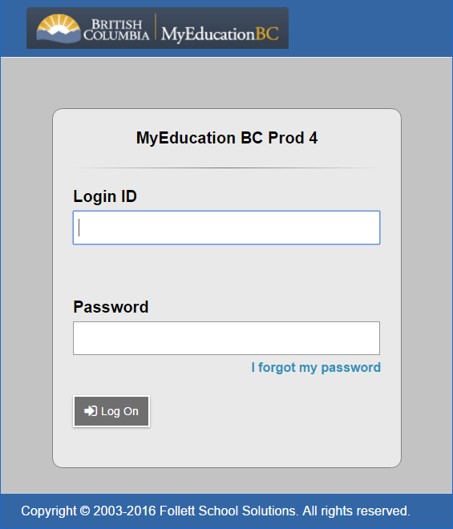  MyEducation BC is case sensitive
- If you don’t know your password, see Ms. Santillan in the main office

- Problem logging in?  a) Forgot your password?  Click the blue “I forgot my password” link on the log-on screen. (This function is only available for those who have set their primary email and security question upon initial login.)The program will ask for your email address as well as the answer to your security question. If you answer them correctly, a new temporary password will be sent to your email account. Retrieve the temporary password from your email and use it log on. You will then be asked to create a new password.  a) Trouble with your account being disabled?  If you mistype your password 5 times, the system will automatically disable your account. See Ms. Santillan in the office. | c) Trouble with your security question? If you mistype your email address or the answer to your security question 3 times, the “I forgot my password” function will be frozen. Email and security question are also case sensitive. Once you have regained access to your account, you will need to follow the steps below to fix your email address and/or your security question  d) Need to change your password, email address or security question?  - Click on your user name in the upper right-hand corner and drag down to “Set Preferences”  - Click on the “Security” tab to access the fields you need to change.

Entering Course Selections

- When you log in you will be taken to your “landing page”

- Click on the “My Info” top tab to begin working on your course selections

- Click on the REQUESTS side tab if it is not automatically selected

- A screen should appear that shows a Course Selection Sheet for your Grade Level

- If you do not see this view click on the FILTER button in the top right corner of the screen and select BUILD
- Review the instructions at the top of the Course Selection Sheet.
- NOTE: Any LINKS in the instructions will lead you to other Web Pages with more information

- French Immersion and English programs differ, so read carefully

- You will be selecting:
  - 8 courses (minimum)
  - 2 alternates (minimum)
  - Career Prep option (if in gr 10/11)
- Review the requests area of the Course Selection Form

- Any Course Selections that have already been made (they may be a default or required course) are shown in BLUE and do not need to be changed unless you would like a different course

5.To make course selections click on
beside each subject area you would like to take.
6. A “pop-up” window will appear that allows you to select the courses you would prefer  - Please read the instructions to be sure you have selected the correct number of courses  - Put a checkmark beside the Courses you would like to select, uncheck the courses you do not want selected  - Click on OK when your selections for that subject area are complete | 3  2  1  Note: if you cannot uncheck the checkbox the Course selected is a REQUIRED COURSE
7. Some subject areas (like electives) may have more than one page of options to choose from  - Be sure to review ALL the pages available by clicking on the next page arrow (>) to move to the next page | This list can be sorted by Course Description by clicking on the column heading for Course Description

Entering Alternate Course Requests
8. In a Separate Box you will see ALTERNATE REQUESTS  - Follow the same steps to select your Alternate Requests  - Make sure to read the instructions and select the correct number of alternate courses. | 1  2

Review
- Review all courses selected and ensure you have:  - 8 courses (minimum)  - 2 alternates (minimum)  + Career prep option (if you  are in grade 10 or 11) | Note that the number of selections made appears in the top right corner of the window.

Notes for Counsellor
Do NOT leave a note here | Your counsellor will NOT be able to read any notes you make in this section. Instead, see your counsellor in room 317 if you have any questions or if you would like to relay any information

POST to save your work
- In order to confirm that you have completed your course selections, click on the POST button in the bottom left of the screen. You MUST do this to save your work

- A GREEN message will appear when course selections have been successfully posted/saved

