HOW STUDENTS TURN IN ASSIGNMENTS IN CLASS TEAMS – OFFICE 365
Source: https://support.office.com/en-us/article/turn-in-an-assignment-in-microsoft-teams-e25f383a-b747-4a0b-b6d5-a2845a52092b

How to Turn in an assignment in Microsoft Teams
Microsoft Teams for Education
To turn in an assignment, select its assignment card. Depending on the status of your assignment, you may be turning your work in on time, late, or submitting revised work.
- Navigate to the General channel in the desired classroom, then select Assignments. You can also use your search bar to search for an assignment by keyword.
- Your upcoming assignments will show in order of when they're due. Select any assignment card to open it and view the assignment’s details.

Tip: Select the Expansion icon (diagonal, double sided arrow) to work in full-screen mode.

- If your teacher specified a document for you to turn in or you have other files to attach to this assignment, select +Add work and upload your file. Note: You can attach a file up to 50 mb in size.
Want to complete your work in google docs or Office 365? Be sure to give proper permission for your teacher to VIEW your assignment!! Links should be ‘view only’ and not editable. If we are asked to sign in to get permission, you will not get credit for your homework!
Tip: Work on Office files associated with this assignment right from here—no need to leave the app.
Select the Turn in button to turn in an assignment before its deadline. The button will change depending on the status:
  - Turn in again if you’re editing an assignment you’ve already turned in and need to submit work again.
  - Turn in late if you’re turning in your assignment after the due date, but your teacher has allowed late turn-ins or asked for a revision.
  - Not turned in if the assignment is past due and your teacher is no longer accepting turn-ins. You cannot turn in work.
  - Undo turn in if you decide you want to edit your assignment before the due date. You'll need to turn it in again after you make your edits.

You can download any .docs files to your computer. Work on it in Microsoft Word, save the final copy (ensuring that it is readable and still formatted in a tidy way), and re-upload it to submit your finished assignment.
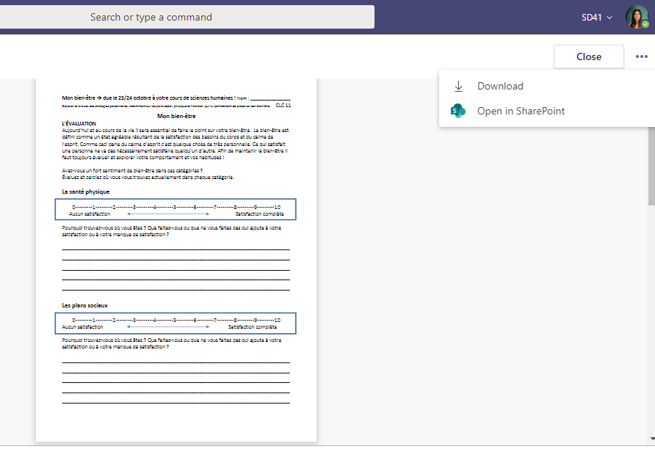
You will get a blue message once your assignment has been marked and assessed. The “Activity Centre” will light up with a red notification to remind you that your assignment has been marked.

RULES FOR SUBMITTING HOMEWORK: PLEASE READ!!
-DO type your work (don’t submit hand-written work – in many cases it’s too difficult to read)
-DO NOT take a photo of your work and upload that, it is too difficult to read
-DO NOT link a google doc or office 365 doc unless you have given proper “View only” permission (otherwise we cannot access it!). De-select the ability to ‘edit’ BEFORE you share it.
-DO save word documents as PDF’s if you can – so that the formatting is not completely messed up. Pdf documents will ensure that the words, columns, text boxes etc. do not get jumbled up.

