CLC 11 – Assignment Four: Grit & Core Competencies
INFORMATION:
GRIT
Grit is passion and perseverance for long-term goals.
One way to think about grit is to consider what grit isn’t.
Grit isn’t talent. Grit isn’t luck. Grit isn’t how intensely, for the moment, you want something.
Instead, grit is about having what some researchers call an “ultimate concern”–a goal you care about so much that it organizes and gives meaning to almost everything you do. And grit is holding steadfast to that goal. Even when you fall down. Even when you mess up. Even when progress toward that goal is halting or slow.
Talent and luck matter to success. But talent and luck are no guarantee of grit. And in the very long run, [many] think grit may matter at least as much, if not more.
Source: https://angeladuckworth.com/qa/#faq-125
CORE COMPETENCIES
The cross-curricular competencies are the set of intellectual, personal, and social skills that all students need to develop in order to engage in deeper learning—learning that encourages students to look at things from different perspectives, to see the relationships between their learning in different subjects, and to make connections to their previous learning and to their own experiences, as members of their families, communities, and the larger society.
Need more help understanding Core Competencies? More information and Core Competency profiles can be found at: https://curriculum.gov.bc.ca/competencies
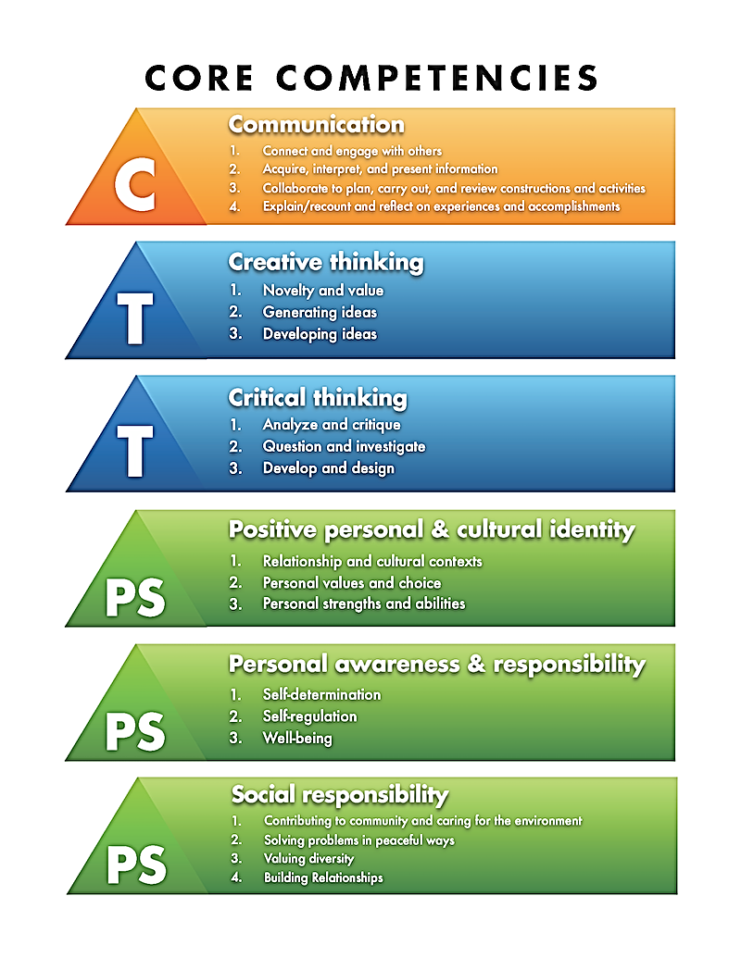
ASSIGNMENT FOUR INSTRUCTIONS: BUILDING A CORE COMPETENCY PORTFOLIO
Due Date: end of February – have 2 artefacts saved
Due Date: end of March – have 2 more artefacts saved
Due Date: end of April – have 2 more artefacts saved
CORE COMPETENCY ARTEFACTS
Activity Description:
Begin uploading artefacts from in school and out of school examples, and reflect on these experiences to assess development in the Core Competencies and share highlights of your learning journey. Do this in preparation for your Grade 12 Capstone Presentation.

Instructions:
- In www.MyBlueprint.com, (if you haven’t already) create a NEW Portfolio called “Your name’s Core Competency Portfolio” Example: “Joe Smith’s Core Competency Portfolio”
- Take/upload a photo or video related to how you’ve developed your competencies in one of the core areas (See Competency diagram on front page) over your Grade 10 and/or 11 years (inside or outside of school) – for example a project or presentation you’re particularly proud of.
- Answer the following questions for EACH artefact:
**Do not attach a file or link for the reflection: type directly into the reflection box area, or copy and paste your text**
  - Use an “I Can” statement to describe what the artefact represents, explain why you selected this item, and which competency area it relates to the most.
  - Explain your understanding of what that competency means.
  - How does this artefact illustrate your change or development over time in this area?
  - Why is the development of this competency important to success in a career path you’ve chosen?
  - What qualities of GRIT did you display in this example? (EX/ Think about what long-term goals it may relate to. What challenges had to be overcome?)
  - How does this competency connect with your own personal development as a responsible, socially conscious citizen?
- Do this for two different artefacts that represent two different Competencies (see chart for examples)
- Continue to add two more artefacts each month (i.e./ 2 for Feb, 2 for Mar, 2 for April) for a total of 6 artefacts covering all 6 competency areas before May.
Please tag both reflections with: #assignment4 and #corecompetencies by choosing “Add Tag” at the bottom of your entry, and selecting the tags from the “Teacher tags” already created. (You may need to select the three small lines in the top right hand corner of the box to do this)
SELF-ASSESSMENT CRITERIA (4 Point Scale (out of /5)) Please check off the criteria that you meet, and include this self-assessment by taking a picture of it and uploading it to your “Influences” portfolio. Call it “Assignment Four – Self-Assessment”
- You have created a “Core Competencies” portfolio
- 2 artefacts saved to your portfolio, representing proficiency in 2 different Core Competencies
  - Reflection completed for both & please identify where on the spectrum below you believe you fall for this month’s Core competency reflections:
 | ^{EMERGING (2)} | ^{DEVELOPING (3)} | ^{PROFICIENT (4)} | ^{EXTENDING (5)}
Ability to reflect on learning & growth in Core Competencies | I am able to show an initial understanding for how some of my life experiences demonstrate learning, growth or proficiency in the Core Competencies. |  |  | I am able to demonstrate a sophisticated ability to analyze life experiences that demonstrate learning, growth or proficiency in the Core Competencies identified.
- You have met the above criteria, checked off each aspect, and then uploaded this Self-Assessment criteria, as a photo, to the “Core Competencies” portfolio (“add box” then select picture, and take a clear photo)

