Black History Month STEM Edition February 2021
WEEK 1: Black Canadians in STEM
Mon 1 | Tues 2 | Weds 3 | Thurs 4 | Fri 5
Anderson Abbott  First Black Canadian medical doctor trained in Canada | Onye Nnorom  Physician and specialist in public health inequities. | Alfred Shadd 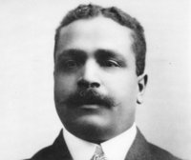  Educator, medical doctor, politician, human rights advocate. | June M. James  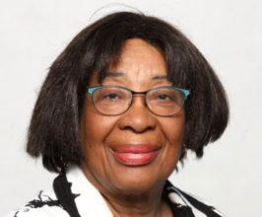  First woman of colour admitted to U of Manitoba Medical School. Expert in pediatric allergies | Elijah McCoy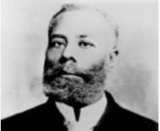  Engineer with over 60 patents, whose work greatly increased train efficiency.

Great resources:
BC Black History: https://bcblackhistory.ca/black-history-month/
Canadian Black Scientists Network: https://www.blackscientists.ca/

