Choice Board –Grade 9 Questions, Activities and Investigations
Big Ideas  Curricular Competencies | Exponents and Radicals | Computational fluency with rational numbers | Continuous linear relationships | Proportional Reasoning with 2-D shapes | Analyzing data and Financial Literacy
Reasoning and analyzing  - Connections  - Estimates  - Mental strategies  - Technology  - Model math in context | Try evaluating these statements about Radical expressions. To determine the truth of an expression, find values of x and y that are true or not true. | Play this game of Remainders. What is the best score you got? How did using the Modulator help you? | Use DESMOS to run through this graphing activity. | The photo here shows the facade of the neo-Gothic St Petrus and Paulus Church in Ostend, Belgium. Assume that the person dressed in a black suit in the bottom right-hand corner of the photograph is 2 metres tall.  a What is the approximate scale of the photograph?  b What is the approximate height of the top of each spire from the ground? | Are drug tests fair? Read this article about drug testing in the United States and this one about racism in hiring. Then proceed with discussing the questions in this handout.
Understanding and solving  - Inquire and solve  - Visualize  - Multiple Strategies  - Connection to place and Indigenous cultures | Without using a calculator, write the following numbers in order from least to greatest. Explain how you know.  3⁵⁵ 4⁴⁴ 5³³ | You divide two rational numbers and the answer is between the numbers. What might the numbers be? Are there lots of solutions? | Look at these boxes on the multiplication table. Can you determine any linear relationships between the numbers? Explain. 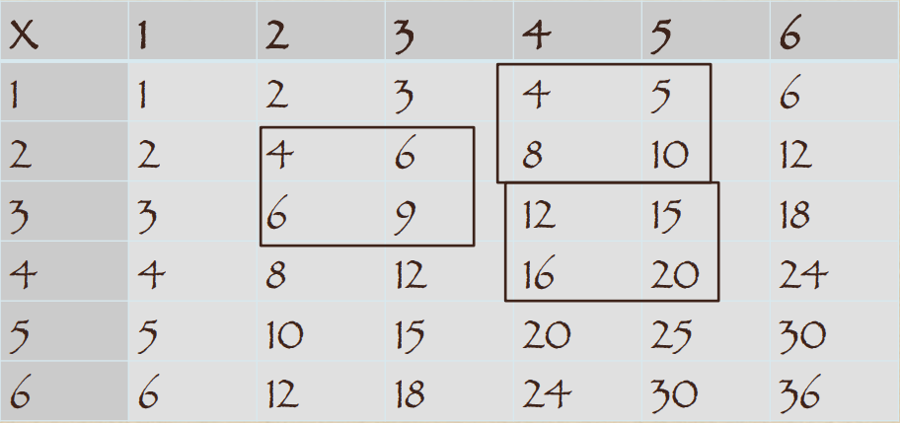 | Design a traditional BC dwelling suitable for your family and location. | You are planning a grade-wide party for all 150 of the Grade 9’s in your school. You want to pay for snacks, drinks, decorations and a DJ. Research the costs for each of these items and make a budget. If the students’ council is giving you $200 towards the party, how much will you have to charge each student?

Communicating and representing  - Language  - Explain and Justify  - Concrete, Pictorial and Symbolic forms | Use this sheet to explore various representations of exponents, then explain why these rules make sense, using examples:  - (a^{m})(a^{n})=a^{m+n}  - a^{m}÷a^{n}=a^{m-n}, m>n  - (a^{m})^{n}=a^{mxn}  - (a/b)^{n}=a^{n}/b^{n} | Create a numerical expression with rational numbers AND exponents that requires you to know the rules for the order of operations. Explain how the rules make a difference to the result. | Examine this stained glass activity. Complete the Stained Glass Blueprints, then the Design Your Own Stained Glass. | A 1:25 scale drawing has been used for the shed below. The area to build the shed is a 5.1 m by 4 m rectangle. Will the shed fit into the space allocated? Explain and justify your conclusion  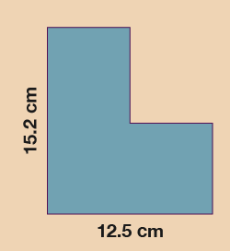 | You see a “buy 2 pairs get 1 pair of equal or lesser value FREE” sale at the local shoe store. The problem is that you only want to get two pairs of shoes. So, you bring your best friend with you. You settle on two pairs of shoes – a sporty red pair for $20 and a dressy black pair for $55. You friend finds a practical sneaker for $35. When you proceed to the check out desk the cashier tells you that your bill is $90 plus tax. How much should each of you pay? Justify your decision.
Connecting and reflecting  - Connect concepts  - Indigenous Perspectives | Below are the first stages of Sierpinski’s Triangle. In each stage a triangle 1/4 of the size of each existing black triangle is cut out from the centre of the black triangle. Construct and answer these questions.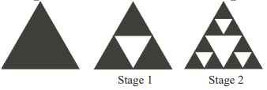 | In the rational number – $\frac{A}{B}$  If both A and B are positive, does the number usually change more if you increase A by 1 or if you increase B by 1.? Explain your answer. | Challenge yourself by running through these challenges on pHet. How many levels can you do? Take some screen shots to provide evidence. | Complete this mapping activity called A Map of Home (Adapted from FNESC Math First Peoples) | Play the Stick Game and answer the discussion about the probabilities involved.
Resources to learn each topic | Evaluating Statements about Radicals math unit  CEMC materials on Exponents and Radicals  Exponent Card Game |  | Weaving and Math from SD41 Indigenous Educators  DESMOS activity teacher info:  http://www.troup.org/userfiles/929/My%20Files/MS%20Math/8%20Math/8th%20Unit%204/Concept%202/comparing%20functions.pdf?id=11501 | FNESC Guide to math  https://amsi.org.au/teacher_modules/Scale_drawings_and_similarity.html#Scale_drawings | Mathematics Lessons to Explore, Understand and Respond to Social Injustice  Peter Liljedahl’s Numeracy Tasks

