Choice Board –Grade 8 Questions, Activities and Investigations
Big Ideas  Curricular Competencies | Ratios, rates, and percents. | Computational fluency with fractions. | Discrete linear relationships. | Surface area and volume of 3D objects | Analyzing data.
Reasoning and analyzing  - Connections  - Estimates  - Mental strategies  - Technology  - Model math in context | Is 80% of 20 the same as 20% of 80? Does this always work? Explain why in drawing, video or letter | Play this online card game:  Provide some evidence about the level you got to (screen shots, for example) | Solve this problem from Mr Barton 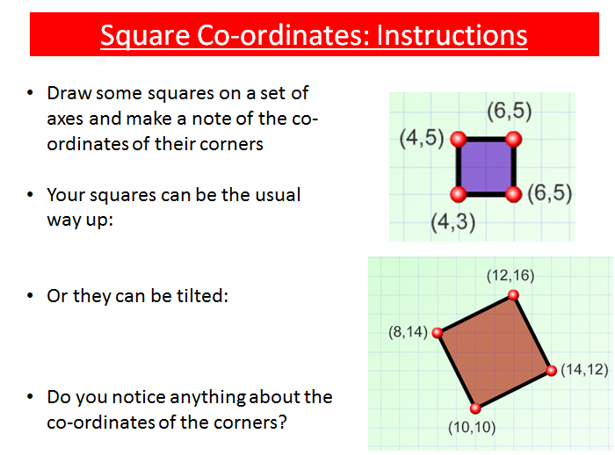 | Complete this activity on building bentwood boxes (FNESC) | Rock, Paper, Scissors. Play this game and collect and analyze data.  Rock,Paper, Scissors DOC
Understanding and solving  - Inquire and solve  - Visualize  - Multiple Strategies  - Connection to place and Indigenous cultures | If you know how much 6 items cost, what strategies could you use to figure out how much 8 items would cost? | Use fractions to lay astroturf on a playing field.  Teacher Info here. | Try out this number trick. Then make your own, using a letter to represent the starting number …explain how it works. | Use Pythagoras Theorem and a model canoe to explore canoe travel (FNESC)  Teacher info here. | Design (along with classmates) a survey for telling an exchange student about typical Gr 8’s at your school  (see pdf link)
Communicating and representing  - Language  - Explain and Justify  - Concrete, Pictorial and Symbolic forms | Complete this cell phone plan task. | 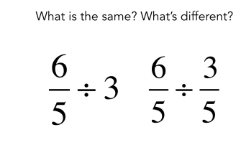 | Examine this pattern.  What is step 5? Step 10? What is step 43? How do you know? Can you write an equation for this image?  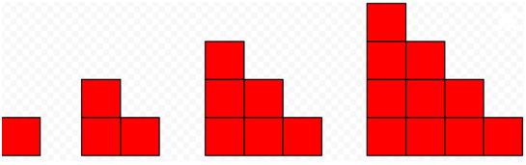  More like this here. | Make a video using origami, tiles or some other hands on way to represent Pythagoras’ Theorem. | If you roll a pair of dice 10 times, would you rather get $5 every time you roll doubles OR $3 every time you roll any two even numbers?  Explain and justify your choice.
Connecting and reflecting  - Connect concepts  - Indigenous Perspectives | A car uses a little less than 1 L of gas for every 100 km it travels. Think of someone who lives a long way away, but that you could drive to in one day. Estimate how much in gas you would spend to visit that person and return home. You will need to check today’s gas prices. | Think of a time when it is more appropriate to write a fraction rather than a decimal. Write a story to explain the situation. | Design a game that uses a co-ordinate grid as a game board. | Use one sheet of letter-sized (8.5 x 11 inch) paper or cardstock to make a popcorn container. What design would hold the most and least popcorn (when filled level with the top)? If you owned a movie theatre, what shape would you use? Explain. * | Read about the Mi’kmaq game of Waltes here Try playing a few rounds against the computer. Now explain by writing a comic book, the probabilities involved in scoring points.
Resources to learn each topic | Ratio  Rate  Percent | FRACTIONS  Common Denominator  Adding and Subtracting  Multiplying and dividing | Co-ordinate graph  Expressions | Surface Area  Volume  Pythagoras | Central Tendency  Probabilities

