Choice Board –Grade 2/3 Open Questions, Activities and Investigations
Big Ideas  Curricular Competencies | Number fluency to 100(2) and 1000(3) and Fractions (3) | Computational fluency +/- (2) and ÷ /x (3) | Patterns and Relations | Attributes of shape, including measurement (3) | Graphing and Probability
Reasoning and analyzing  - Connections  - Estimates  - Mental strategies  - Technology  - Model math in context | Choose 5 numbers less than 100 (less than 1000 for Gr 3’s). Put them in order from least to greatest. Tell how you know they are in order.  SAMPLE ANSWER (This is an open question, so answers will vary):  12, 120, 622, 987, 999  I know because I compare the hundreds place, then the tens place then the ones place. | Take this hundreds chart and a variety of crayons. Place a dot of a colour on 2, then on each multiple of 2 as you skip count. Pick a different colour and do the same for each number 3, 4, 5, 6, 7, 8, 9, 10… What do you notice about the colours? What does it mean if a square has many different colours in it?  SAMPLE ANSWER: (Sheet should show many coloured dots at all multiples) What I notice: some numbers have no dots, some have one or 2, some have more. A few squares have many dots, which means they have many numbers that landed on them during skip counting (these are factors). | Use this app to make an interesting pattern. Then use words or number to explain the pattern you made. | Use this app (on an iPad or on the web) to design at least 5 different shapes. Compare the area they cover and the perimeter of them.  Sample Answer:  A triangle, small area (area of 1, perimeter just over 5)  B rectangle, medium area (area of 4)  C large triangle, area of 6, perimeter of 12)  D Square, area of 9, perimeter of 12  E Large rectangle, area of 12, perimeter of 14 | Use this graphing template to investigate a question of your own. Need some ideas? Check this list.
Understanding and solving  - Inquire and solve  - Visualize  - Multiple Strategies  - Connection to place and Indigenous cultures | Play this game of totals with another person. Increase the total to 100 or even 1000. Write a letter explaining the winning strategies. | Gr 2: Fill in the blanks to make three addition expressions. Use each digit 4 to 9 only once.  + + +  Use mental math to add. Try to use different strategies—describe the strategies you used.  Gr 3: As above, but do mulitiplication expressions:  x x x  SAMPLE ANSWER (This is an open question, so answers will vary):  4 + 9 = 13; 5 + 8= 13; 6+7= 13 When adding, I try to make 10 first.  4x9 = 36 5 x 8 = 40 6 x 7=42 I try to find the nearest x fact I know of the 5 or 10 x table. | Use this video or this website to make a cardboard loom. Use different colours of wool to make a pattern. Describe your pattern using words and numbers. | Take a shapes walk out in the garden or neighbourhood. What shapes can you find? Draw or write about them. If you are in Grade 3, what things can you find that have 2 or more different shapes? | Consider the plight of Leo the Rabbit…Leo is hopping up 10 steps…Leo can only take 1 or 2 hops at a time. How many different ways can Leo hop up the stairs?
Communicating and representing  - Language  - Explain and Justify  - Concrete, Pictorial and Symbolic forms | Create a number line by skip-counting by 10’s to 100 (gr 2) or 100’s to 1000 (gr 3). Choose 5 other numbers not ending in 0 and place them on your number line. Describe the placement of each of the numbers. | Create a story problem with more than one answer that you could solve by subtracting a two-digit number from another two-digit number. Solve the problem to get several answers.  SAMPLE ANSWER: (This is an open question, so answers will vary) | Use this hand-out to make a pattern of your own, using blocks, lego or just drawings. If you are in Grade 3, complete the questions in pages 2 to 3 as well. | Use this graph paper and draw a line down the middle vertically or horizontally. Use different colours of pencils to create a symmetrical design (same on both sides of the line) by filling in boxes with different colours.  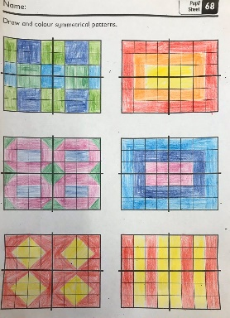 | In an ice-cream shop there are many different flavor combinations, even with only a 2-scoop cone. With 2 flavors there are 3 possible combinations (eg van/van, choc/choc, and van/choc).  How many kinds of 2-scoop cones are there with 3 flavors? 4?  Create a poster that represents your thinking. 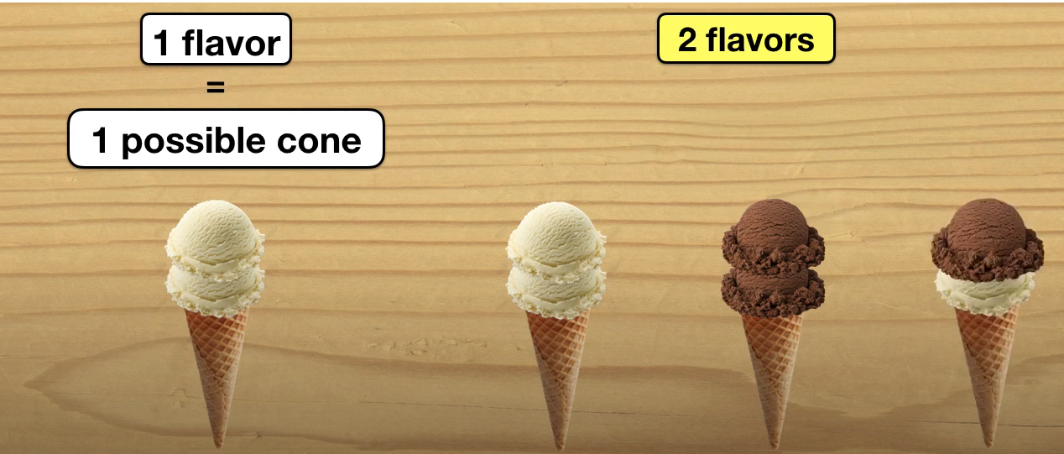
Connecting and reflecting  - Connect concepts  - Indigenous Perspectives | Listen to this book Balancing Act. Can you find some things around your house or room to balance? Write a story or draw a picture about it. | Sometimes you might estimate the sum of two two-digit numbers by just adding the tens of the original numbers, but sometimes you would not. Give an example of each situation. Explain your thinking.  SAMPLE ANSWER: (This is an open question, so answers will vary) for 42 + 21 if you estimate with 40 + 20, you get 60 which is a close estimate for the sum of 63. But for 47 + 25, if you estimate 40 + 20, 60 is not close to the actual sum of 72. So if the ones digit is above 5, it is not good to estimate using just the tens digit. | Read or listen to one of these books, Rooster, Cats, or Crocodiles. Make a drawing or use objects to illustrate the patterns of the numbers in the book. | Write and illustrate a story about three or more different shapes. include things that are the same and things that are different about the shapes. Gr 3’s write about the sizes and measurements of the shapes. | Using tongue depressors or popsicle sticks, make 5 sticks for the game here. Play the game. Use a tally sheet or counting sticks to keep track. Do you think this game is fair? Explain.
Resources for teachers | Learning to Think Mathematically with the Number Line: https://www.mathlearningcenter.org/sites/default/files/pdfs/LTM_Numberline.pdf | BC Numeracy Network has many resources on numeracy routines: https://sites.google.com/view/bc-numeracy-network/instruction/what-routines-will-support-mathematical-thinking-and-reasoning | A great overview of patterns: https://www.edu.gov.mb.ca/k12/cur/math/support_gr3/patterns_relations.pdf | These math apps are great for visualizing across the math curriculum: https://www.mathlearningcenter.org/resources/apps | Virtual Learning Commons on Gr 3 Data and Probability  https://vlc.ucdsb.ca/c.php?g=101077&p=656182

