Level: K
Category: Numeracy

Title of Lesson: Getting to 10
Goals/Objectives:
Big Idea: Number represents and describes quantity.
Curricular Content: number concepts to 10
Curricular Competencies: visualizing and representing number; communicating number
Materials Needed:
- Any objects around the house that can be counted—toys, beans, crackers, rocks.
- A deck of playing cards
- An egg carton with the last 2 compartments cut off to make a 10-frame
Task Instructions: (Step by Step)
Activity 1: Counting—count different collections of objects in the home. Engage children in counting up to 10…extend to 20 or higher.

Activity 2: 10 Frames
Level A: Sort out a set of cards, 1-10 (if using Ace, explain to child that Ace=1). Child draws a card, then places that many objects in a 10 frame to match.

Level B: Child draws a card, fills the 10 frame with that many objects (example: 6 red beads). Then child fills the 10 frame up with a contrasting object (in our example, 4 black beads). Child then finds the card representing 4, and says 6 and 4 makes 10.

Level C: Ten Frame Challenge
I have a horizontal ten-frame that has some counters on it. One row of the frame is full and one is not. What is the largest number I could make? What is the smallest number I could make? (Source: https://www.openmiddle.com/)

Activity 3: 5-Sum-Memory Game (Source: https://mathforlove.com/)
Materials: Playing cards
- Create a deck from 4 ones or aces, 4 twos, 4 three, and 4 fours.
- Deal out the cards face down.
- Players take turns turning two cards face up.
If a player turns a pair upward and that pair sums to 5, the player puts that pair of cards in their stash and plays again.
- If the upward pair does not sum to 5, the player turns the cards back face down, and the next player moves.
- The game ends when the cards are all claimed. Whoever has the most cards wins.
10-Sum-Memory Game (Source: https://mathforlove.com/)
- Materials: Playing cards
- As above but the deck consists of 2 ones or aces, 2 twos, 2 threes, 2 fours, 2 fives, 2 sixes, 2 sevens, 2 eights, and 2 nines, and the target sum is 10 instead of 5.
Adaptations/Adjustments: (consider different environments)
-Cut the egg carton down to 5 and start with counting and adding to 5
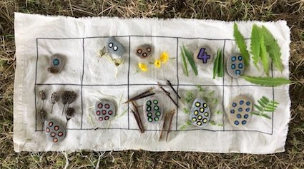
-Go outside, make a 10 frame of sticks or a cloth 10 frame (photo from Juliet Robertson), use objects found in nature to make 10’s or count

Extensions (Optional):
-Count two different collections of objects. Draw your collections on a piece of paper and label how many are in each collection.
-Extend activities to 20 and beyond.

References:
Fawn Nguyen
SD38-Janice Novakowski

