Level: Gr 2
Category: Numeracy
Title of Lesson: Addition and Subtraction to 100
Goals/Objectives:
Big Idea:
• computational fluency in addition and subtraction with numbers to 100 requires an understanding of place value.

Curricular Content:
• comparing and ordering of fractions with common denominators
• estimating fractions with benchmarks (e.g., zero, half, whole)
• using concrete and visual models

Curricular Competencies:
• Apply multiple strategies to solve problems
• Visualize to explore mathematical concepts
Materials Needed:
- Legos
- Cards/paper
Task Instructions: (Step by Step)
Activity 1: Problems with fractions
Divide a rectangle into equal parts.
What fractions can you show?
Compare your fractions.

How can you show that two-thirds is greater than one-third?
Make 2 different drawings that compare these two fractions.

Create a sentence that includes all of these words and numbers:
$\frac{1}{4} \frac{2}{4}$ greater whole

Activity 2: Fraction Fluency Practice

Lego Fractions:
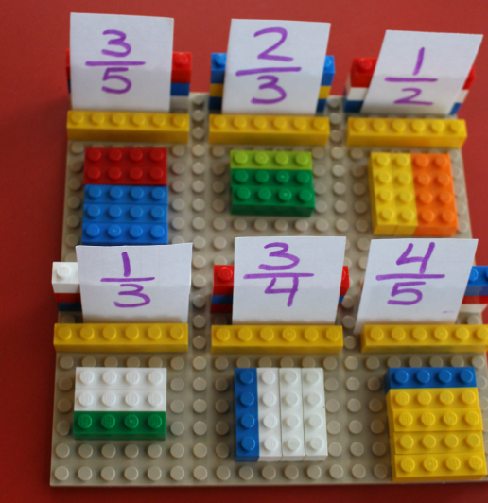
For this activity, make a number of cards with simple fractions (denominators 2 through 8) and varying numerators (don’t exceed the denominators, as Gr 3’s aren’t ready for mixed fractions)

The student then makes a lego version of that fraction by using different colours of lego.

Activity 3: Open Question

The fractions
and

are close together.
The numerator of the first is the same as the denominator of the second.
What might the numbers be?
Explain your thinking.
Adaptations/Adjustments:
-Look at the activities in the Grade 2 Week 2 Lessons
Extensions (Optional):
References:
Marian Small; https://jdaniel4smom.com/2015/02/lego-fraction-games-kids.html

