Level: Gr 7
Category: Numeracy
Title of Lesson: Decimals, fractions, and percents
Goals/Objectives:
Big Idea: • Decimals, fractions, and percents are used to represent and describe parts and wholes of numbers
Curricular Content:
• Relationships between decimals, fractions, ratios and percents
Curricular Competencies:
• Apply multiple strategies to solve problems
• Visualize to explore mathematical concepts

Materials Needed:
- Deck of Cards

Task Instructions: (Step by Step)
Activity 1: Problems with decimals, fractions and percents
3/5 2/3 3/8 4/5

Of the four fractions above, which one doesn’t belong?
Why doesn’t it belong?
Can you make an argument for any of the 4 fractions?

Is 20% of 80 the same as 80% of 20?
Does this always work?
How can you explain that it will always work?

One fraction is just slightly more than another. They have different denominators.
What might they be?
Can you find five different answers to this question?
Activity 2: Fraction Fluency Practice

Largest Fraction:
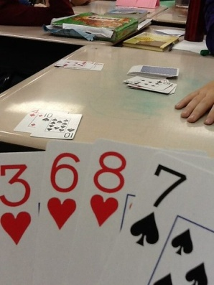
For this game, students can use a regular deck of playing cards with all the face cards and joker cards removed. Ace cards = a value of 1." Shuffle the cards. Deal four cards to each player. Players use the cards they were dealt to make the largest possible fractions.
Example:
Player 1 holds the cards 2, 3, 6, and 8
Player 2 holds the cards 1, 3, 3, and 7*
Each player makes the largest proper fraction s/he can make:
Player 1: 6/8 Player 2: 3/7*
*Note: Player 2 could make the fraction 3/3, but that is not a proper fraction. A proper fraction always has a smaller number in the numerator than it has in the denominator.
Player 1 has the largest proper fraction, so player one gets a point. Shuffle the deck and play another round. First player to 10 points wins.

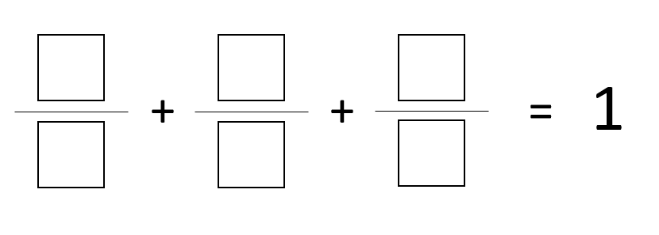
Activity 3: Open Question
Directions: Using the digits 1 to 9, at most one time each, place a digit in each box to make a true statement.
Adaptations/Adjustments: (consider different environments)
-Look at the activities in the Grade 6 Week 1 Lessons
Extensions (Optional):
More fraction card games here: https://www.educationworld.com/a_lesson/dailylp/dailylp/dailylp139.shtml
Try this limits game: https://www.stem.org.uk/resources/elibrary/resource/28198/fraction-activities-students-aged-11-13#&gid=undefined&pid=5
References:
Marian Small
https://www.educationworld.com/a_lesson/dailylp/dailylp/dailylp139.shtml
https://www.openmiddle.com/adding-3-fractions-to-get-1/

