Level: Gr 6
Category: Numeracy
Title of Lesson: Mixed numbers and decimals
Goals/Objectives:
Big Idea:
• Mixed numbers and decimal numbers represent quantities that can be decomposed into parts and wholes.
Curricular Content:
• Relationship between mixed numbers and improper fractions
• Relationship between decimals and fractions
Curricular Competencies:
• Apply multiple strategies to solve problems
• Visualize to explore mathematical concepts

Materials Needed:
- Deck of Cards
Task Instructions: (Step by Step)
Activity 1: Problems with decimals and fractions
5/3 2/3 8/3 4/5

Of the four fractions above, which one doesn’t belong?
Why doesn’t it belong?
Can you make an argument for any of the 4 fractions?

Suppose the numerator of a fraction is 10 more than the denominator.
Write a fraction for each statement:
- The fraction is greater than 2
- The fraction is less than $1\frac{1}{10}$
- The fraction is greater than 8
- The fraction is greater than 12

Name 3 fractions with different denominators that are easy to turn into percents.
Explain why it is easy to represent them as percents.

Activity 2: Fraction Fluency Practice

Largest Fraction:
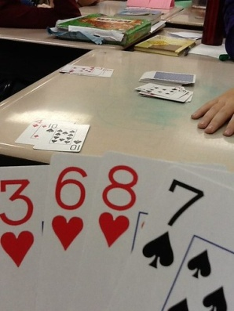
For this game, students can use a regular deck of playing cards with all the face cards and joker cards removed. Ace cards = a value of 1." Shuffle the cards. Deal four cards to each player. Players use the cards they were dealt to make the largest possible fractions.
Example:
Player 1 holds the cards 2, 3, 6, and 8
Player 2 holds the cards 1, 3, 3, and 7*
Each player makes the largest proper fraction s/he can make:
Player 1: 6/8 Player 2: 3/7*
*Note: Player 2 could make the fraction 3/3, but that is not a proper fraction. A proper fraction always has a smaller number in the numerator than it has in the denominator.
Player 1 has the largest proper fraction, so player one gets a point. Shuffle the deck and play another round. First player to 10 points wins.

Activity 3: Open Question
Use the digits 0, 1, 2, 3, 4, 5, 6, 7, 8 and 9 exactly once. Complete
the following:
Fraction < decimal < fraction < whole # < percentage
What strategies did you use? How many ways can you find?
Adaptations/Adjustments: (consider different environments)
-Look at the activities in the Grade 5 Week 1 Lessons
Extensions (Optional):
More fraction card games here: https://www.educationworld.com/a_lesson/dailylp/dailylp/dailylp139.shtml
Try this limits game: https://www.stem.org.uk/resources/elibrary/resource/28198/fraction-activities-students-aged-11-13#&gid=undefined&pid=5
References:
Marian Small; Carole Fullerton; https://www.educationworld.com/a_lesson/dailylp/dailylp/dailylp139.shtml

