Level: Gr 5
Category: Numeracy
Title of Lesson: Fractions and decimals
Goals/Objectives:
Big Idea:
• Numbers describe quantities that can be represented by equivalent fractions.
Curricular Content:
• Two equivalent fractions are two ways to represent the same amount (having the same whole).
• Comparing and ordering of fractions and decimals

Curricular Competencies:
• Apply multiple strategies to solve problems
• Visualize to explore mathematical concepts

Materials Needed:
- Deck of Cards
Task Instructions: (Step by Step)
Activity 1: Problems with decimals and fractions
1/2 3/4 3/6 2/4

Of the four fractions above, which one doesn’t belong?
Why doesn’t it belong?
Can you make an argument for any of the 4 fractions?

Model 3 fractions with a numerator of 2.
How are the fractions the same?
How are the fractions different?
Pick one of your fractions and model two equivalent fractions to it.

The number 0.75 is the answer to a real-life problem that involves fractions. Describe several problems where 0.75 might be an answer.

Activity 2: Fraction Fluency Practice

Largest Fraction:
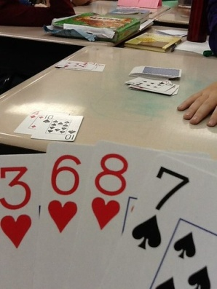
For this game, students can use a regular deck of playing cards with all the face cards and joker cards removed. Ace cards = a value of 1." Shuffle the cards. Deal four cards to each player. Players use the cards they were dealt to make the largest possible fractions.
Example:
Player 1 holds the cards 2, 3, 6, and 8
Player 2 holds the cards 1, 3, 3, and 7*
Each player makes the largest proper fraction s/he can make:
Player 1: 6/8 Player 2: 3/7*
*Note: Player 2 could make the fraction 3/3, but that is not a proper fraction. A proper fraction always has a smaller number in the numerator than it has in the denominator.
Player 1 has the largest proper fraction, so player one gets a point. Shuffle the deck and play another round. First player to 10 points wins.

Activity 3: Open Question

Ms. Morgan has a bag of marbles. $\frac{1}{4}$ are blue.
How many and what sort of marbles might be in the bag?
How might you express $\frac{1}{4}$ as an equivalent fraction?
Adaptations/Adjustments: (consider different environments)
-Look at the activities in the Grade 4 Week 2 Lessons
Extensions (Optional):
More fraction card games here: https://www.educationworld.com/a_lesson/dailylp/dailylp/dailylp139.shtml
References:
Marian Small; Carole Fullerton; https://www.educationworld.com/a_lesson/dailylp/dailylp/dailylp139.shtml

