Level: Gr 4
Category: Numeracy
Title of Lesson: Fractions and decimals
Goals/Objectives:
Big Idea:
• Fractions and decimals are types of numbers that can represent quantities.
Curricular Content:
• comparing and ordering of fractions with common denominators
• estimating fractions with benchmarks (e.g., zero, half, whole)
• using concrete and visual models
Curricular Competencies:
• Apply multiple strategies to solve problems
• Visualize to explore mathematical concepts

Materials Needed:
- Deck of Cards
Task Instructions: (Step by Step)
Activity 1: Problems with decimals and fractions
1/2 3/4 1/4 2/4

Of the four fractions above, which one doesn’t belong?
Why doesn’t it belong?
Can you make an argument for any of the 4 fractions?

Model 3 fractions with a denominator of 5.
How are the fractions the same? How are the fractions different?
Pick one of your fractions and model it in two different ways.

You add two numbers and the answer is 4.16.
What might the two numbers be?
Activity 2: Fraction Fluency Practice

Largest Fraction:
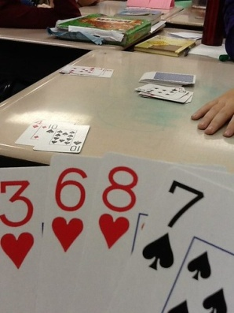
For this game, students can use a regular deck of playing cards with all the face cards and joker cards removed. Ace cards = a value of 1." Shuffle the cards. Deal four cards to each player. Players use the cards they were dealt to make the largest possible fractions.
Example:
Player 1 holds the cards 2, 3, 6, and 8
Player 2 holds the cards 1, 3, 3, and 7*
Each player makes the largest proper fraction s/he can make:
Player 1: 6/8 Player 2: 3/7*
*Note: Player 2 could make the fraction 3/3, but that is not a proper fraction. A proper fraction always has a smaller number in the numerator than it has in the denominator.
Player 1 has the largest proper fraction, so player one gets a point. Shuffle the deck and play another round. First player to 10 points wins.

Activity 3: Open Question

The numbers
and

are close together.
What might the numbers be?
Explain your thinking.

Adaptations/Adjustments: (consider different environments)
-Look at the activities in the Grade 4 Week 2 Lessons
Extensions (Optional):
More fraction card games here: https://www.educationworld.com/a_lesson/dailylp/dailylp/dailylp139.shtml
References:
Marian Small; Carole Fullerton; https://www.educationworld.com/a_lesson/dailylp/dailylp/dailylp139.shtml

