Level: Gr 2
Category: Numeracy
Title of Lesson: Addition and Subtraction to 100
Goals/Objectives:
Big Idea:
• computational fluency in addition and subtraction with numbers to 100 requires an understanding of place value.

Curricular Content:
• decomposing numbers to 100
• estimating sums and differences to 100
• using addition and subtraction in real-life contexts and problem-based situations

Curricular Competencies:
• Apply multiple strategies to solve problems
• Visualize to explore mathematical concepts
Materials Needed:
- Dice
Task Instructions: (Step by Step)
Activity 1: Problems with Addition and Subtraction
What is easier to add, 10 + 10 or 9 + 9?
How might you use the strategy of making 10 to add 9 + 9?
What are some other sums that you could do using this strategy?

How does knowing 15 + 3 = 18 help you figure out 18 – 6?

Fill in the blanks using each digit 4 to 9 only once.

+ + +

Use mental math to add. Try to use different strategies. Then describe a story that matches each of your addition facts.

Activity 2: Fluency Practice: Getting to 20, 50 or 100

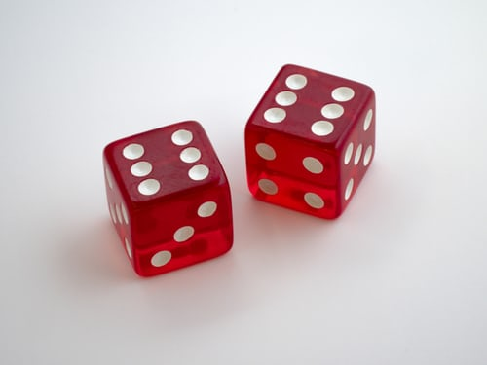
Pick a target number (20, 50 or 100). Roll a single die, roll again and add, continue until you hit the target number (score a point) or go over (“bust”). Keep track of the points.
Example:
Target is 20
Roll 5: 5
Roll 2: 7
Roll 6: 13
Roll 4: 17
Roll 3: 20—you get a point
But if that last roll was a 4, you are at 21, so you BUST and no point.

Variations: Besides changing the target number, consider using 2 dice (so numbers added will be greater); or starting at the target number and getting to zero by using subtraction. Use the dice to represent digits, and add or subtract double digit numbers.

Activity 3: Open Question

You write a two digit number. You switch the digits around and now your number is 18 more than the number you wrote. What could the number you wrote have been? Is there more than one possibility?
Adaptations/Adjustments:
-Look at the activities in the Grade 1 Week 2 Lessons
Extensions (Optional):
References:
Marian Small; https://www.hwdsb.on.ca/lincolnalexander/files/2018/02/Dice-Games-Lincoln-Alexander-1.pdf

