Budgeting for School Supplies

Gr. 8 Financial literacy: best buys
Students will be able to apply reasoning skills to making informed decisions around budgeting.
Curricular competencies:
- Use mathematical vocabulary and language to contribute to mathematical discussions
- Explain and justify mathematical ideas and decisions
- use mathematical arguments to support personal choices
Task 1: School Supply List.
Content goal: students will be able to determine a school supply budget based on their individual needs. Students will have to calculate how much their supplies will cost and make decisions based on their own situations.
Language goal: students will be able to justify orally and in writing, their reasons for their buying decisions.
Vocabulary: add, budget, calculate, cost, decide/decision, determine, establish, item, justify, multiply, price, supply/supplies, total
Lesson Preparation: Provide the sample school supply list for students to use as a model for creating their own lists, or use the sample provided.
- Have students fill out their own supply lists based on what they would need (use graphic organizer provided)
- Calculate the costs, including tax (use graphic organizer provided)
- Justify your budget decision (use graphic organizer provided)

Sample School Supply List | Item | $ Price $
Pencils, 12 pack | 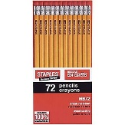
Pens, 12 pack
Binders: 3 ring, 1” | 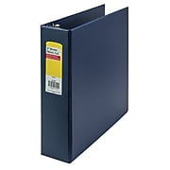
Scientific calculator | 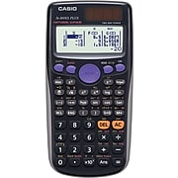
eraser
Ruler | 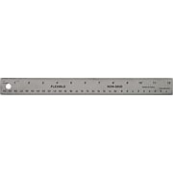
Refill paper | 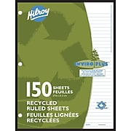
Pencil case
Pencil sharpener

School Supply List

Item | Cost  $ | I have it | I need it | I don’t need it

- Calculate the cost. | - Calculate the taxes.
Add the costs of the supplies you need.  Example: ____ + _____+ ____ = ____(Total) | Calculate 5% tax. Multiply (Total) by 5%  Example: (Total) x 0.05 = $ tax  Total + tax = ______________

- Justify your budget.
- Explain your reasons

I need a total of $ ________

I decided to buy ______________________ because _____________________________

I decided not to buy __________________ because _________________________________

Task 2.
Content goal: students will be able to calculate shipping costs and taxes in order to determine the best deal.
Language goal: students will be able to express their choices verbally and in writing.
Vocabulary: budget, calculate, determine, explain, grand total, justify, price, research, save/savings, shipping and handling, supplies/suppliers, taxes, total
Question: What issues and concerns are there?
Lesson preparation: Provide the school supply list with prices from 2 other suppliers.
- Have students choose two online suppliers and fill in the School Supply List (use graphic organizer provided)
- Students determine the shipping costs and tax (use graphic organizer provided)
- Students justify their choices (use graphic organizer provided)

Situation: School is going to start in 2 weeks and you need school supplies! Using your list from Task 1 as a guide, research the prices from two online suppliers: Amazon, Staples or Walmart.

School Supply List
Item | Supplier: __________ (Amazon, Staples or Walmart)  Price | Supplier: ____________  Amazon, Staples or Walmart)  Price
 | Total cost:  $ | Total cost:  $

Costs | Supplier: _______ | Supplier: ______
Total cost of the items:

Shipping costs:

Calculate the tax:
Total cost x 0.05 = _____

Grand total:

- Justify your budget.
- Explain your reasons: Where will you shop? Why?
I will buy the _____________ at ____________________ because I will save $______

- What issues and concerns are there when you are shopping online?

When you shop online, you must remember ____________________

- What kind of shopping do you like? Online shopping? Shopping in a store? Why?

I like shopping (online, in a store) because _________________________________________

Task 3. If students have chosen to buy supplies from a US supplier, they will need to convert to Canadian dollars.
Content goal: students will be able to calculate exchange rates on items bought in $USD and determine the best deal.
Language goal: students will be able to explain their decisions verbally and in writing.
Vocabulary: US dollars ($USD), Canadian dollars ($CAD), convert/conversion, cost, current/currency, determine, exchange rate, purchase, shipping and handling, bank, cheaper, more expensive.
Name of online store:  - Amazon  - Staples  - Walmart  - other | Canadian conversion ($CAD)  Daily rate: $1 USD = $______ CAD  How to determine the exchange rate:  Google the current exchange at any bank. (e.g. CIBC, BMO, BNS, etc.)
- Cost of supplies in US dollars ($USD)  Total cost = $_________USD | - Daily rate: ______ x total cost $USD = $_______CAD
- Cost of shipping in US dollars ($USD)  Shipping cost = $ _______USD | - Daily rate: ________ x shipping cost $USD = $______CAD
Total Cost: $USD: a + b = ______ | Total cost: $CAD: c + d = _________

What is the effect/impact of currency exchange on your budget?

It is cheaper to buy at ____________________ because _________________________________

