Morgan and Dapinder are caterers who have been contracted to make cupcakes for a 100 people.

Vanilla Cupcakes
Prep Time: 15 min Serves: 12 Yield: 12 Cupcakes

INGREDIENTS

1 cup white sugar
1⁄2 cup butter
4 eggs
2 teaspoons vanilla extract
1 1⁄2 cups all-purpose flour
1 3⁄4 teaspoons baking powder
1⁄2 cup milk

DIRECTIONS
- Preheat oven to 350 degrees F (175 degrees C).
- Line a 12-muffin pan with paper liners.
- In a medium bowl, cream together the sugar and butter.
- Beat in the eggs, one at a time, then stir in the vanilla.
- Combine flour and baking powder, add to the creamed mixture and mix well.
- Stir in the milk until batter is smooth. Pour or spoon batter into the liners.
- Bake 25 minutes. Cake is done when it springs back to touch
- Remove cupcakes from pan 5 minutes after removing from oven

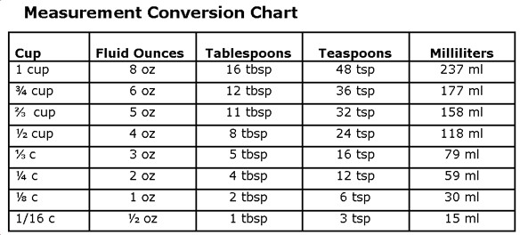
- If the recipe makes 12 cupcakes, how many times should the recipe be multiplied?

- The number of cupcakes ordered has changed to 78. How much of each ingredient is needed?
White sugar:
Butter:
Eggs:
Vanilla Extract:
All-purpose flour:
Baking Powder:
Milk:

- Based on the recipe, which option is best?
Option 1: 12 eggs - $3.98 Option 2: 18 eggs - $4.84 Option 3: 30 eggs - $7.32

- Dapinder wants to calculate how much she earned from this contract. It was agreed upon that she did 60% of the work. Which of the following equations would help her calculate her earnings (select all that apply):

  - $Profit= \frac{3(Revenue-Expenses)}{5}$
  - $Profit= \frac{6(Revenue-Expenses)}{10}$
  - $Profit=0.06( Revenue-Expenses)$
  - $Profit= 0.6 (Revenue-Expenses)$

- Estimate how many cupcakes you need for 100 people. There are 33 adults attending and 67 children. What would be a good strategy to estimate how many cupcakes they should make?

- Morgan and Dapinder need to provide an invoice to their customer for the cupcakes. What items are required on their invoice? Select all that apply.

  - Cost of ingredients
  - Competitor’s prices
  - Cost of labour (wages)
  - Cost of delivery
  - Cost of baking supplies and equipment
  - Length of time needed to complete contract
  - Gratuity

- Morgan calculated how much it would cost to buy sugar using this equation: This is incorrect. Find the error and explain how you would correct it.
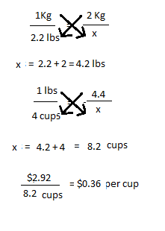

- What is the least amount of time it will it take to make all 78 cupcakes? Justify your answer

- Dapinder and Morgan meet at the bakery at 7 am to start the cupcake contract. When they arrive, they discover the power is out and won’t be on any time soon. To ensure contract completion, they decide to return to their individual homes and make the cupcakes there.
It takes Morgan 20 minutes to drive home and it takes Dapinder 30 minutes. Delivery to the party takes 20 minutes for each of them.
Once they have made the Vanilla Cupcake recipe, the cupcakes need to cool for 30 minutes before icing can be applied. To ensure quality control, they will wait until all the cupcakes are made and cooled before icing them. It will take 10 minutes to make the icing and 1 minute to ice each cupcake.
Party starts at noon and the contract states that delivery needs to be made 15 minutes before that. Do they make it on time?
Explain and justify your solution.

